HAND: n-detection efficiency measurements
(written by Igor)

We propose to perform the following triple coincidence D(e,e'pn) measurements listed in Table 1. The considerations are detailed below.

Table 1
Kin |  | Pmiss | conditions | Q2 | Events/day  (10 micA  4 cm target) | time
LD1 | X<1 | 250 | during N – Delta  (1 pass)  or D-Thr  (2 or 3 pass) | Minimal | 15,000 | 1 day | Effciecny point  (enough data  to check individual counters)
LD2 | X>1 | 500 | 3 pass  Just before pass 4 | Minimal  Q2=0.4 | 900 * | 1-2 days | A second efficiency  point
LD3 | X>1 | 500 | Just before Production | Q2=2 | 100 | 1 day | A check before production  (not for n efficiency)

* Other pass (2 or 4) means only half the rate.

The Hand n detection efficiency will be determined based on the exclusive scattering from Deuterium target (e',epn) measurements at two n momentum, and the calculated efficiency curve normalized to the data. Same as done in E01 – 015. See Figure from Ramesh thesis

In order to perform the fit we will need minimum two data points.
From the known behavior of the efficiency curve we need data point on the plateau region and on the slope. This two regions correspond to 250 MeV/c and 500 MeV/c missing momentum.

Based on the previous SRC experiment, we know that for scattering from Deuterium with 500 MeV/c missing momentum we get ~ 100 Events / C or 50 Events / day based on 10 uA 4cm target LDK3). (from the figure 6.9 in Ramesh Thesis we identify ~50 events in total and from the E01-015 site we found that the total accumulated charge is ~ 0.6 C).

In order to increase the rate for this missing momentum we will lower the Q² in order to increase the Mott cross section:
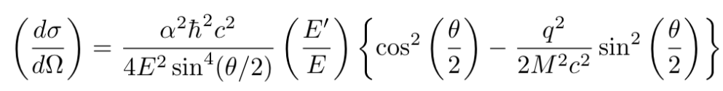
because the angle is small we can neglect the correction is the brackets and we can ignore the constant contribution from:
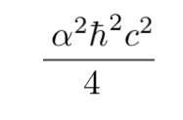
So, Mott for the LDK3 case approximately: 45 (must be multiplied by constant above). The Q² in LDK3 is 1.97 GeV² .
In order to increase the Mott cross section we should minimize Q² .
Kinematics with highest Mott cross section were found in 3 pass.

E =3.356 GeV. KIN LD2
E' = 2.4 GeV.
theta_e = 12.5 deg.
Ep = 1.500 GeV/c
theta_p = -42.3 deg.
En = 0.5 GeV/c
theta_n = -101 deg
Q² = 0.38 GeV² .
Mott = 450 .

Similar procedure was done for pass 2 and 4 (however the best result coming from pass 3).
In addition the efficiency of HAND expected to be high by factor two because of the thinner lead wall and two additional layers (this mean that in production we should expect 100 Events / day instead of 50).
Following table summarize the results (for 4cm target and 10 microA):

 | Mott | Events / day
Production (4 pass) | ~ 45 | 100
4 pass (calibration) | ~ 178 | 400
3 pass (calibration) | ~ 450 | 900
2 pass (calibration) | ~ 191 | 400

Second point for the efficiency calibration must be around 250 MeV/c (missing momentum). For this momentum the kinematic configuration don't allow significant increase of the Mott cross section.For this reason we propose to perform this measurement at X<1.
Another reason to do at x<1 is that this is the only way to collect enough statistic in a short time to allow efficiency check for individual counters with significant statistical meaning.

In this case the kinematics is similar to the LDK0. From the data we find that ~ 30000 Events / C (15000 Events / day).

For this measurement the polarity of the HRSs is opposite to the production. Left for protons and Right for electrons.
The measurement for X<1 is be at 1 pass when HRS Right (electrons) is at 12.5 deg. In such way Mott cross section is maximal. For example:

E = 1.160GeV.
E' = 0.995 GeV.
theta_e = - 12.53 deg.
Ep = 0.516 GeV/c
theta_p = 63.8 deg.
En = 0.250 GeV/c
theta_n = -100 deg
Mott = 4500 .

compared to LDK0 with Mott cross section = 292.

This calibration should be performed during the N – Delta experiment with 1 pass beam or during the D – threshold with 2 or 3 passes. In both experiments the polarity in the HRSs is as needed.

The final measurement should be made with the high P miss (500 MeV/c) but with the correct Q2. This is just to identify the TOF before production. No change except target. We should not consider that as a n –efficiency –no significant statistic.

