To: g2P/GEP Readiness Committee

From: L. A. DILLON-TOWNES; Mechanical Engineering Group

Subject: Responses to Requests and Suggestions from the 1/17/12 Readiness Review

* **Request #3: Beam line Chicane Drawing**

See attached Drawing.

* **Request #4: Procedure to operate the beam chicane. How are the two instrumentation arms adjusted and aligned? Is the target magnetic field kept on while adjusting the chicane? Is/has/should the beam chicane be vented to be able to adjust it?**

*The detailed operation of the beam line chicane is included in the OSP #ACC-12-006-OSP. The procedure is predicated upon the following criteria:*

* + - * 1. *The Run coordinator has initiated the communication chain for making a chicane changes to designated HALL A and Accelerator Service providers.*
        2. *The Adjustment/Movement Checklist is used, annotated, and reported to the Run Coordinator when complete to resume the experiment.*
        3. *HALL A and Accelerator service providers coordinate their efforts.*
        4. *All magnet fields are deactivated.*
        5. *The beam line vacuum from FZ#1 to the beryllium window is brought up to atmosphere before any movements are done.*
        6. *The Helium Bag between the target chamber and the end of the beam line is disconnected before any movements are done.*
        7. *All mechanical linkages and restraints are disconnected before any movements are done.*
        8. *All safety and risk hazard procedures are followed.*

*Concisely, the two instrumentation arms are adjusted from the straight thru configuration to the various angular configurations in the following sequence:*

1. *The beam line vacuum from FZ#1 to the beryllium window is brought up to atmosphere.*
2. *Bellows restraint bars are disconnected from the downstream girder.*
3. *The upstream and downstream Arm vertical restraint bars are disconnected.*
4. *The motor control box for elevating the FZ#2 magnet is connected to the motorized stand. As the magnet is lowered/ raised to its prescribed location, the arms pivot about the center of the FZ magnet which positions the girders at their prescribed angular orientations. The arms are then lowered/raised (using a 1” ACME screw) to their prescribed height. Then the downstream and upstream girders are raised/lowered (using a 3/8” ACME screw) to their prescribed elevation to capture the beam for various energy runs.*
5. *Alignment of the arms and girders will be done at each relocation event while the beam line is at atmosphere. A re-check of the alignment will be done when vacuum is restored.*

* **Request #9: Make available the bellows flange load/stress calculations. How is the vertical motion of the chicane magnets interlocked and limited? Does vacuum loading interferes with the motion of the FZ2 magnet?**

*The vertical travel of the chicane magnet is controlled by two limit switches which limit the upper and lower travel of the magnet. In addition the motor control box is physically disconnected from the stand when chicane changes are not being performed. The movement of the magnet will be done at atmosphere therefore eliminating unfavorable loads to the bellows. The load from the 10” diameter bellows is 1154 lbf. The FZ magnet is 14,000 lbf, therefore there will be no effect on movement of the magnet.*

*A finite element analysis was conducted to examine the total downstream arm-girder behavior. A bellows load of 1700 lbf was used to stress the flange. The picture below shows the loads that the bellows-to-downstream girder flange experience. The maximum stress of 5357psi occurs at the bolt holes. Thirty-two (32) 5/16” diameter stainless steel bolts will be used to secure the bellows flange. Each bolt has a minimum tensile stress of 70,000 psi, therefore an adequate factor of safety is available. The stresses around the perimeter of the flange are low and present no issues or concerns.*

***bellows-to-downstream girder flange***

***stress distribution***

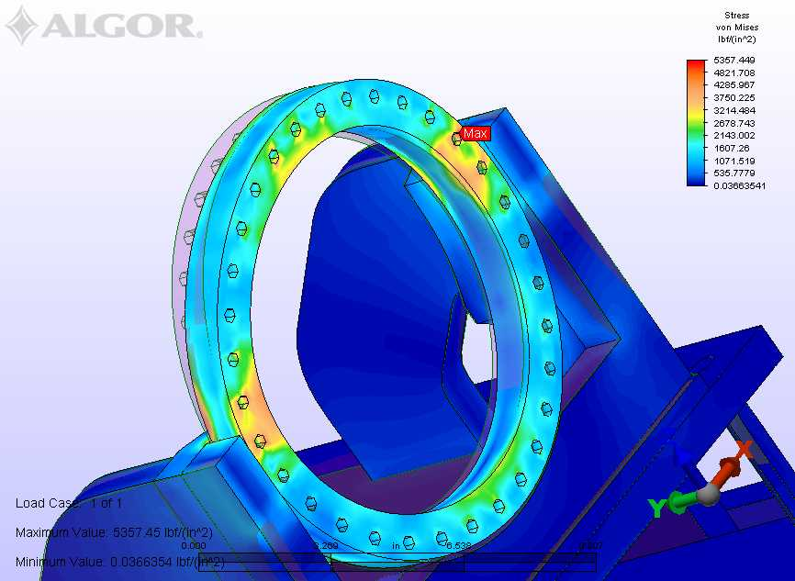

**Max Stress 5357 psi @ bolt holes**.

**G2P/GEP REGION #3 CHICANE ARANGEMENT**

**Drawing # ACC0363603-0001**

**

* **Suggestion#8: Consider protecting the bellows from particulate material lodging in the bellows. These can and have cause bellows ruptures when bellows are compressed.**

*Standard vacuum grade aluminum foil will be wrapped around bellows after they are installed. I will be removed for each adjustment/movement of the chicane.*

* **Comment #3: Beam chicane: are there any spare bellows?**

*There are three spare bellows- one for each location. They are store in the Accelerator vacuum lab.*

I hope this response answers your queries and addresses your suggestions and comments.

If further information is needed, please contact me at x7563 or email me.