Left S2 timing:

requirements/cuts:
    - no edtm
    - evtypebits ==8 (T3 alone)
    - has track at the center of the paddle abs(try)< 5 cm
    - register signal in S1 in the paddle that is closest to the interested S2 paddle.

Using DBB.s2or[0] as the new gate.

- Time Alignment

The right “rt_c” are self timing. So we have narrow peaks with sigma = 0.4 ns. All are aligned together at 850 ns.

The left “lt_c” are aligned at the same 850 ns as the requirement on the center of the paddle, (symmetric ly) would suggest. The sigma are around 0.7-0.8 ns

The “time” are check on the alignment which fall on 848.4 ns +/- 0.1 ns with the sigma around 0.5 ns.

The following are the plot of lt_c/rt_c/time in order with the mean and sigma given ,at the new gate.

Using only 4 runs 2013-16

Note that the paddle #0 need a lot more statistic. And with the limit of the cut impose, track required, it will have a larger spread in sigma.
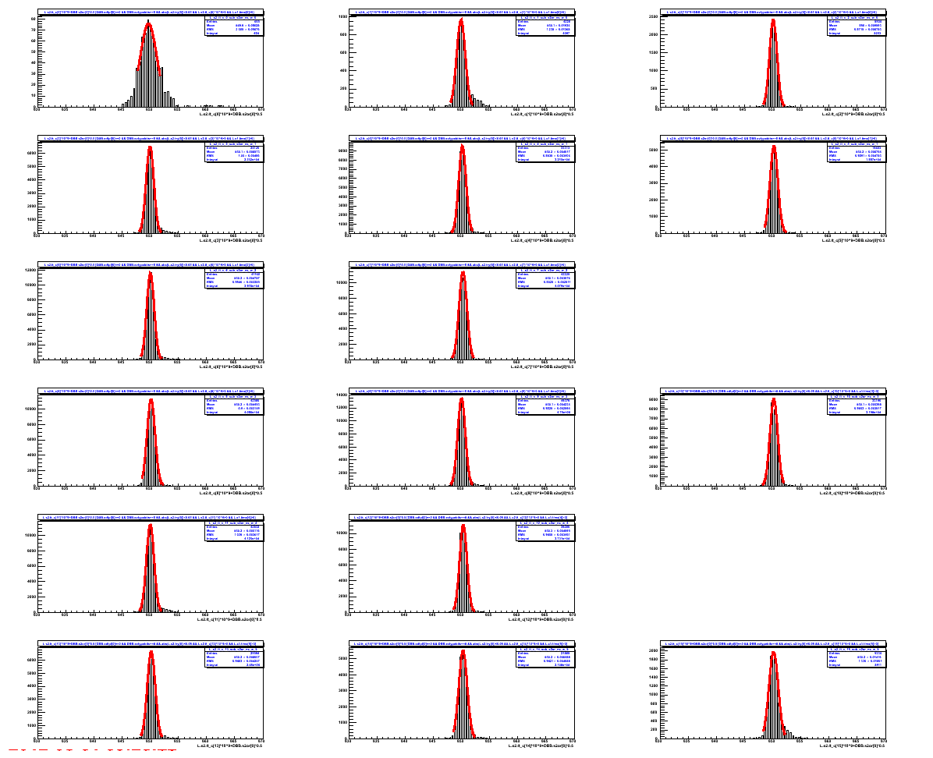
s2bar = 0 mean = 849.7 sigma 1.5 entries = 665

s2bar = 1 mean = 849.9 sigma 0.8 entries = 4226

s2bar = 2 mean = 850.1 sigma 0.7 entries = 8504

s2bar = 3 mean = 849.9 sigma 0.7 entries = 24126

s2bar = 4 mean = 850.1 sigma 0.7 entries = 33313

s2bar = 5 mean = 850.2 sigma 0.7 entries = 19603

s2bar = 6 mean = 850.0 sigma 0.7 entries = 41160

s2bar = 7 mean = 850.2 sigma 0.7 entries = 42225

s2bar = 8 mean = 850.1 sigma 0.7 entries = 42586

s2bar = 9 mean = 850.0 sigma 0.7 entries = 49379

s2bar = 10 mean = 850.2 sigma 0.7 entries = 33196

s2bar = 11 mean = 850.0 sigma 0.7 entries = 42832

s2bar = 12 mean = 850.3 sigma 0.7 entries = 39260

s2bar = 13 mean = 850.2 sigma 0.7 entries = 25594

s2bar = 14 mean = 850.2 sigma 0.7 entries = 21885

s2bar = 15 mean = 850.1 sigma 0.8 entries = 9334

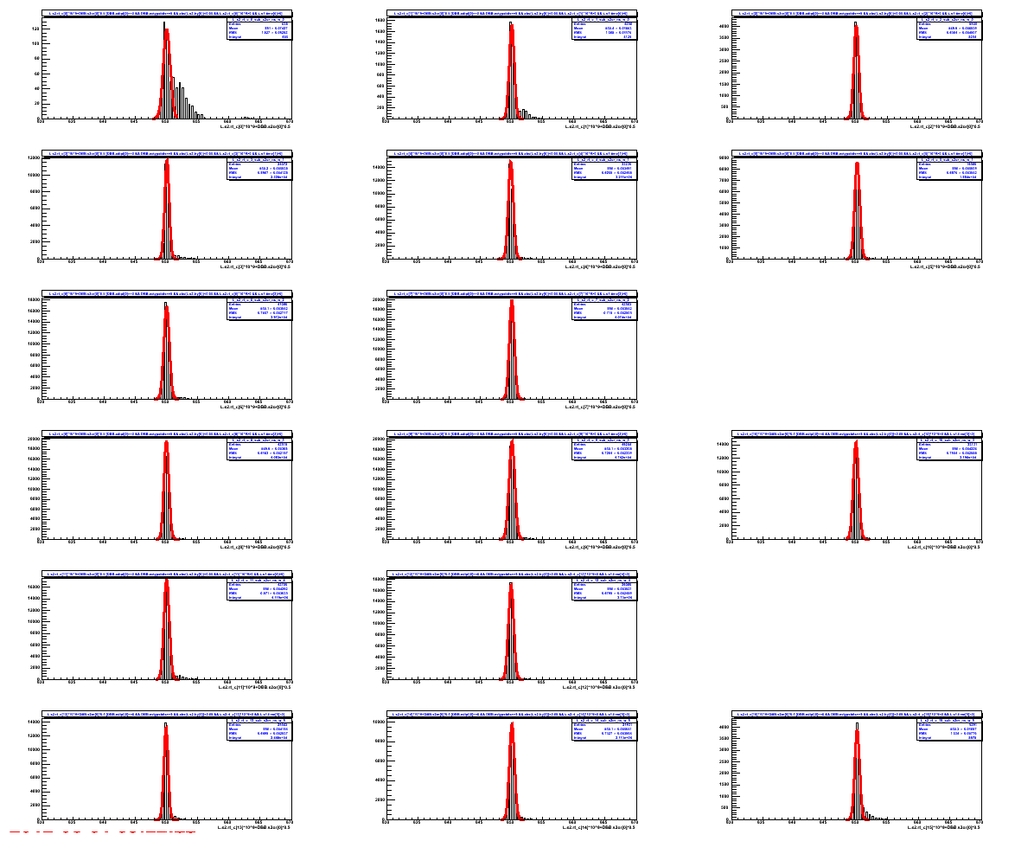
s2bar = 0 mean = 850.0 sigma 0.6 entries = 638

s2bar = 1 mean = 850.0 sigma 0.4 entries = 4258

s2bar = 2 mean = 850.0 sigma 0.4 entries = 8505

s2bar = 3 mean = 850.1 sigma 0.4 entries = 24072

s2bar = 4 mean = 849.9 sigma 0.4 entries = 33236

s2bar = 5 mean = 850.1 sigma 0.4 entries = 19566

s2bar = 6 mean = 850.0 sigma 0.4 entries = 41090

s2bar = 7 mean = 850.0 sigma 0.4 entries = 42503

s2bar = 8 mean = 850.0 sigma 0.4 entries = 42515

s2bar = 9 mean = 850.1 sigma 0.5 entries = 49244

s2bar = 10 mean = 849.9 sigma 0.4 entries = 33131

s2bar = 11 mean = 850.0 sigma 0.4 entries = 42700

s2bar = 12 mean = 849.9 sigma 0.4 entries = 39060

s2bar = 13 mean = 849.9 sigma 0.3 entries = 25543

s2bar = 14 mean = 850.1 sigma 0.4 entries = 21931

s2bar = 15 mean = 850.1 sigma 0.4 entries = 9291

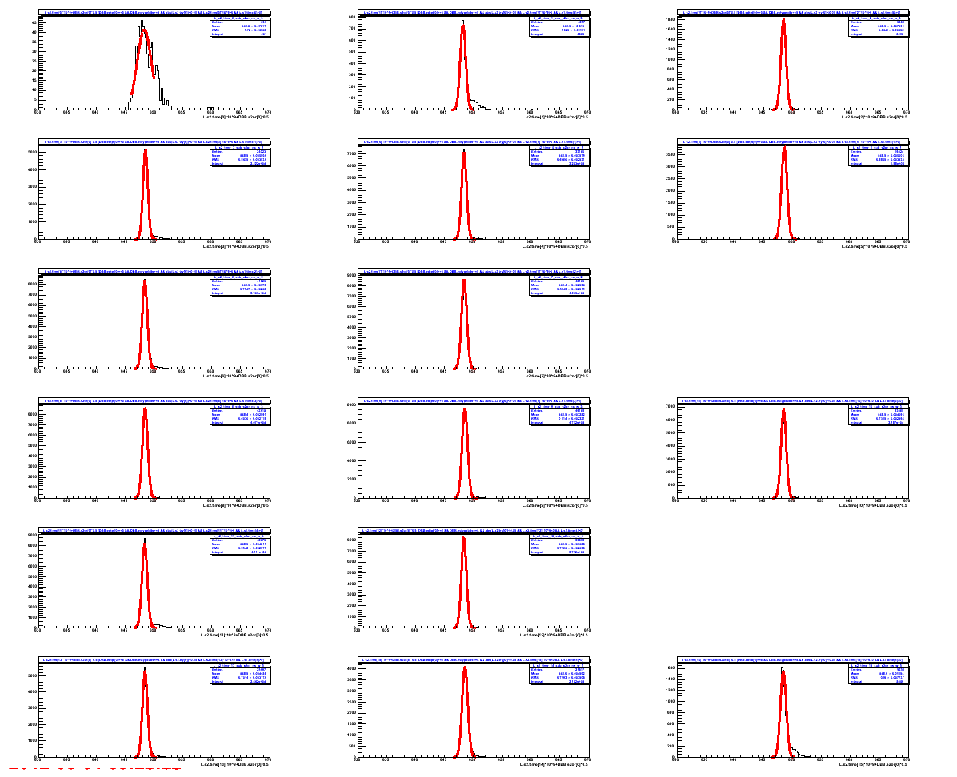
s2bar = 0 mean = 848.3 sigma 1.2 entries = 634

s2bar = 1 mean = 848.2 sigma 0.5 entries = 4217

s2bar = 2 mean = 848.4 sigma 0.5 entries = 8486

s2bar = 3 mean = 848.5 sigma 0.4 entries = 24023

s2bar = 4 mean = 848.4 sigma 0.4 entries = 33180

s2bar = 5 mean = 848.5 sigma 0.5 entries = 19524

s2bar = 6 mean = 848.4 sigma 0.5 entries = 41020

s2bar = 7 mean = 848.4 sigma 0.5 entries = 42186

s2bar = 8 mean = 848.4 sigma 0.5 entries = 42418

s2bar = 9 mean = 848.5 sigma 0.5 entries = 49184

s2bar = 10 mean = 848.4 sigma 0.5 entries = 33065

s2bar = 11 mean = 848.4 sigma 0.5 entries = 42670

s2bar = 12 mean = 848.4 sigma 0.4 entries = 39032

s2bar = 13 mean = 848.4 sigma 0.4 entries = 25497

s2bar = 14 mean = 848.5 sigma 0.5 entries = 21817

s2bar = 15 mean = 848.4 sigma 0.5 entries = 9252

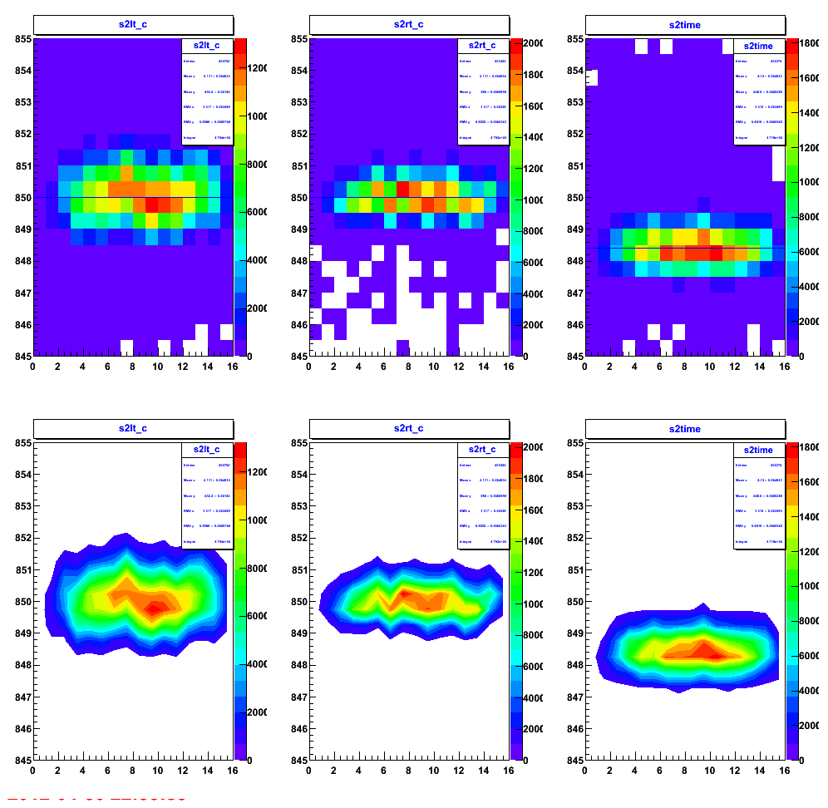
The lt_c, rt_c and the time vs paddle number. The y axis is 10 ns wide. This require nothing on S1.

- TimeWalk Correction Needed?

I check for the time walk correction. As we expect the
timewalk(tw) = Const/sqrt(ADC_pedestal)

Note that because of the self timing on the right side, the correction from right ADC needed to transfer to the left lt_c.

The timewalk parameters are eliminate from the database.

The plot of
lt_c vs la_p,
rt_c vs ra_p,
time vs la_p+ra_p

show that our resolution are not high enough for the timewalk effect to change any significant distribution (sigma). See the following plots:

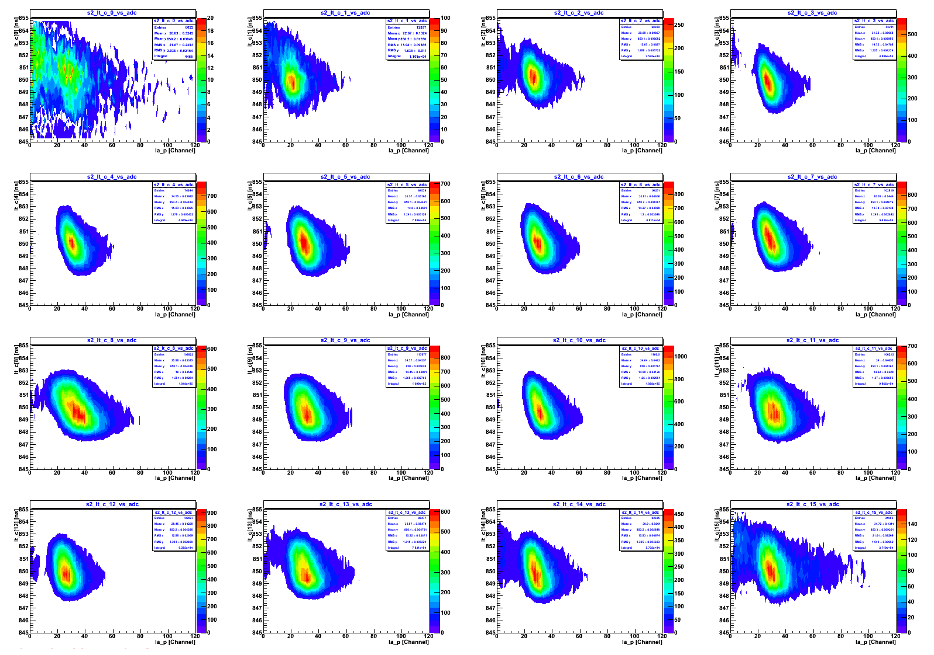
lt_c vs la_p---->There are dependent on the ADC value
scale Y = 10 ns, X = 120 channel

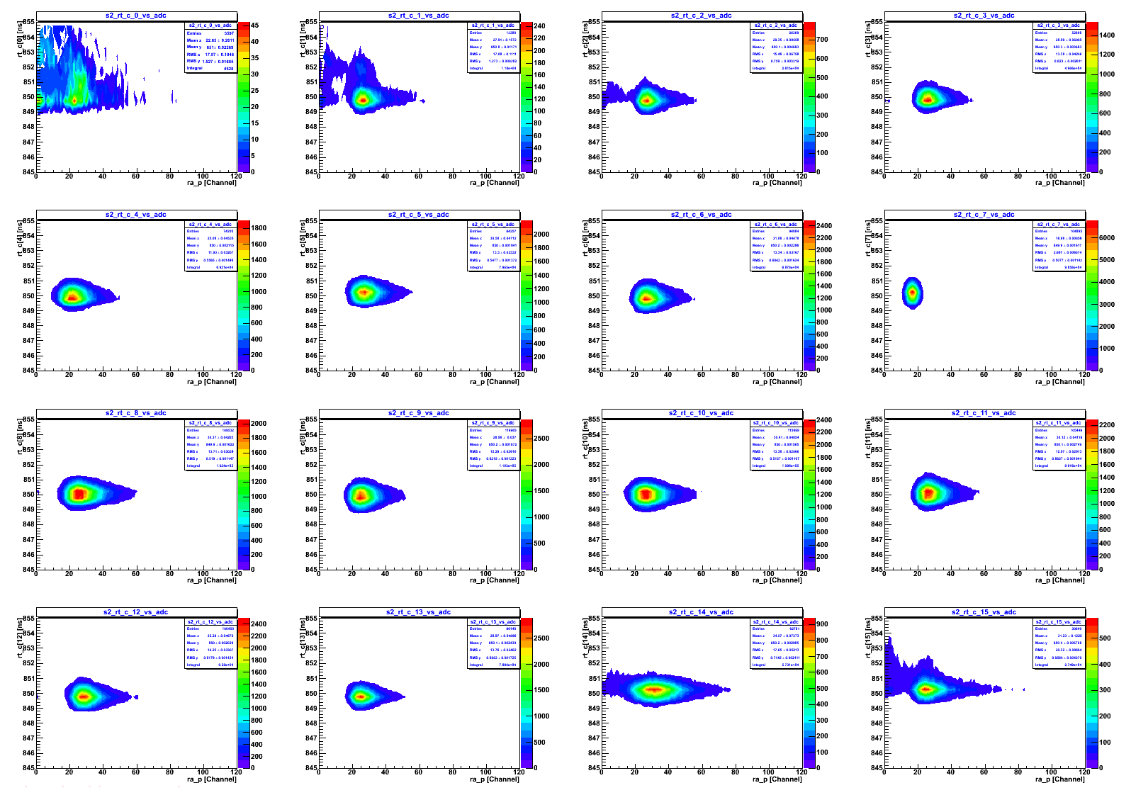
rt_c vs ra_p same scale

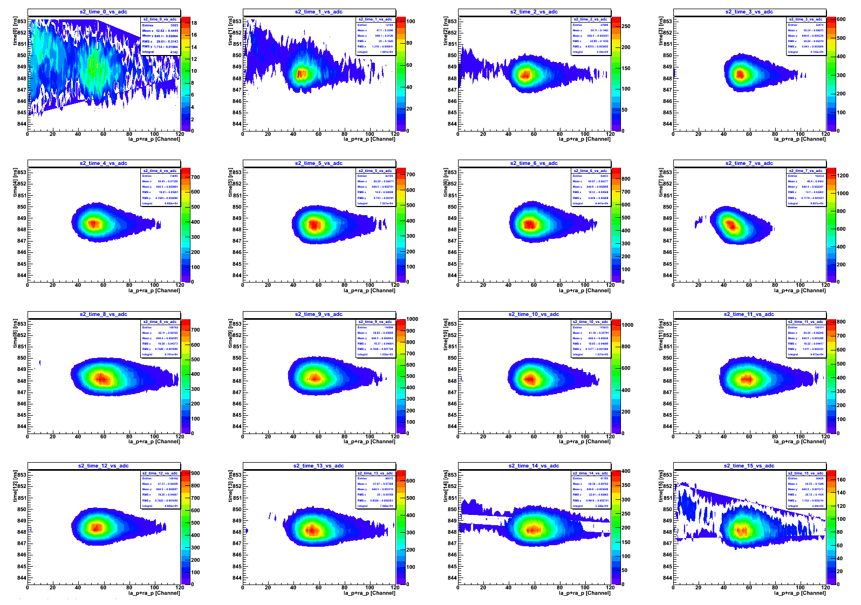
time vs adc sum

Now let see whether we can extract the constant.

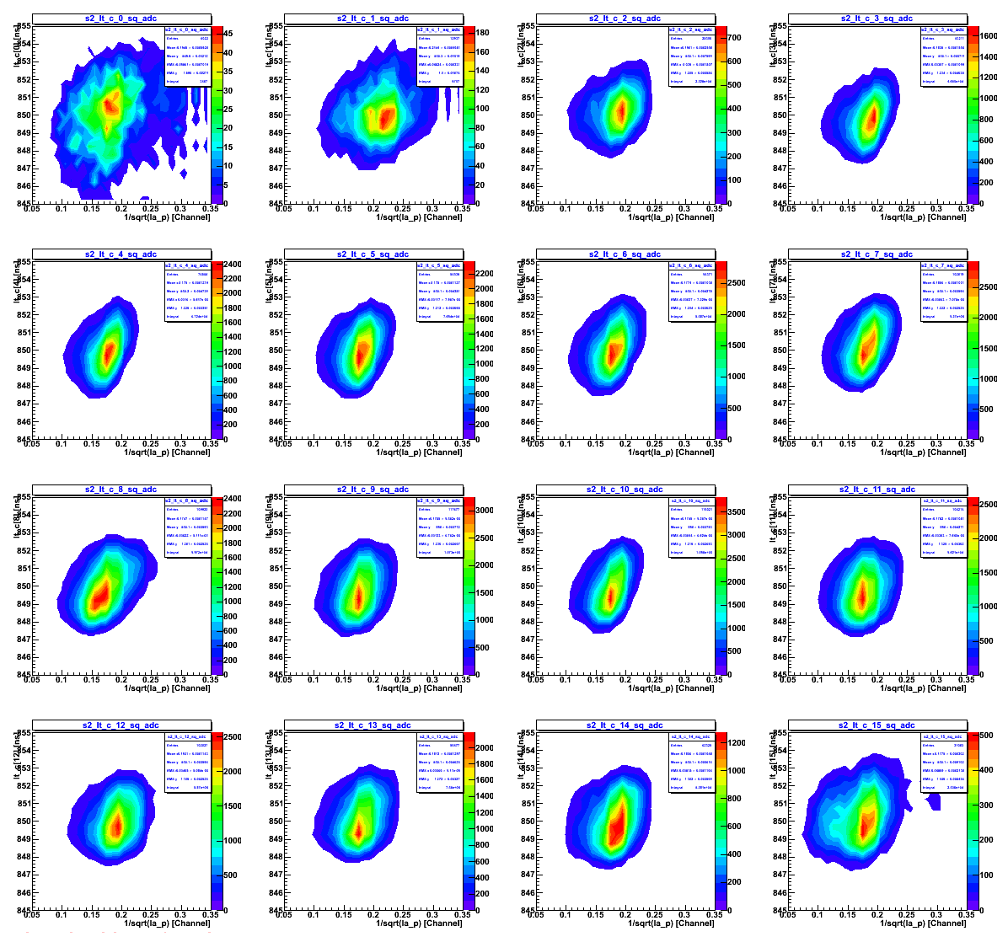

lt_c vs 1/sqrt(la_p)

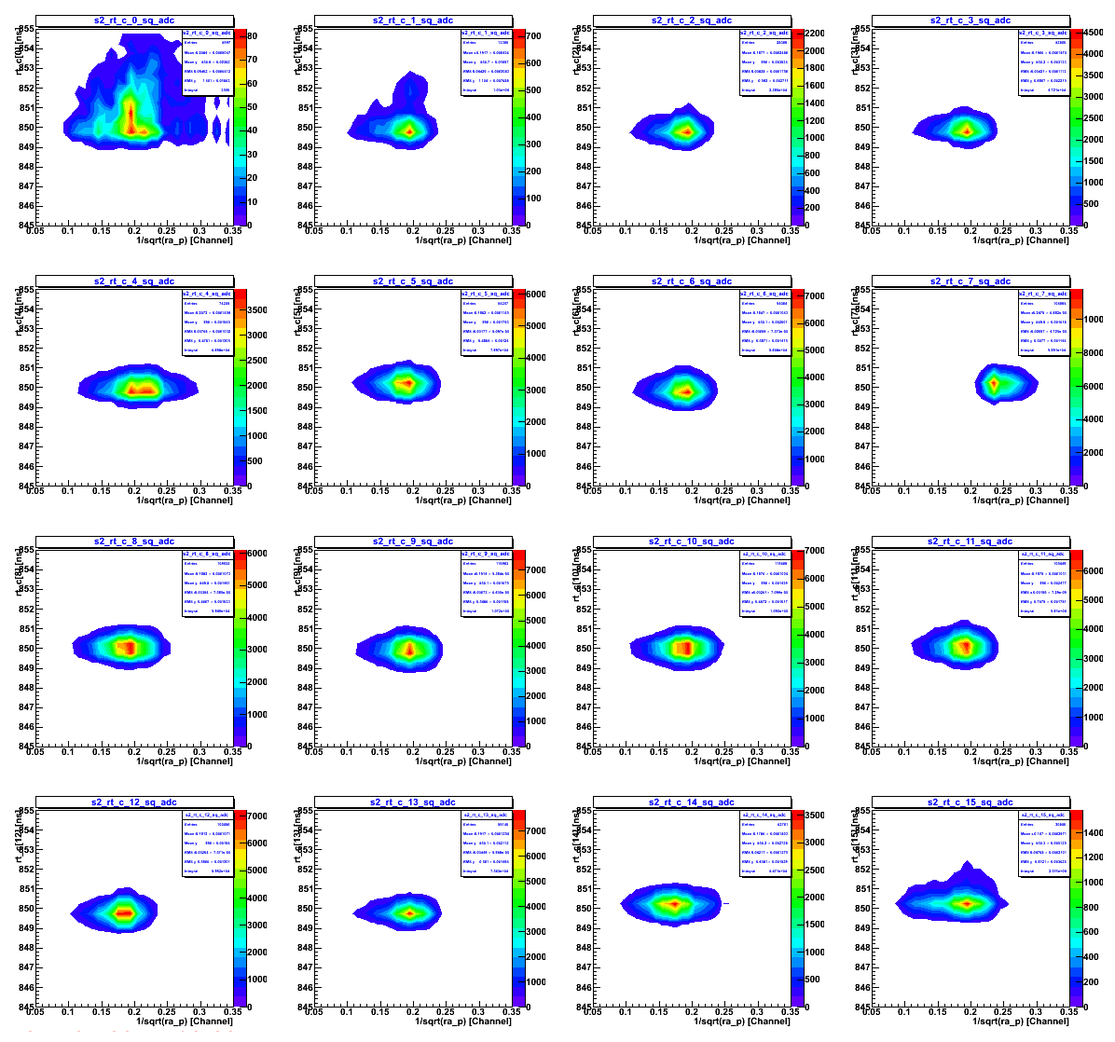
rt_c vs 1/sqrt(ra_p)
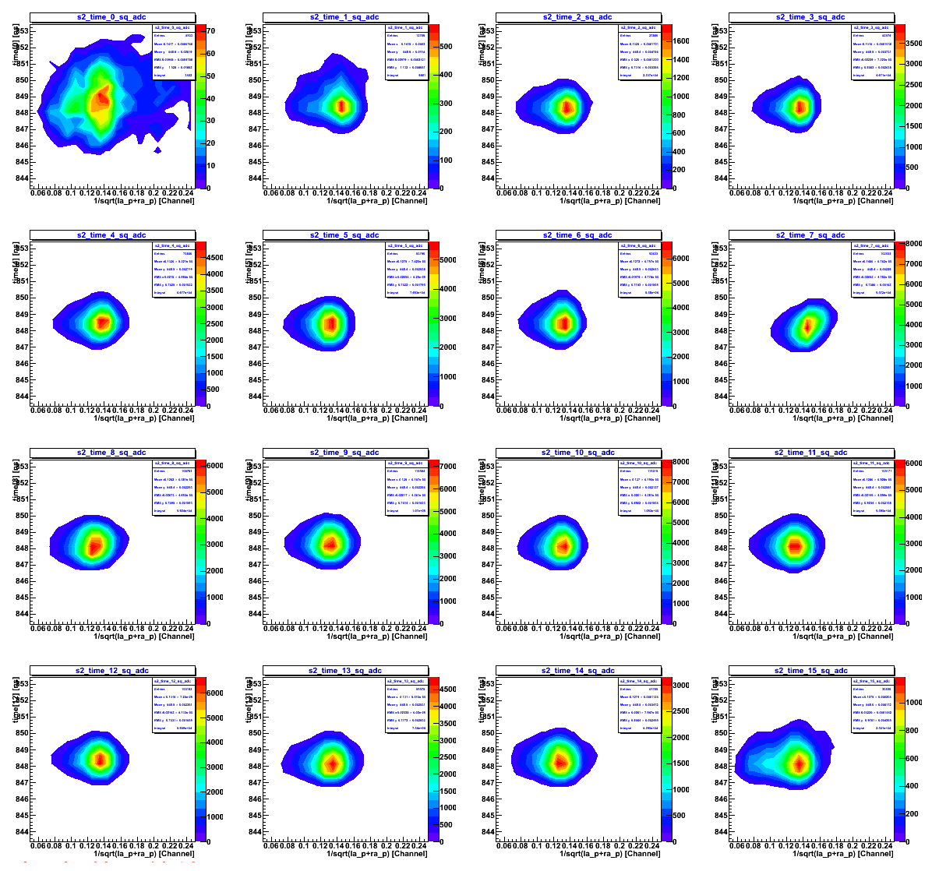
time vs 1/sqrt(la_p +ra_p)

EXTRA

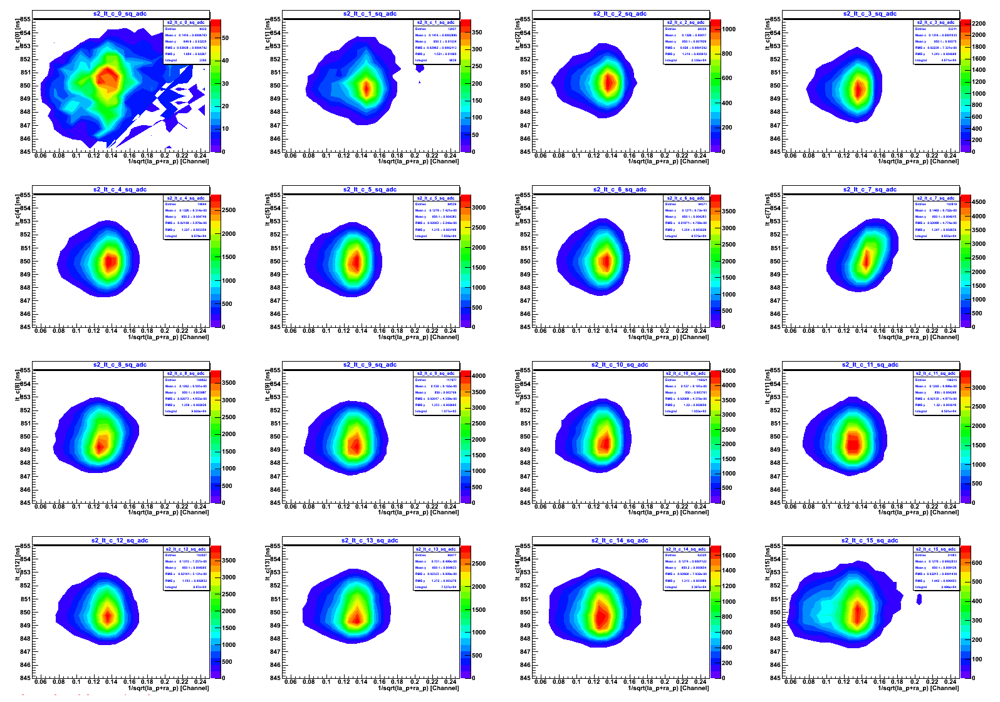
lt_c vs 1/sqrt(la_p + ra_p)
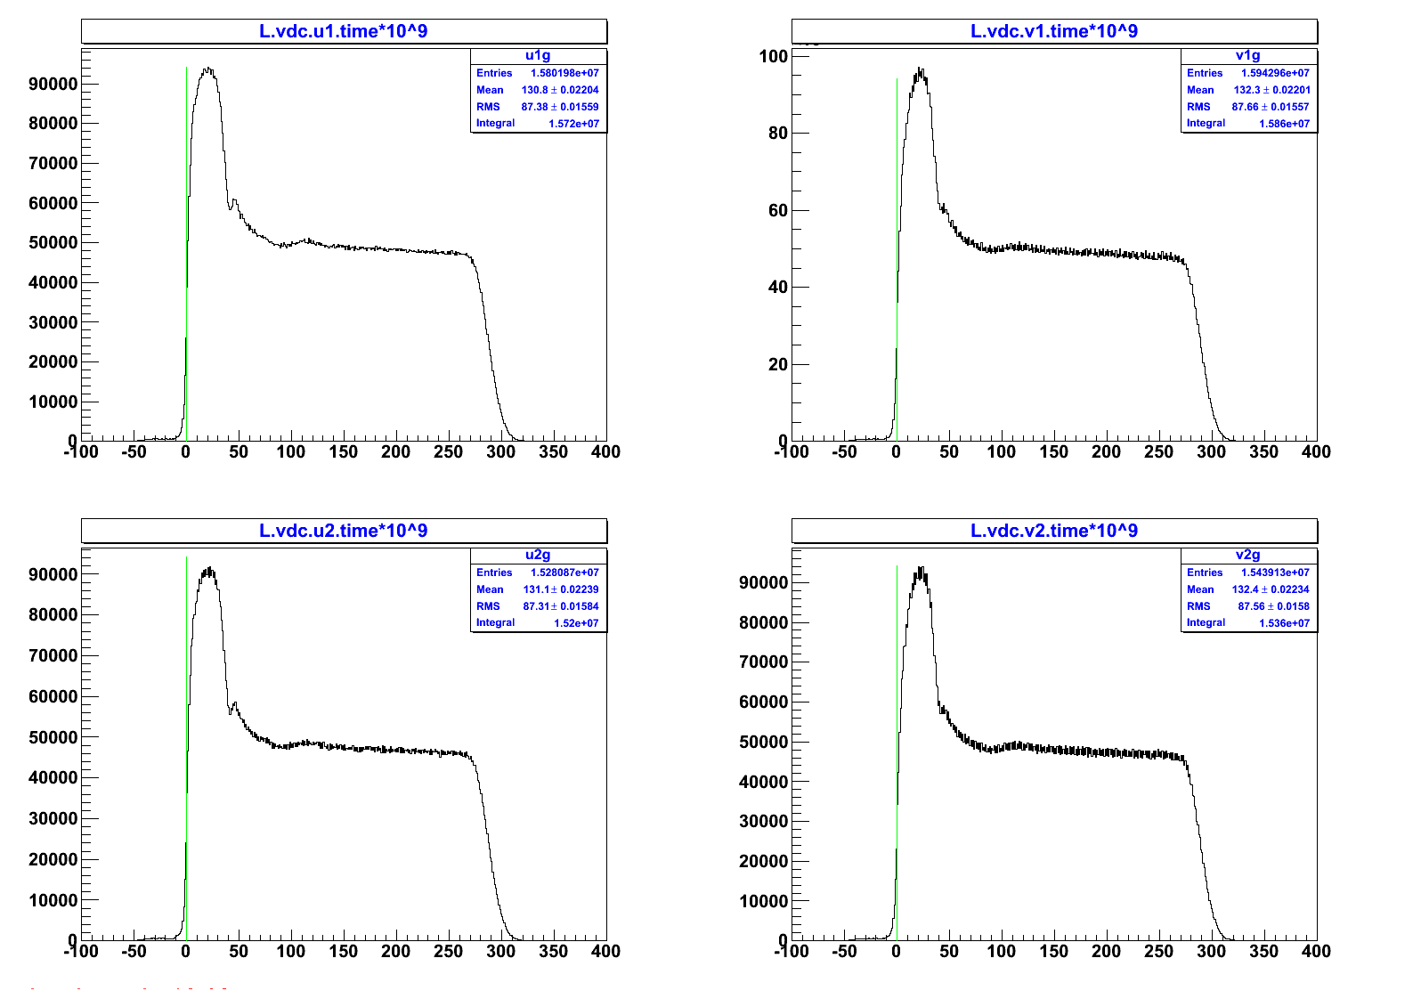
vdc adjustment

assume that each 16-wire are connect with the same ribbon cable and to the same tdc readout.
I adjust he VDC time offset according to those set of 16 wires each.

The data below 0 are 0.8% which will be ignore from the analyzer in analysis process.
