::::::::::::::::::::::::::::::::::::::::::::::::::::::::::::::::: List :::::::::::::::::::::::::::::::::::::::::::::::::::::::::::::::::::::::::::::
- VDC: u1,u2,v1,v2
- Gas Cerenkov,
- Scintillator: S1&S2
- Pion Rejector: pr1,pr2

:::::::::::::::::::::::::::::::::::::::::::::::::::::::::::::::::::::::::::::::::::::::::::::::::::::::::::::::::::::::::::::::::::::::::::::::::::::

Pion Rejector
:::::::::::::::::::::::::::::::::::::::::::::::::::::::::::::::::::::::::::::::::::::::::::::::::::::::::::::::::::::::::::::::::::::::::::::::::::::

description:

Calibration: Almost the same calibration as the Gas Cerenkov calibration. The pedestal alignment is the same. The gain factor is aligned with the main peak together.

I do the scan of the overlap for each 11 runs (with 1 run from the previous set). There are no change for prl1 however, the prl2 has two PMTs that change value throughout.

Prl2 PMT-14 has no overflow since run 3390

Prl2 PMT-31 has significant drop of the ADC value during the run 3188 to 3288

....................................................................................................................................................................

NEW: Impose additional requirement where ther track .x and track .y must be within the prl block area for each individual block.

The pion(low energy) peak is reappear from what it has been under the large peak of the pedestal. I did the (rough) fit over both main peak (electron) and pion peak. The first realignment is the electron peak for individual plane. (prl1 and prl2). Then we run the data, and check the main peak alignment.

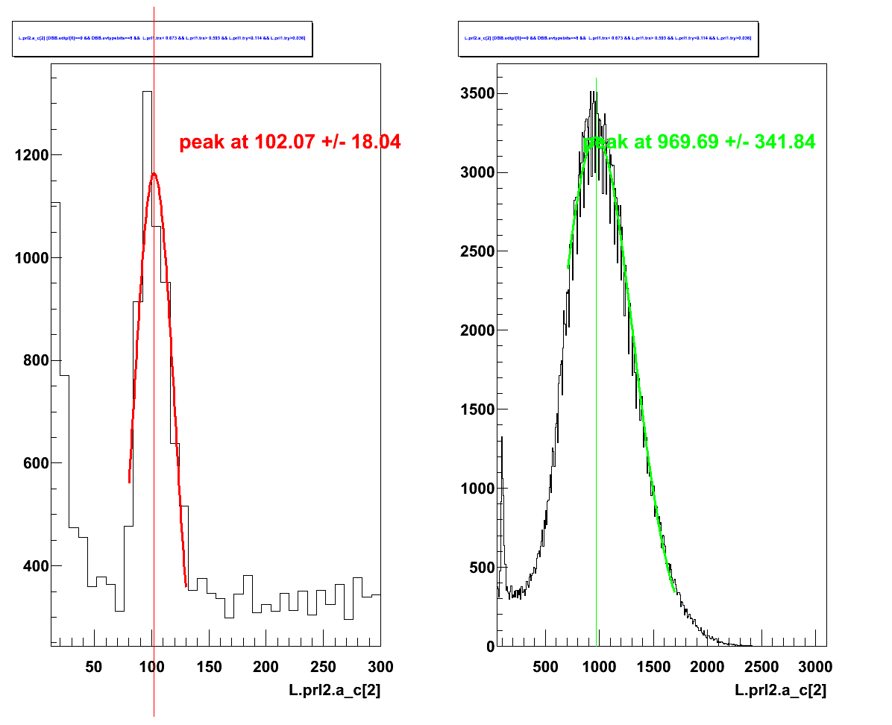
Figure N.1
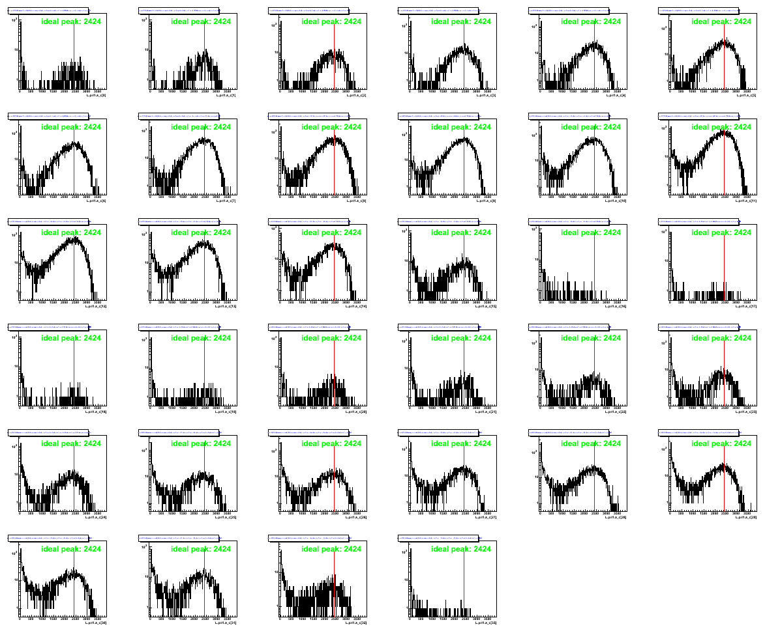
Figure N.2

With this, we check the accumulate energy per plane, prl.e, the sum of the energy and the

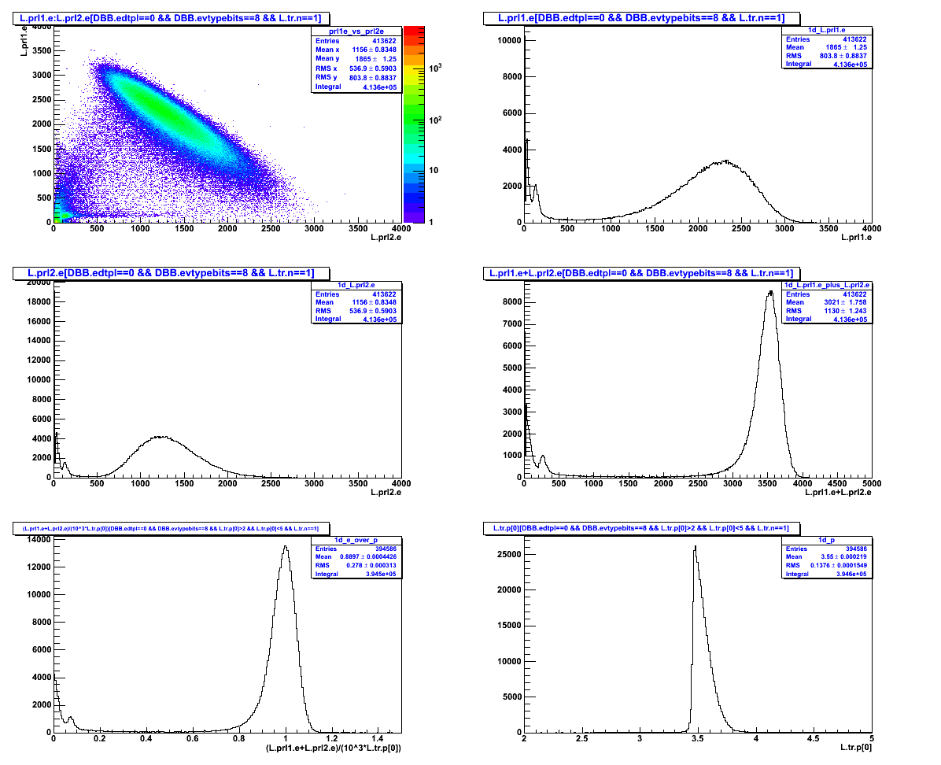
Then align prl1 and prl2 with the pion peak. As the following process.

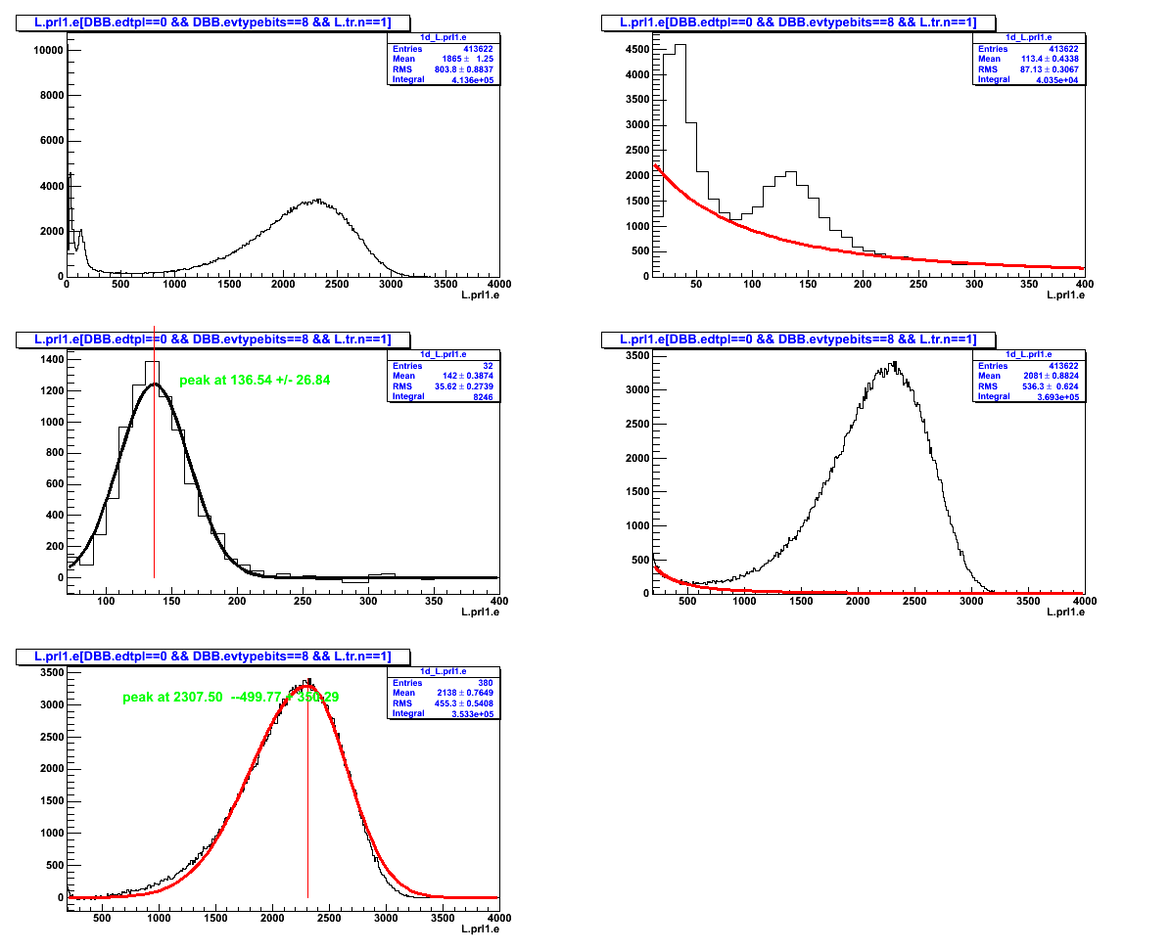
Then we check the E/p to get the peak at 1. and re-modify the constant by the % difference.

Finally we get :
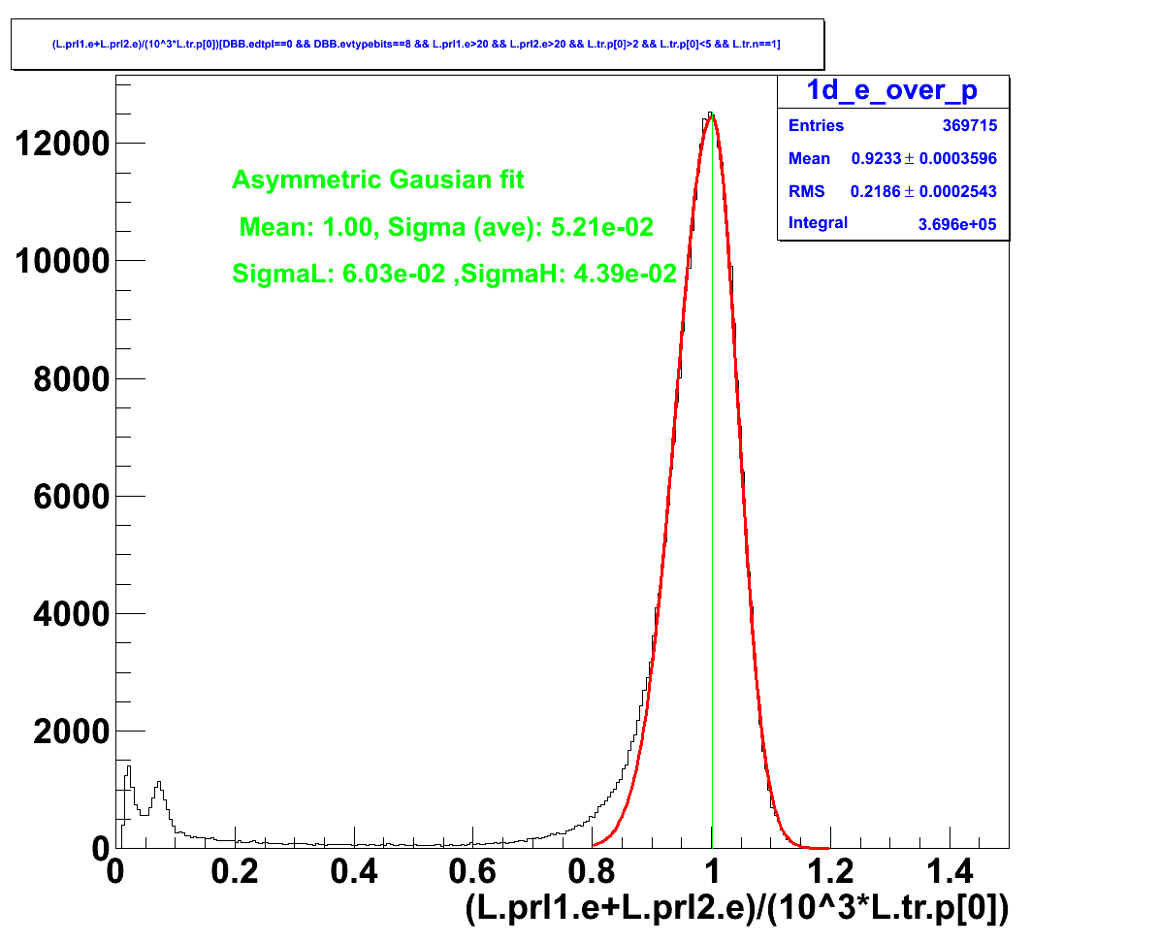

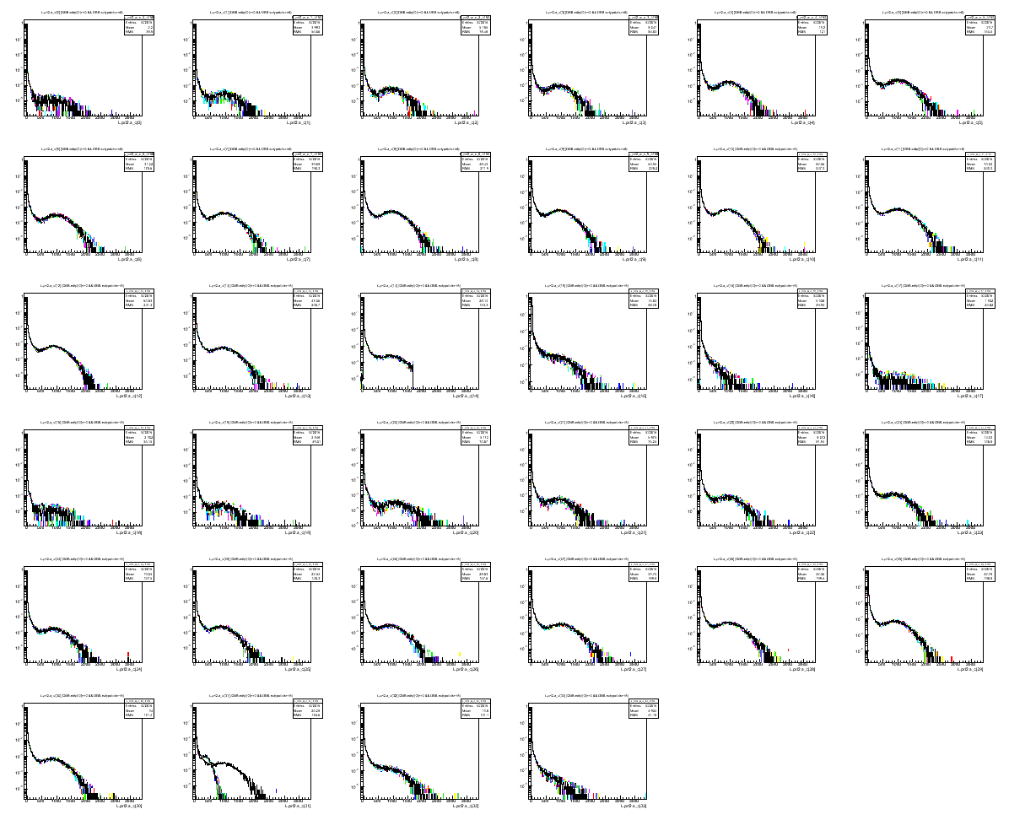

Figure 1.1: The scan of the overlap 11 runs. The last row second column show the sudden change in the ADC value. With all the x axis fix to the same length, this can be clearly seen in the next couple set till the ADC is back to same setting again.

Note that this change has NO record I can find in the halog. By scan though all single run, I would found this.

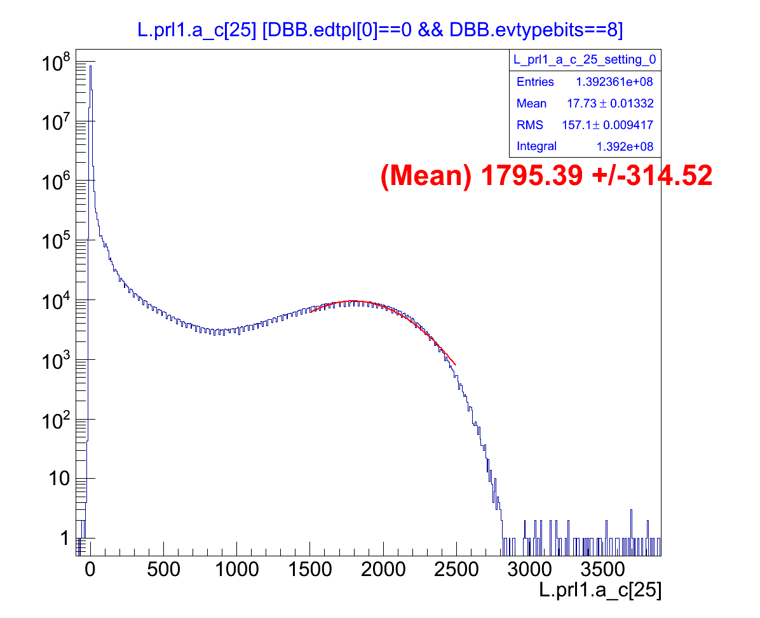

Figure 1.2: ADC main peak. The main peak is obtained on the ADC sum of all the runs. This is the example of the PMT that has clear main peak.

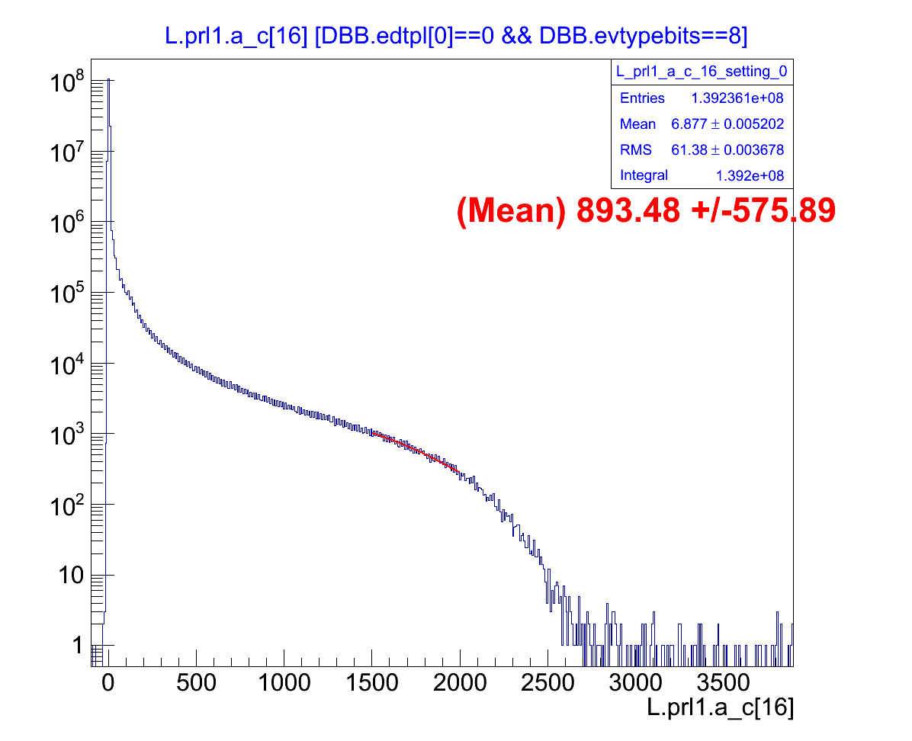
Figure 1.3 : The example of the PMT that has unidentified peak. This applies to PMT # 15 16 32 33.

Figure 1.4-6: The prl2 PMT-14 where the change of the bit type of the ADC readout occurs.

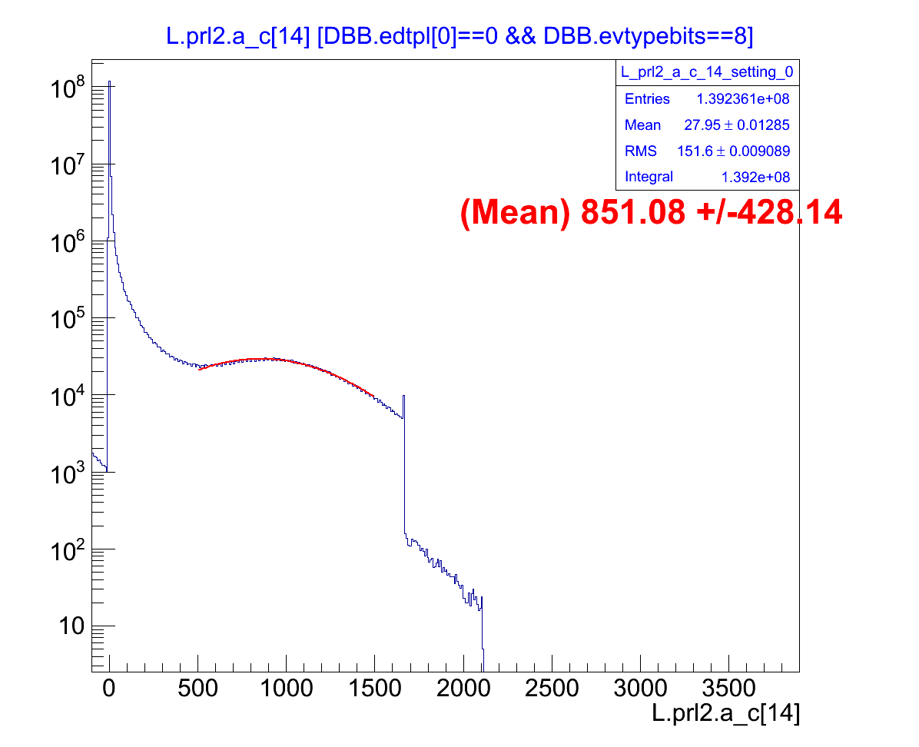
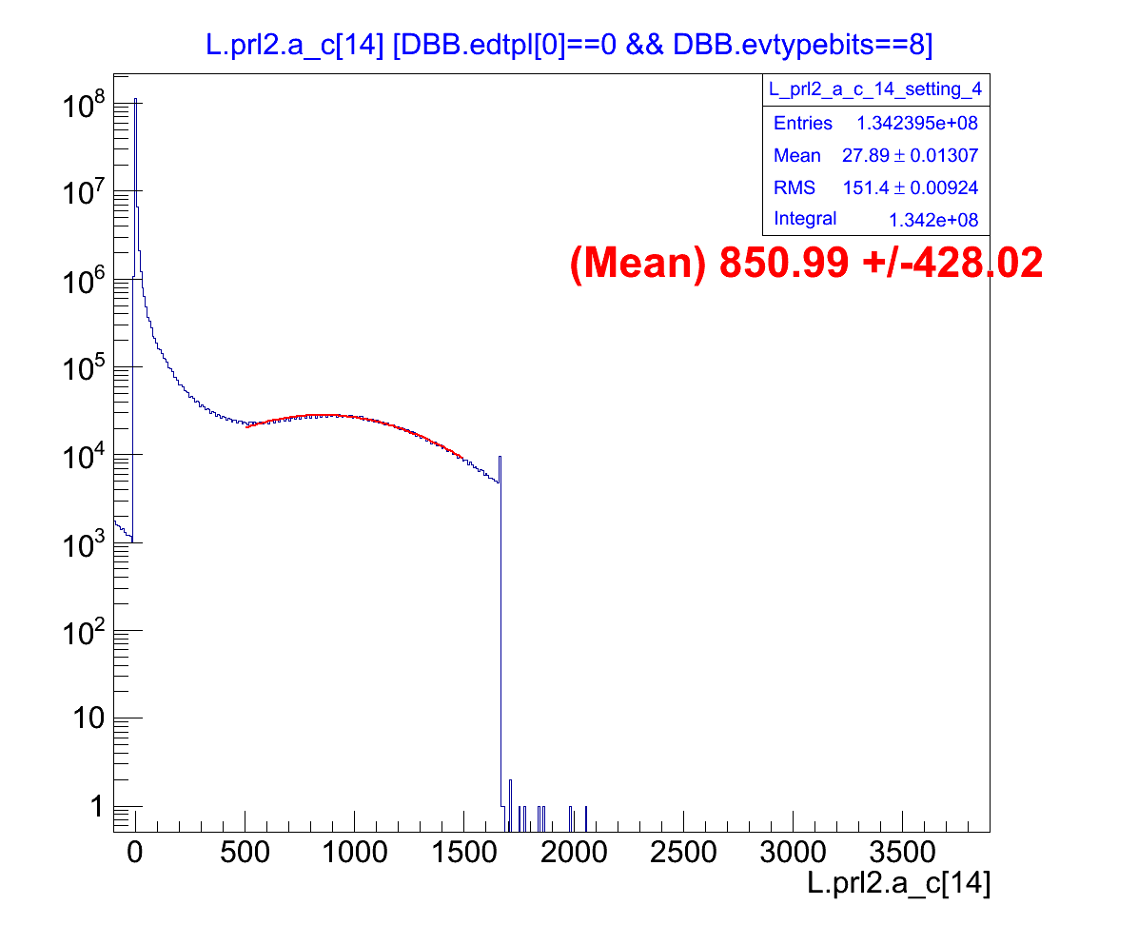
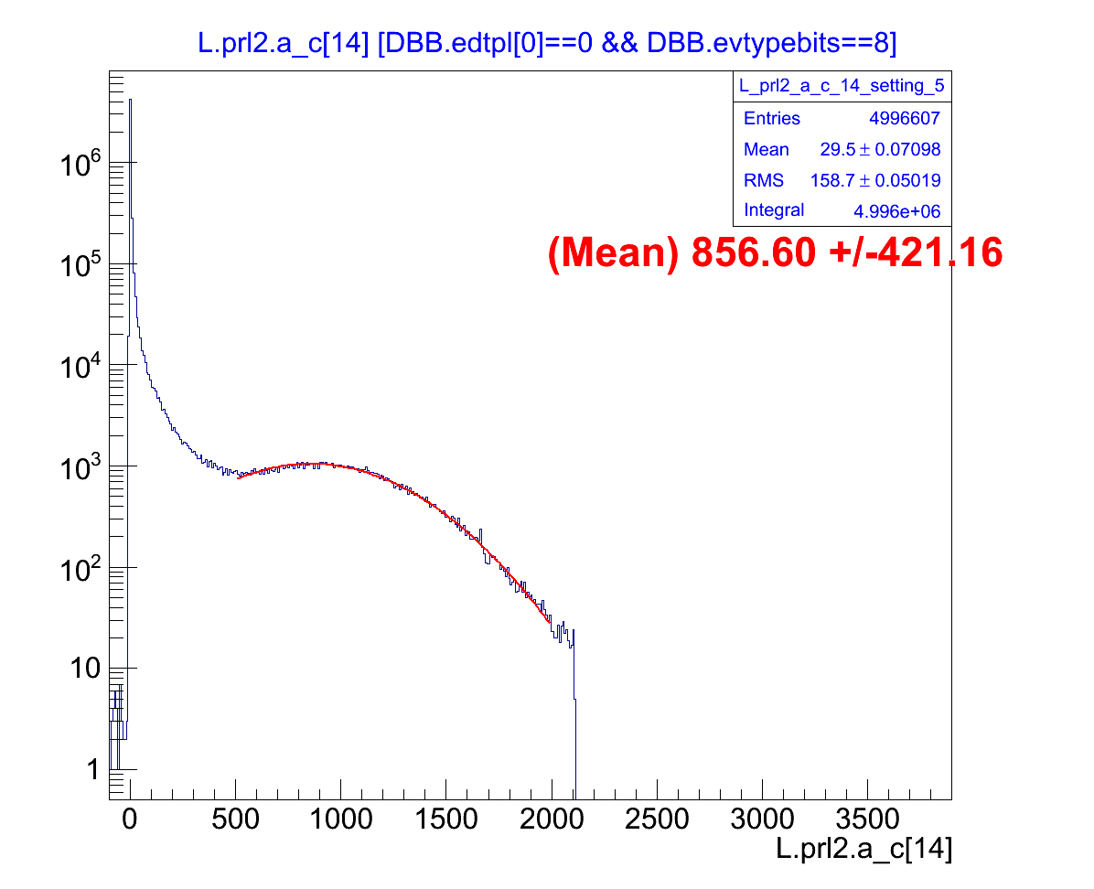

Figure 1.7-1.8
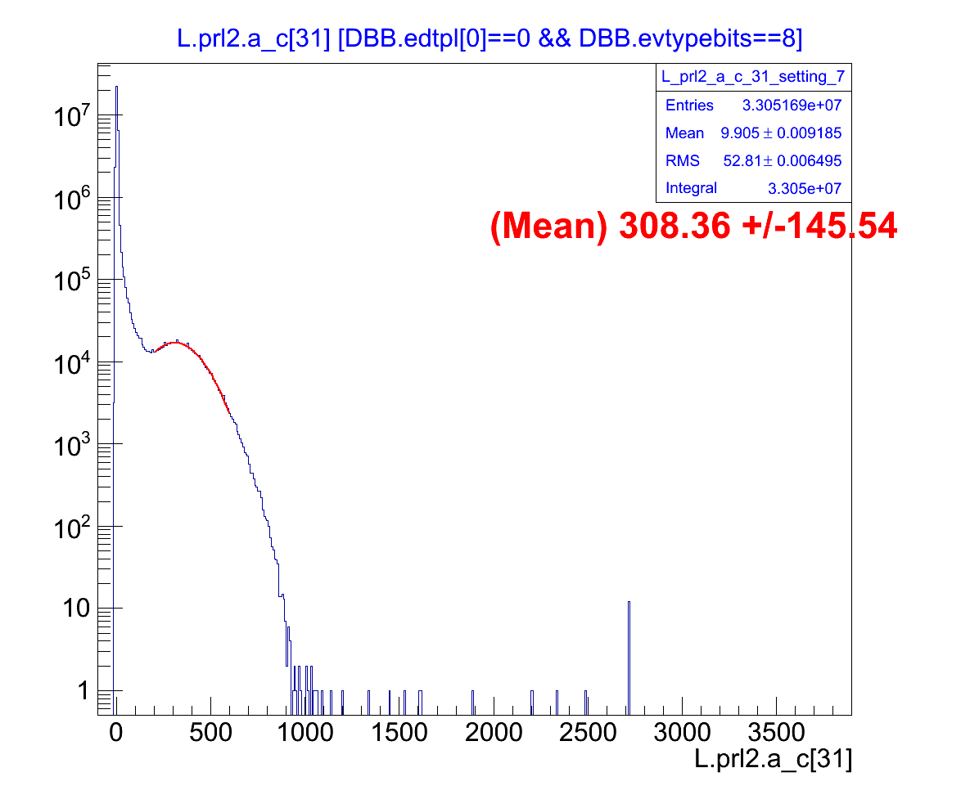
The ADC drop during a period of time.

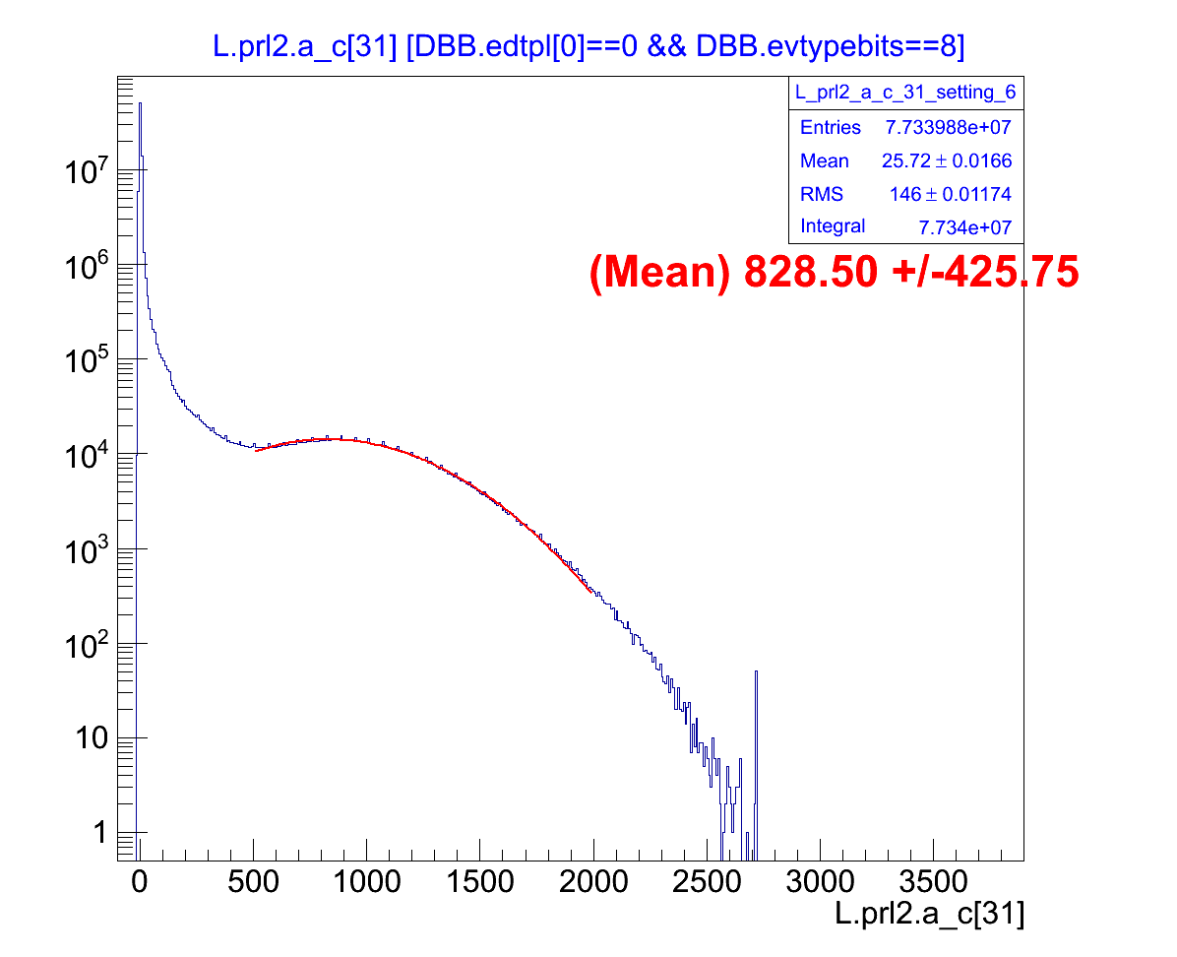
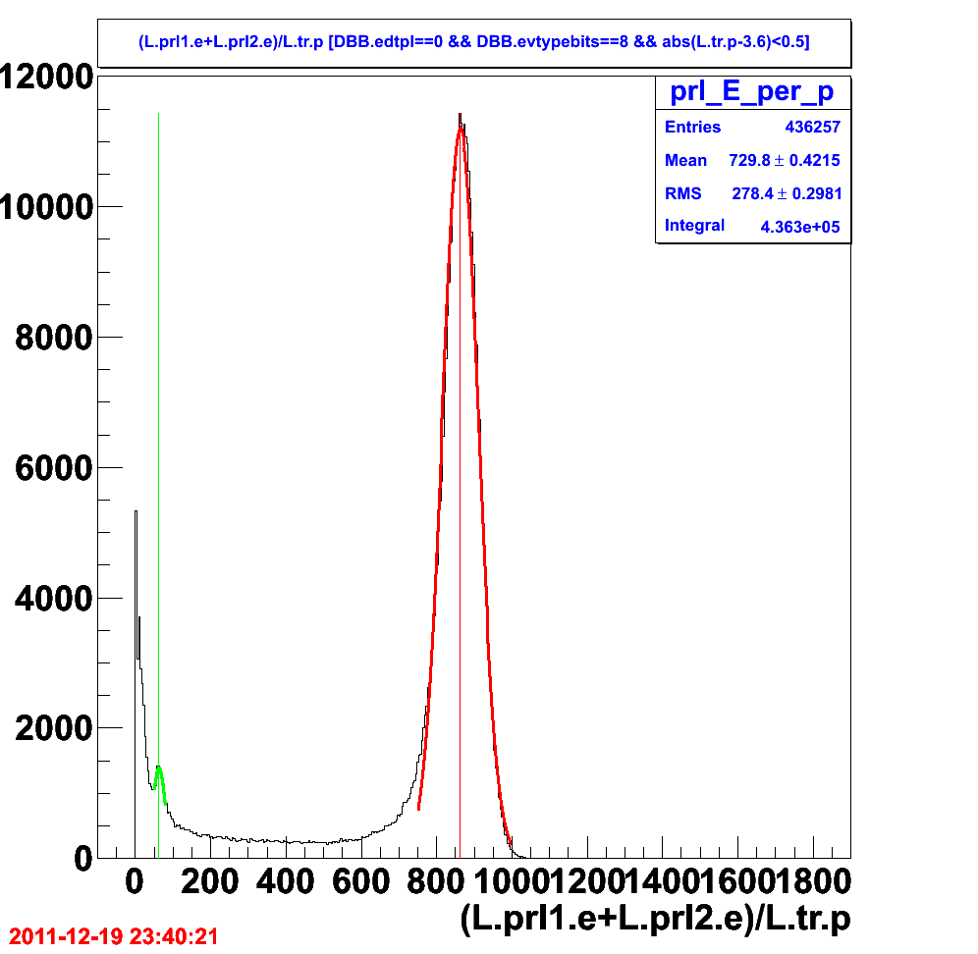
Figure 1.5: The E/p distribution, the ratio of sum of energy deposited in prl1 and prl2 to the track momentum p. The “red” line is at 863 (channel/GeV) where the mean of the “electron” E/p would be. The “green” is the pion E/p peak shown at 62.7 (channel/GeV).

The energy need to go through the conversion factor. With this, the conversion factor should be 863 GeV/channel. (haven't be check)

