BPM calibration summary
July 20,2011 (Tai: Navaphon Muangma)

code :overall_code.C
instruction: instruction.txt

1. pedestal current

using designed pedestal run 1184.

plot urb.[BPMA,BPMB].rawcur.[1,2,3,4]
fit with gausian and take the means

result:
/////////////////////////////////
change the pedestal for BPMA to :
615 543 393 406
change the pedestal for BPMB to :
524 490 493 545
//////////////////////////////////
figure:
BPM_pedestals_run_1184.png

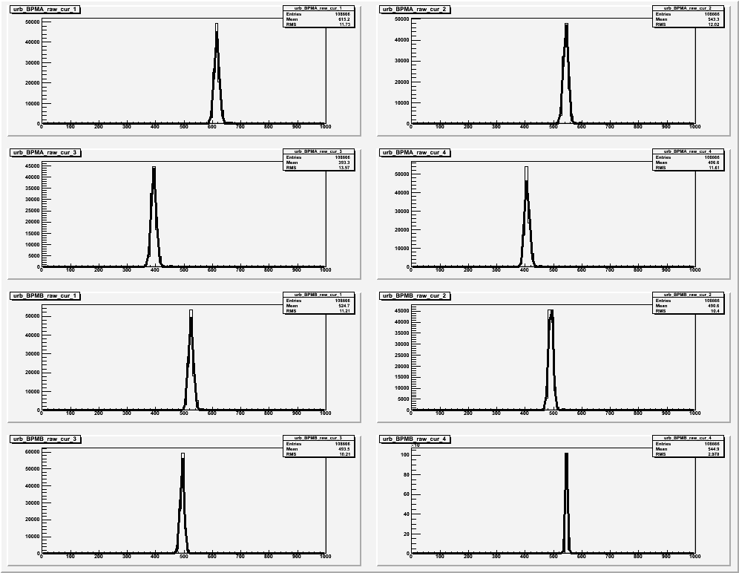
2. transformation constant

using bulleye scan run 4139-43 for calibrate BPMA and 4145-4149 for BPMB.

The following figures show the Bulleye scan points for
BPMA, BPMB rotpos1 vs rotpos2 in the top two figures,
and the epic variable for beam positions in the bottom two.

(all_runs.png)

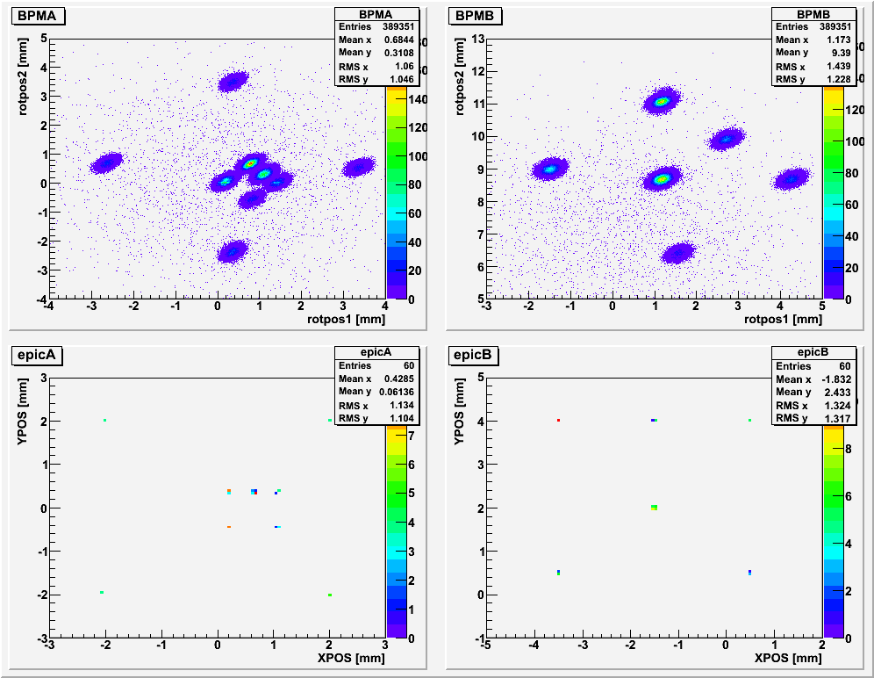

The runs are recorded such that we vary the BPMA first then BPMB.

The following is for the data run 4139-4143 which is design for BPMA.

(2d_rotepic_BPMA.png)

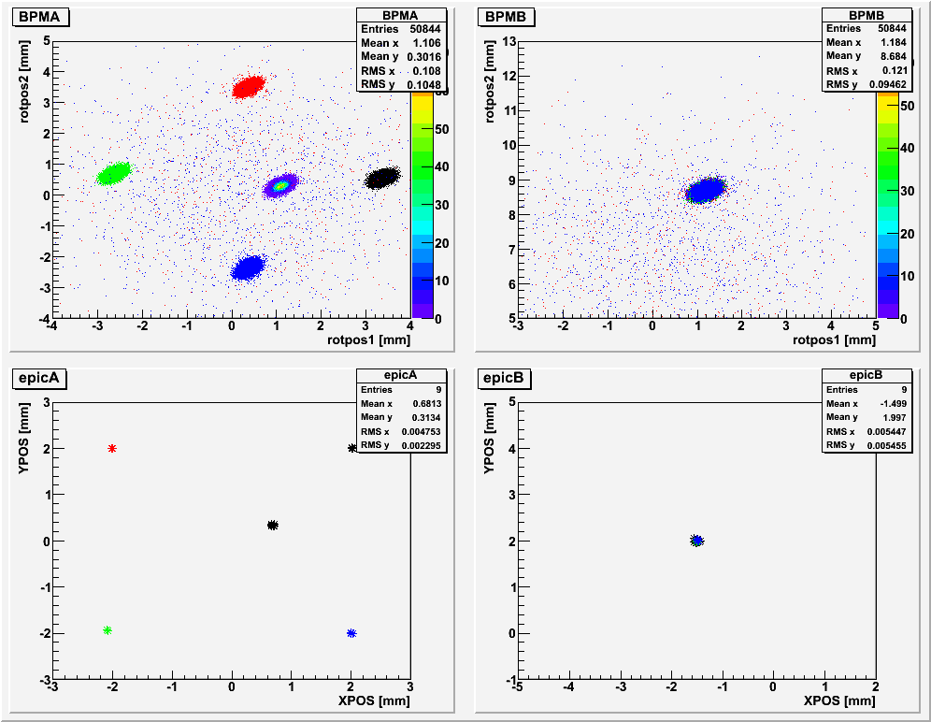

Same data for BPMA run in 1D draw.

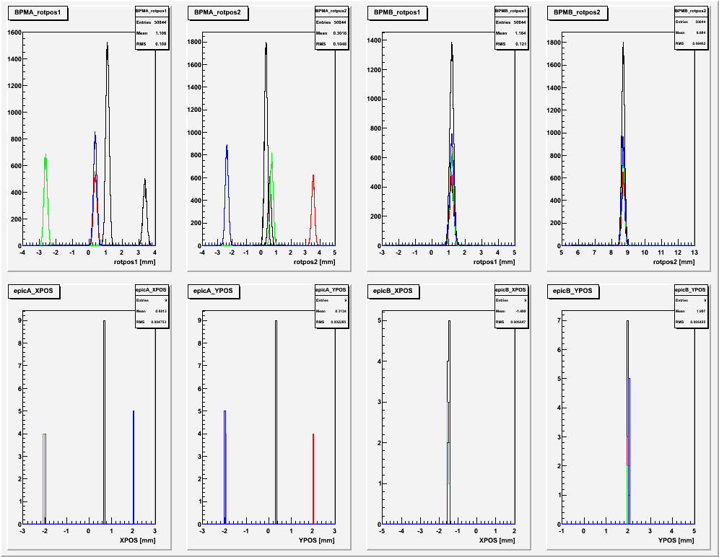
(1d_rotepic_BPMA.png )

same type of these two figure for BPMB

After the right runs are verified, each run then got calculated for the mean value of the following:

plot T-> urb.[BPMA,BPMB].rotpos[1,2]
to get the calculated rot position 1&2
E-> IPM1H04[A,B].[X,Y]POS
get the epic for beam position as the control calibration
(unit mm.)
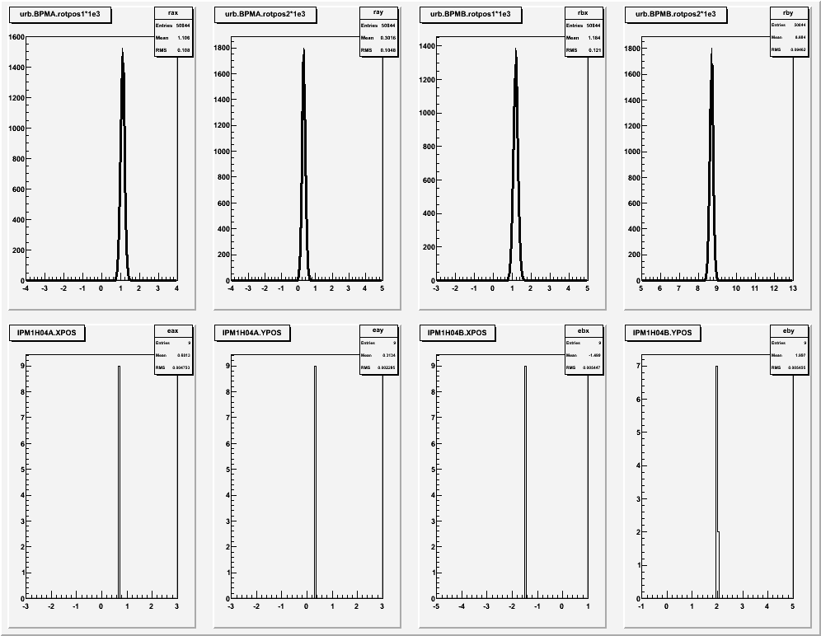
(rotepic_mean_4139.png)

the transformation is as follow:

[X,Y] = [ [M11, M12], [M21 , M22 ] ]*[rot1, rot2] + [offsetX, offsetY]

using the following equations:

x_i = M11 *rot1_i +M12 *rot2_i + offsetX

x_i*rot1_i = M11 *rot1_i*rot1_i +M12 *rot2_i*rot1_i + offsetX *rot1_i

x_i*rot2_i = M11 *rot1_i*rot2_i +M12 *rot2_i*rot2_i + offsetX *rot2_i

with SUM over all i

Then we get 3x3 matrix equation which we can solve for M11, M12, and offsetX

repeated with M21<->M11 and M22<->M12 and offsetX<->offsetY

The same method for BPMB.

result:
//////////////////////////////////////////////
Please change the BPMA the BPMB constants to:
0.668516 -0.684470 0.671702 0.683053 0.144645 -0.633772

0.655600 -0.798088 0.652480 0.802990 4.605999 -5.715145

//////////////////////////////////////////////

testing the result using the transformation equation:
[X,Y] = [ [M11, M12], [M21 , M22 ] ]*[rot1, rot2] + [offsetX, offsetY]

we have a good agreement for all constant as show:

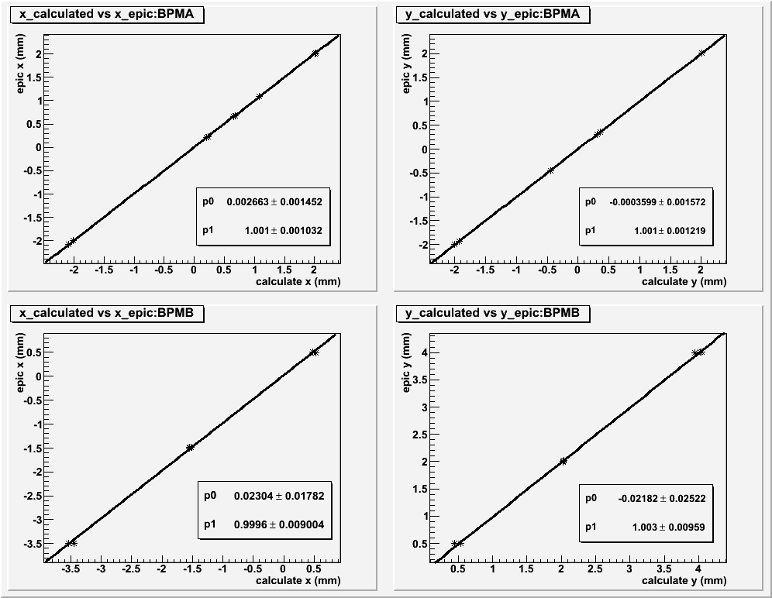

(constant_test.png)

