:::::::::::::::::::::::::::::::::::::::::::::::::::::::::::::::: List :::::::::::::::::::::::::::::::::::::::::::::::::::::::::::::::::::::::::::::
- VDC: u1,u2,v1,v2
- Gas Cerenkov,
- Scintillator: S1&S2
- Pion Rejector: pr1,pr2

:::::::::::::::::::::::::::::::::::::::::::::::::::::::::::::::::::::::::::::::::::::::::::::::::::::::::::::::::::::::::::::::::::::::::::::::::::::

Scintillator S2 timing & beta
:::::::::::::::::::::::::::::::::::::::::::::::::::::::::::::::::::::::::::::::::::::::::::::::::::::::::::::::::::::::::::::::::::::::::::::::::::::

description:
[run: using 3091-3098]
Calibration: (as descripted last week)

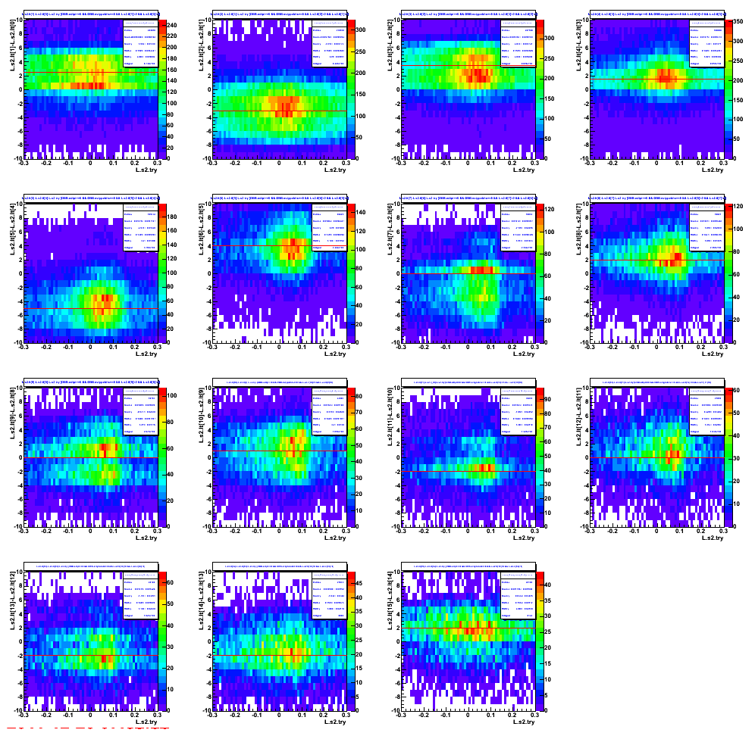
Figure 1.1: The raw tdc difference between adjacent bar for the “S2 left-side”.
[ figure[i] = rawtdc(bar[i+1]-bar[i]) ]

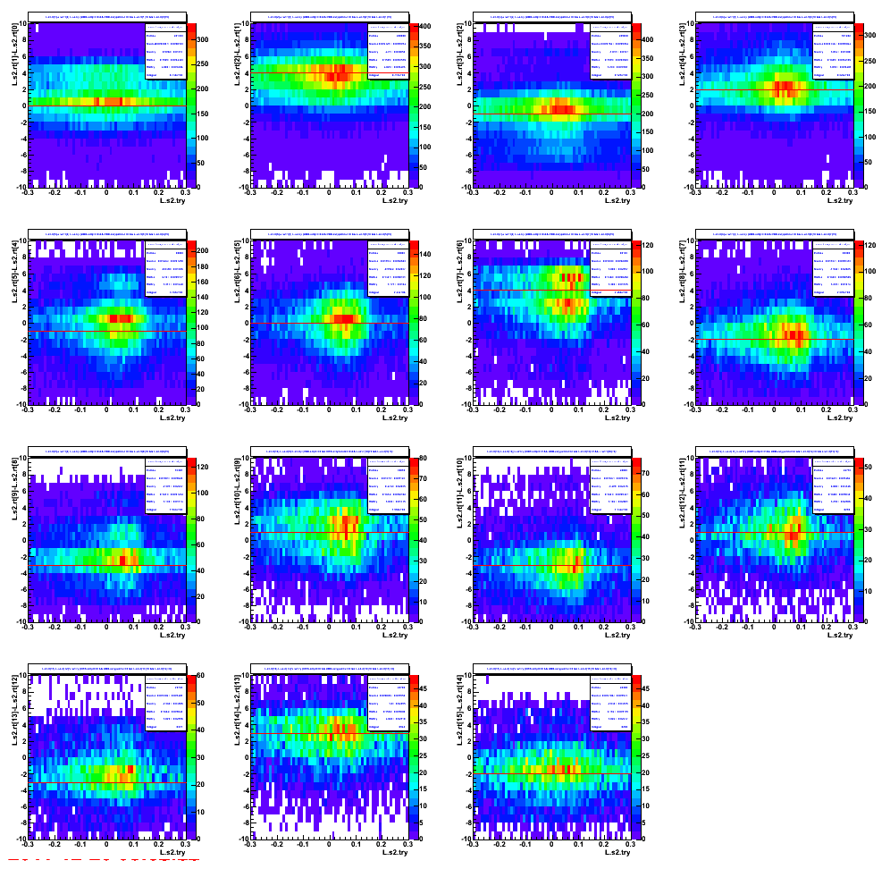
Figure 1.2: The raw tdc difference between adjacent bar for the “S2 right-side”.
[ figure[i] = rawtdc(bar[i+1]-bar[i]) ]

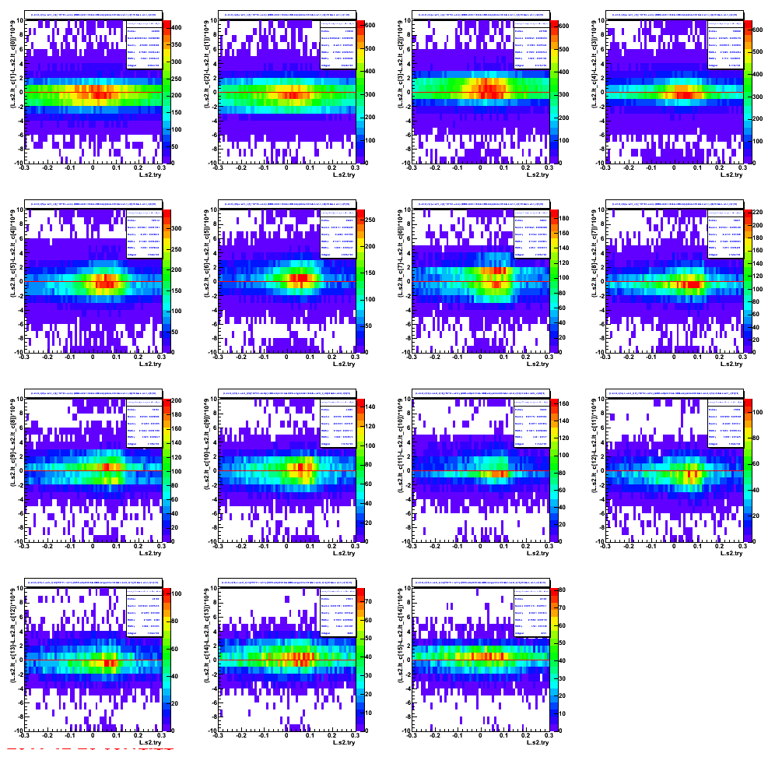

Figure 1.3: The corrected tdc difference between adjacent bar for the “S2 left-side”.
[ figure[i] = corrected tdc(bar[i+1]-bar[i]) ]

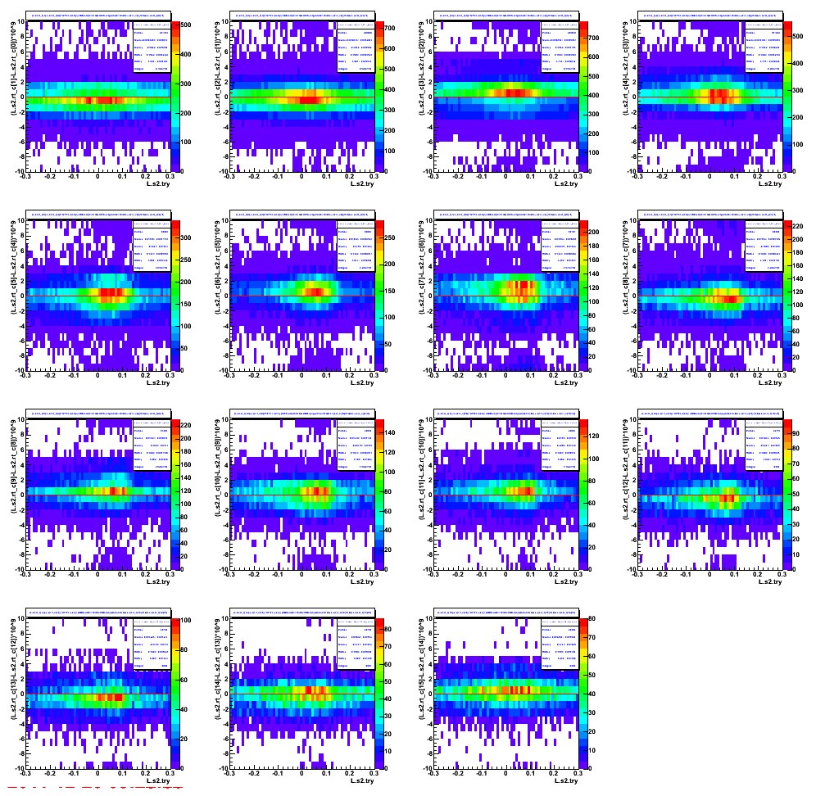
Figure 1.4: The corrected tdc difference between adjacent bar for the “S2 right-side”.
[ figure[i] = corrected_tdc(bar[i+1]-bar[i]) ]

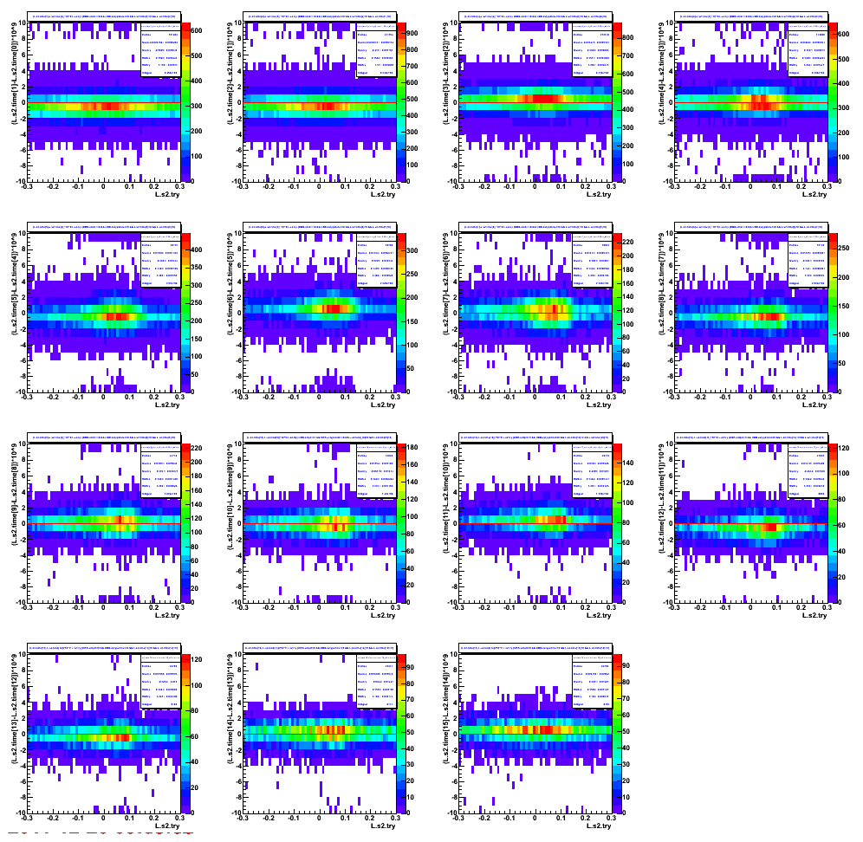

Figure 1.5: The “time” difference between adjacent bar for the “S2”.
[ figure[i] = time(bar[i+1]-bar[i]) ]

Figure 1.6: The final beta.
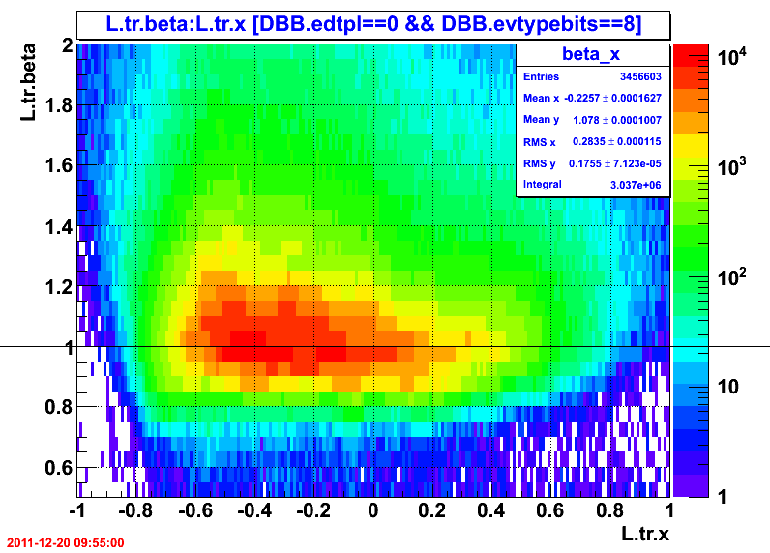

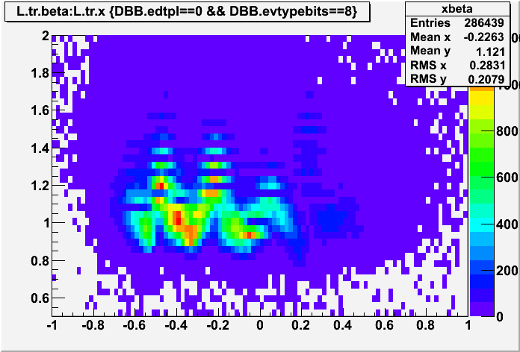
Figure 1.7: The before beta.

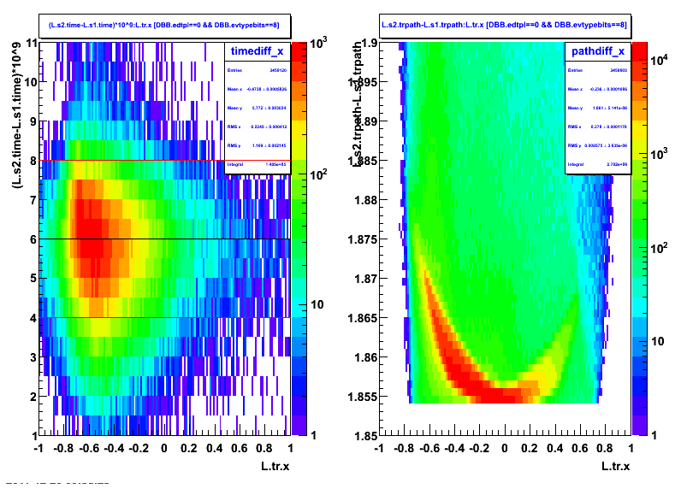
Figure 1.8: The corrected time and the pathlength between S1 and S2.

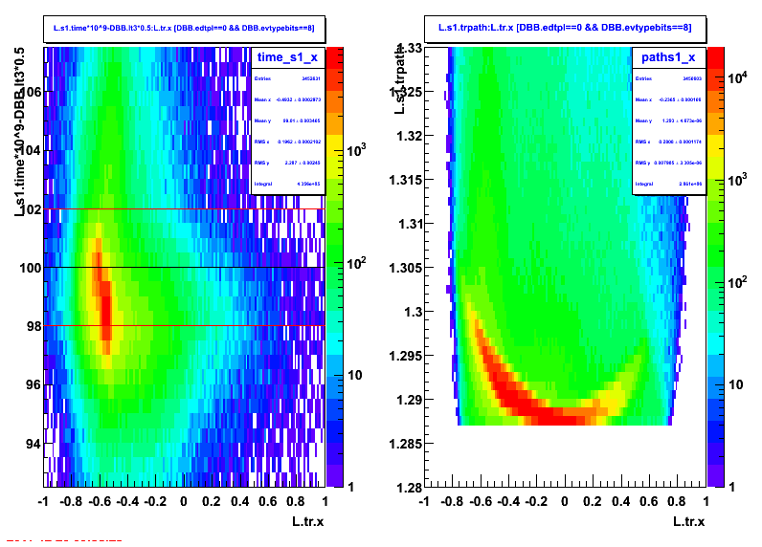
Figure 1.9: The corrected time and the pathlength of S1.
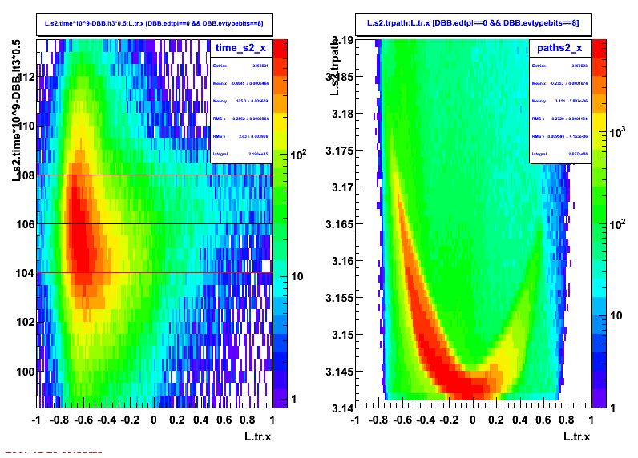
Figure 1.10: The corrected time and the pathlength off S2.

