Left HRS Optics calibration
10/11/2011

- Vertex Calibration:

Using Run 2013 with corrected offset of HRS Origin and the corrected HRS angle

Initial Data with z0 fit to be at ~27 mm

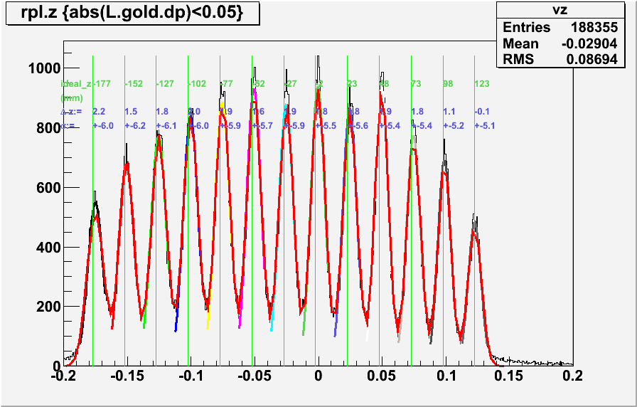

Result: with z0 = -15.32 mm from ideal target
also lower sigma

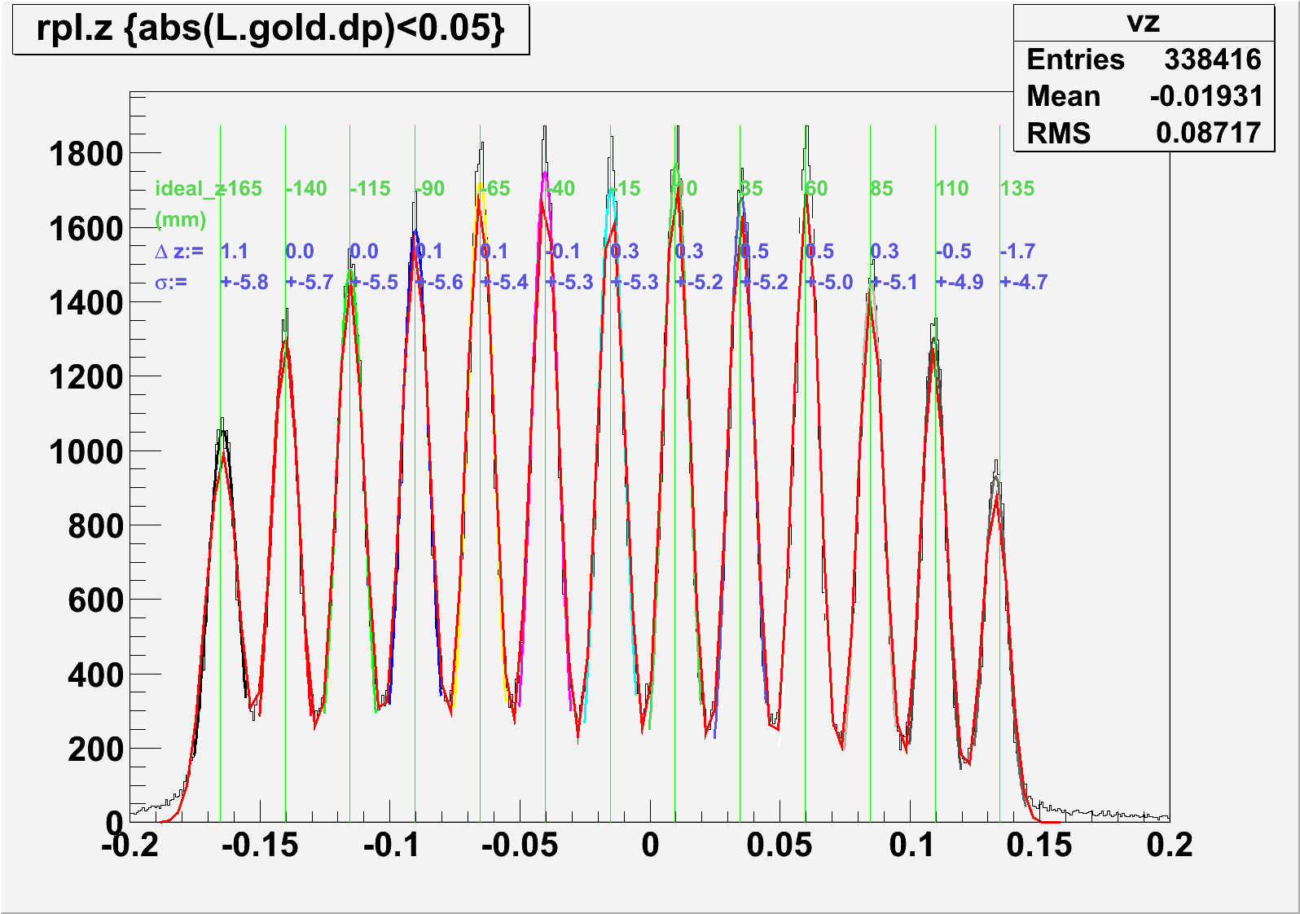
- Z vs Phi
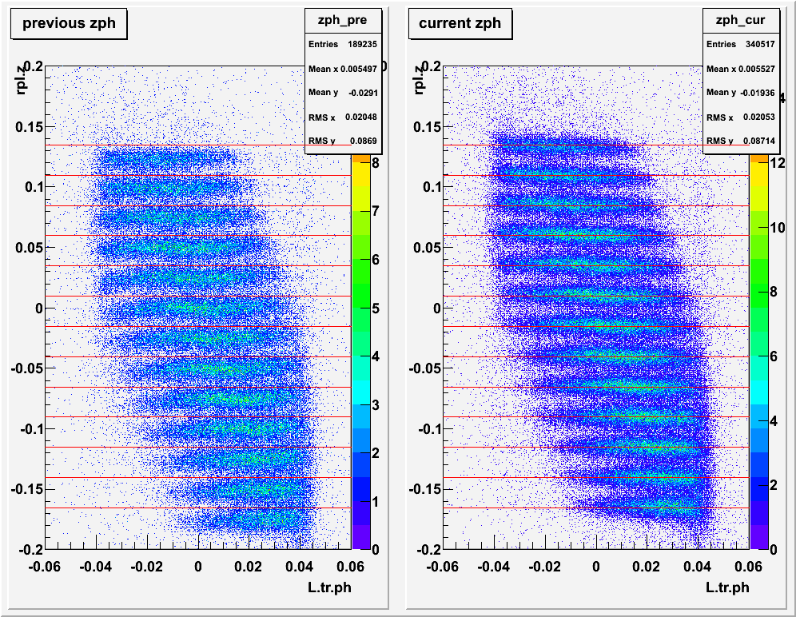

Z previously have some dependent on Phi which is corrected on the right figure.

- Correction on Phi & Theta according to the “Ideal” location of the Sieve at 1157e-3 m.

Before:
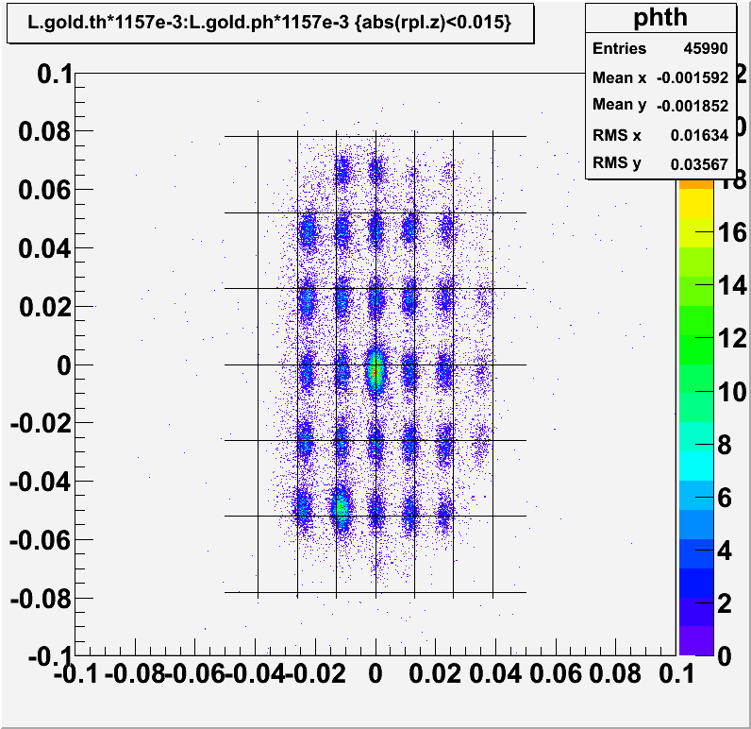
After:
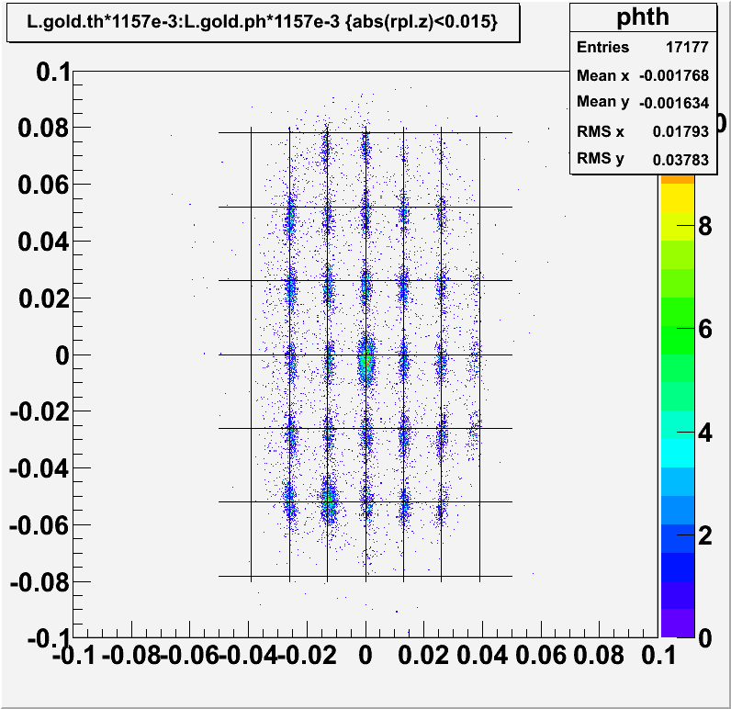

  - Correction for Phi location using Run 1893 BeO target Cut out each Sieve Hole
Before:
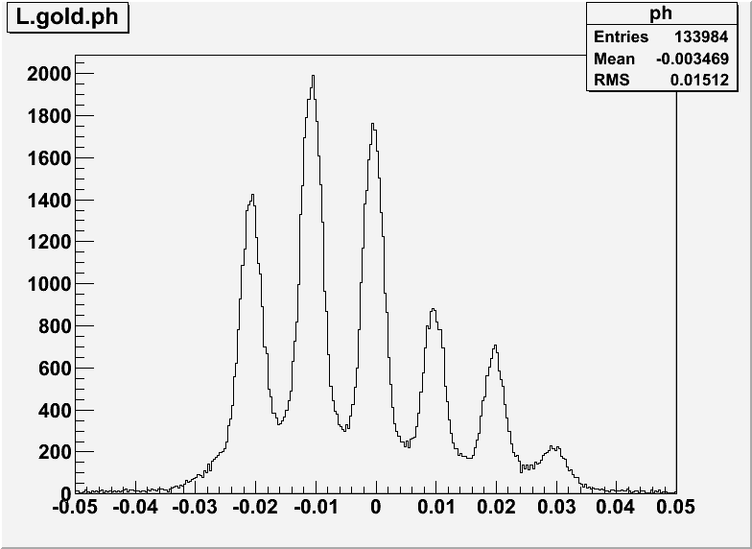
After:
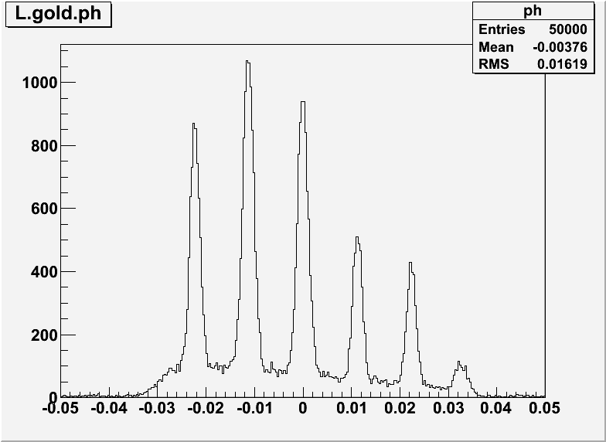

  - Th
Before
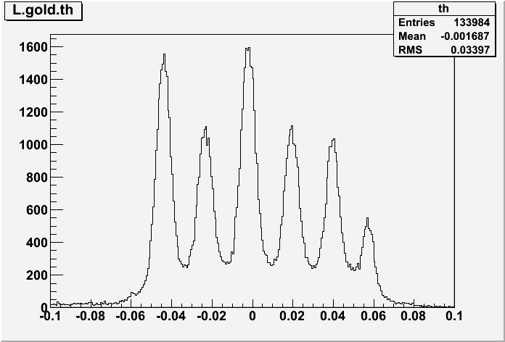

After:
