::::::::::::::::::::::::::::::::::::::::::::::::::::::::::::::::: List :::::::::::::::::::::::::::::::::::::::::::::::::::::::::::::::::::::::::::::
- VDC: u1,u2,v1,v2
- Gas Cerenkov,
- Scintillator: S1&S2
- Pion Rejector: pr1,pr2

:::::::::::::::::::::::::::::::::::::::::::::::::::::::::::::::::::::::::::::::::::::::::::::::::::::::::::::::::::::::::::::::::::::::::::::::::::::

VDC Calibration
:::::::::::::::::::::::::::::::::::::::::::::::::::::::::::::::::::::::::::::::::::::::::::::::::::::::::::::::::::::::::::::::::::::::::::::::::::::

The Vertical Drift Chambers (VDCs) composes of two planes, each plane has two chambers with wires at angle +/- 30 deg (u & v).

The raw data for the VDC is the tdc. This tdc is record the time the signal keeping register in the wire.
The following is the general tdc spectrum for the VDC.

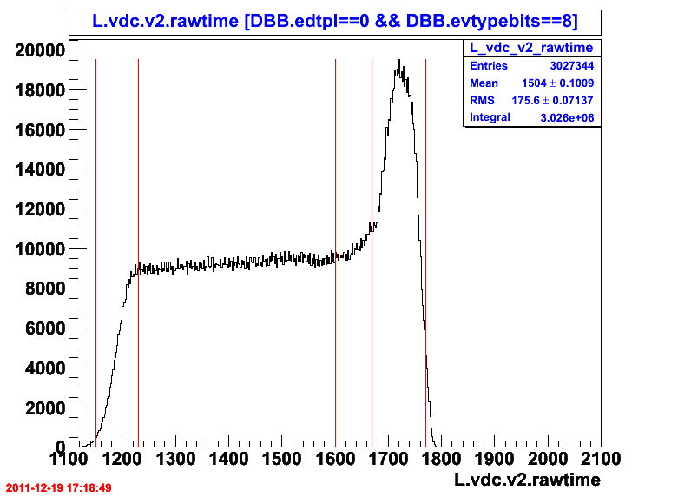
Figure 1.1: General Shape of the tdc spectrum, i.e. v2.
.....................................................................................................................................................................
[using code:/home/nmuangma/2011SRC/scripts/CHECKLIST/draw_collection.C: vdc_rawtime()]
.....................................................................................................................................................................

The TDC unit is operated under the common stop so the actual time is reverse from the channel value.

Section | Description
The first section (channel 1150 - 1230) | the particle hit as far away from the wire as possible.
The second section ( channel 1230-1600) | the drift velocity is approximately constant.
The third section (1600-1670) | the particle get close to the wire to start 'average' accelerated.
The fourth section (1670-1770) | The region very close to the wire, high multiplication of electrons, dramatically increase of velocity

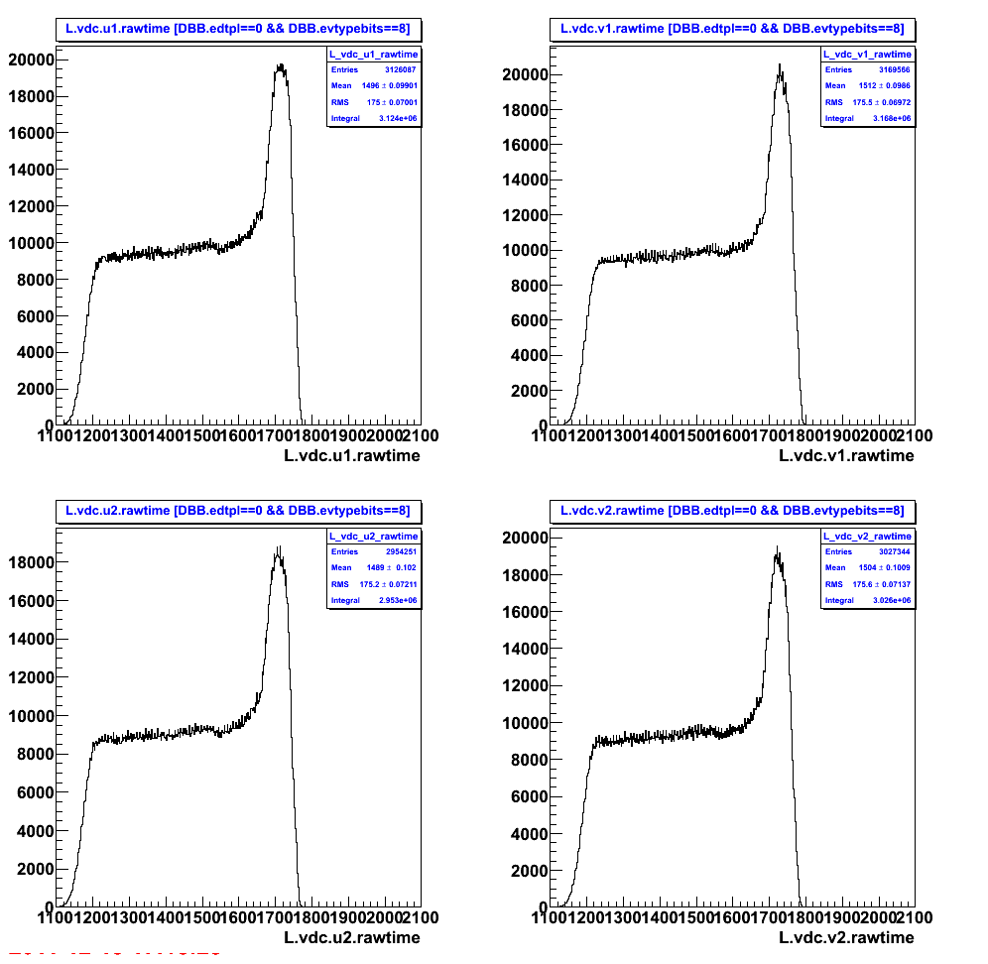
Figure 1.2: General Shape of the tdc spectrum for all u1,v1,u2,v2 of LEFT-HRS.

The calibration needed for VDC is to align the t0 which is the time the particle is presumed to pass the vdc with the shortest time to arrive the registered wire.

The time is calculated base on the offset value subtracted by the the rawtime (tdc).
Time = TDC_resolution(ns/channel)*(TDC_offset – rawtime).

We use the TDC 1877 unit which have 0.5 ns/channel resolution.

The t0 is the TDC_offset which is recorded in the data base db_L.vdc.dat/db_R.vdc.dat.
The t0 is determined as the maximum rising up (slope) of the drift time.

To the finest we calibrate t0 per each wire on each chamber.

The following is the result.

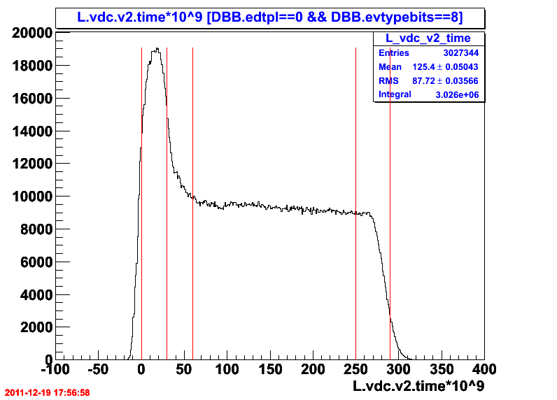
Figure 1.3: General Shape of the time spectrum, i.e. v2.

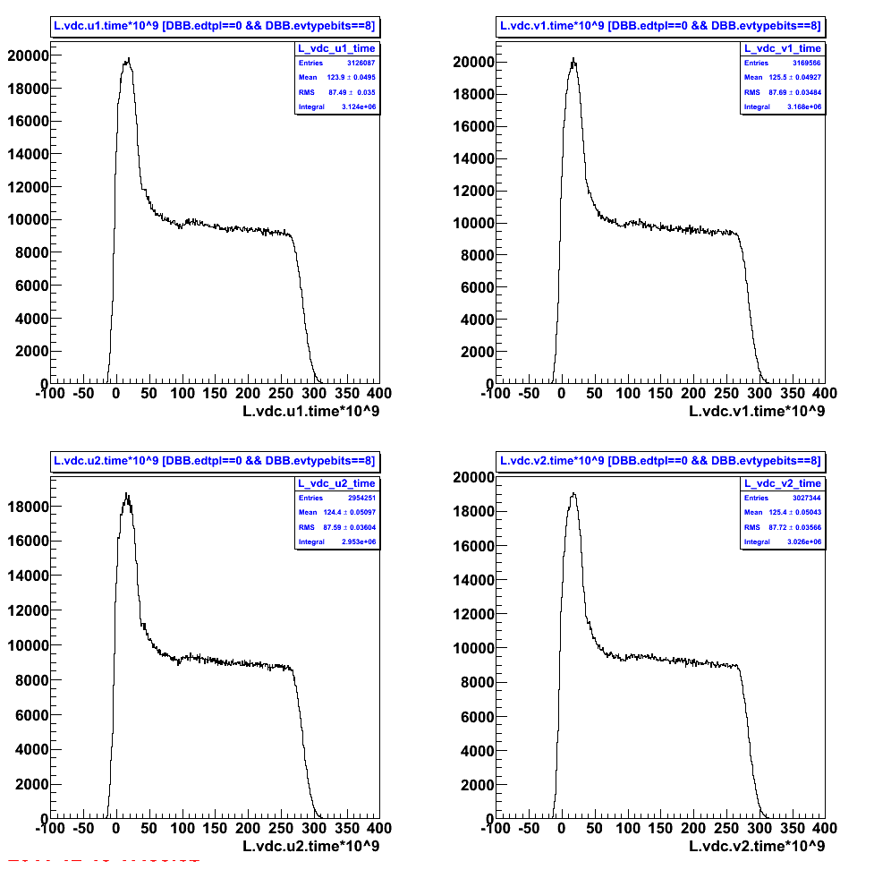
Figure 1.4: General Shape of the time spectrum for all u1,v1,u2,v2 of LEFT-HRS.

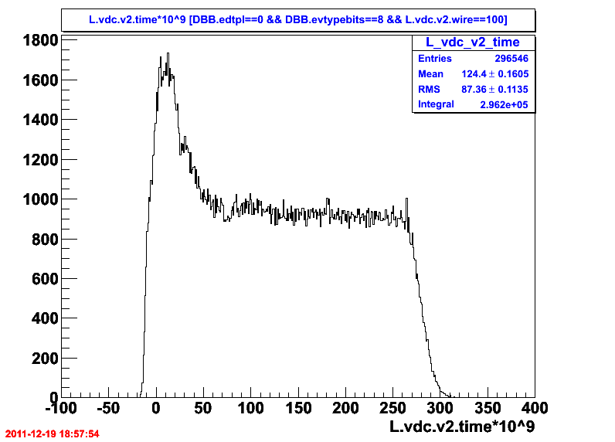

Figure 1.4: General Shape of the time spectrum for v2 wire==100 (100 runs in Kinematic 3).

