08/03/2011

VDC time spectrum study.

The VDC time spectrum for Hall A HRS are as follow:

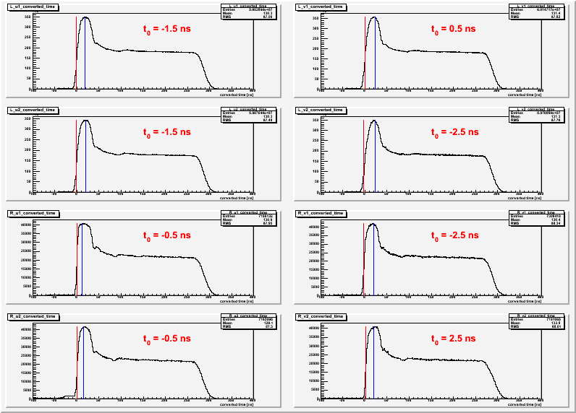
The top four graphs are for vdc timing of Left Arm u1,v1,u2, v2 respectively. The bottom four are those for Right Arm.
This is after shifting the t0 calibration for each plane, i.e. change the offset of the TDC by a specific constant (given as t0 in red).

The arrived time spectrum can be divide into three sections:
- the peak at the short time,
- the flat region in the middle, and
- the fall off at the large time.

Each region can be explained by the drift properties of the created electron/ions in the chambers.

The VDC plane are composed of wires with equally spacing.

- Electrons/Ions that created very closed to the wires feel much stronger electric field which lead to the pile up effect: the peak at the short time.
- Electrons/Ions that created away from the wires experiences almost constant field which lead to the Plato region: the arrive time proportional to the drift distance.
- When the drift distance reach the maximum, we see the fall off region.

[Refer to :Risa Wechsler's thesis chapter 3.5.: Drift-time Properties of CEBAF HALL A Vertical Drift Chamber. June 1996.]

Mathematic approach:

Count rate = (# count)/(drift time interval)

dN/dt = dN/ds * ds/dt

where ds = drift distance

ds/dt = v_D for the drift distance away from the wires. ds/dt increase as electrons get closer to “see” a single wire potential not the collective effect from all the wire.

------------------------------------------------
In the constant electric field, electrons/ions are moving on average of the constant drift velocity, v_{D} , in the electric field direction.

v_D = mu*E = (e/m)E *tau

mu = scalar mobility
tau = mean time between collision.

---------------------------------------------------

