08/03/2011 version 2

VDC time spectrum study.

Shalev Questions:

- Why is the drift velocity constant in the flat region?
- Why does it seem that there are more events closer to the wire?

My answers for #1: part 1: why the drift velocity is constant?

The actual picture that we have to keep in mind is the electric field line of the VDC.
The electric field is perpendicular to the wire plane.
The electric field is “constant” through out the drift region except near the wire where the field is proportional to 1/r where r is the distance from the nearby wire.

Now consider only the “constant” electric field region. The electron is accelerated through the distance \lambda, the mean-free-path, before it collides and ionizes the gas molecule and scatters “isotropically”. The electron is again accelerated until it scatters with another gas molecule.

The “actual” velocity is not constant. The drift velocity are the average over the mean-free-path.

v_D = \mu E = (e/m) E*\tau;

where \tau = the mean time between the collision.

So in the constant electric field region, the drift velocity are constant.

#1 :part 2: how do we depict the flat region of the arrive time as the drift velocity constant?

Suppose the VDC are filled with electrons isotropically. Consider the region away from the wire where E = const, hence v_D =const.

The count rate are given by,
dN/dt = dN/ds *ds/dt

where s is the perpendicular distance from the VDC plane
as electron is isotropically, dN/ds = const
as E = const, ds/dt = v_D = const.

Hence, dN/dt = const where v_D = const as E = const.

My answers for #2 : Why does it seem that there are more events closer to the wire?

The electrons close to the wire are moving much faster as the electric field ( hence the drift velocity) is proportional to 1/r.

From the same equation: dN/dt = dN/dr *dr/dt

dr/dt increase as the radius distance get smaller (v_D = dr/dt ~ 1/r). the dN/dr is the flux which is const in the case of uniformly distribute of initial electrons.

Hence dN/dt is larger when v_D is increasing as the electron gets closer to the wire.

It is not that we have more events closer to the wire, but because the electrons take less time to move through the same distance closer to the wire compare to that away from the wire. Hence the same number of electrons in delta_x at x >> r and delta_x at x<<r are piled up in smaller delta_t for(x<<r) and larger delta_t for (x>>r).

In addition,the initial electron knocks out the secondary electrons from gas molecules through the acceleration. Thus, the avalanche effect.
The VDC time spectrum for Hall A HRS are as follow:

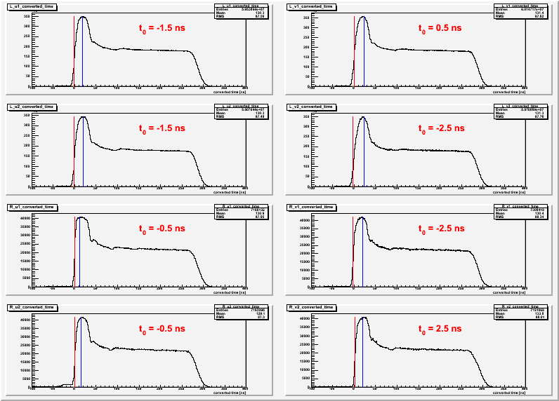
The top four graphs are for vdc timing of Left Arm u1,v1,u2, v2 respectively. The bottom four are those for Right Arm.
This is after shifting the t0 calibration for each plane, i.e. change the offset of the TDC by a specific constant (given as t0 in red).

The arrived time spectrum can be divide into three sections:
- the peak at the short time,
- the flat region in the middle, and
- the fall off at the large time.

Each region can be explained by the drift properties of the created electron/ions in the chambers.

The VDC plane are composed of wires with equally spacing.

- Electrons/Ions that created very closed to the wires feel much stronger electric field which lead to the pile up effect: the peak at the short time.
- Electrons/Ions that created away from the wires experiences almost constant field which lead to the Plato region: the arrive time proportional to the drift distance.
- When the drift distance reach the maximum, we see the fall off region.

[Refer to :Risa Wechsler's thesis chapter 3.5.: Drift-time Properties of CEBAF HALL A Vertical Drift Chamber. June 1996.]

Mathematic approach:

Count rate = (# count)/(drift time interval)

dN/dt = dN/ds * ds/dt

where ds = drift distance

ds/dt = v_D for the drift distance away from the wires. ds/dt increase as electrons get closer to “see” a single wire potential not the collective effect from all the wire.

------------------------------------------------
In the constant electric field, electrons/ions are moving on average of the constant drift velocity, v_{D} , in the electric field direction.

v_D = mu*E = (e/m)E *tau

mu = scalar mobility
tau = mean time between collision.

---------------------------------------------------

