VDC study

main goal: time to distance conversion: TTD conversion

Recapture others thing first:

- The initial information we have on the VDC is the TDC value. We use TDC1877 unit.
[L,R].vdc.[u1,v1,u2,v2].rawtime

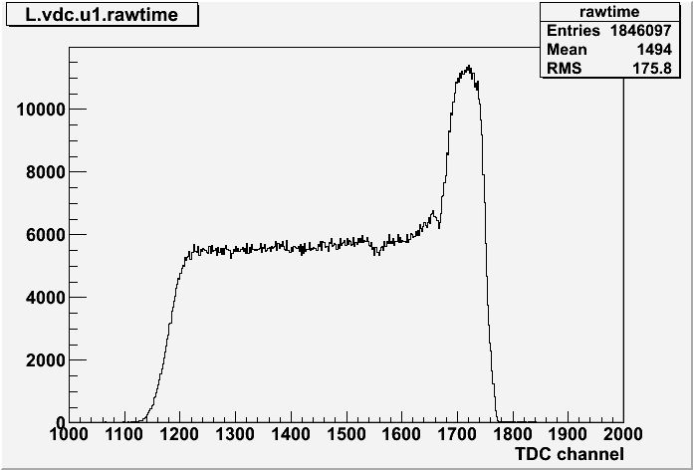
Figure 1: The vdc raw time which is the value we have from the TDC from run 1229 February 13,2011.

- Then we convert TDC value into arrive time (of the drift electron?)
[L,R].vdc.[u1,v1,u2,v2].time = TDCRes * (Offset – tdc) - evtT0
  - here we need to set the offset of TDC readout where the offset is the channel the peak start to rise up. From above example the offset is about channel 1780. this is needed in the db_[L,R].vdc.dat for each plane (u1,v1,u2,v2) and specifically for each wire (#1 to 368).
  - The TDC resolution is 0.5 ns/channel of TDC unit id1877. [ This is hard code in ThaVDCPlane.C as fTDCRes. So if TDC unit for L/R HRS changes to others, change this accordingly!! ]
  - the evtT0 is the time offset from the trigger.
  - The study of the VDC spectrum is given in respond.doc and respond_v2.doc

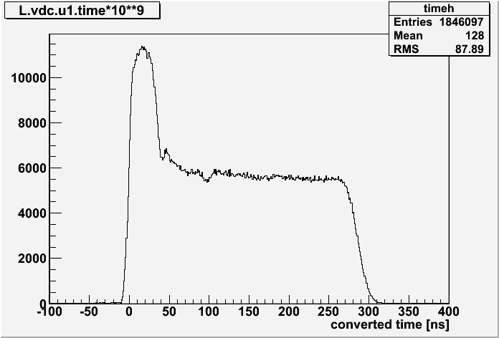
Figure 2: The Arrive time spectrum for the VDC after the conversion.

TTD conversion

The TTD conversion for the VDC.
- The THaVDCAnalyticTTDConv(drift_velocity) is what initially used by the analyzer. The only input needed are the drift-velocity: v_D [m/s]. v_D are set in the db for VDC where the current setting are 49.28 x 10^3 m/s. (at this point, I still don't know how they get this number.)
- another possible is ThaVDCLookupTTDConv which require the constant conversion tables. The modification are needed in: database table, ThaVDCPlane.C, and check the actual ThaVDCLookupTTDConv itself too.

In our case, I will only study the first option.

ThaVDCAnalyticTTDConv

Drift velocity are set in ThaVDCPlane.C. There are two set of four constants “hard code” in the construction along with the dtime = 4 ns (uncertainty in time) . The TimeToDistConv require (time, tantheta ==slope, *ddist)

The algorithm are as follow:

dist = v_D * time;
ddist = v_D * dtime;

if (0<dist<a1)
dist *=(1+a2/a1);
else
dist +=a2;

where a = x^3*off[3] + x^2* off[2] + x^1 *off[1] + off[0];

off[0-3] are constant hard code in.

