Version 1: VDC_t0 by plane

Using run 1229 as the start. The Right arm VDC timing is clearly not set.

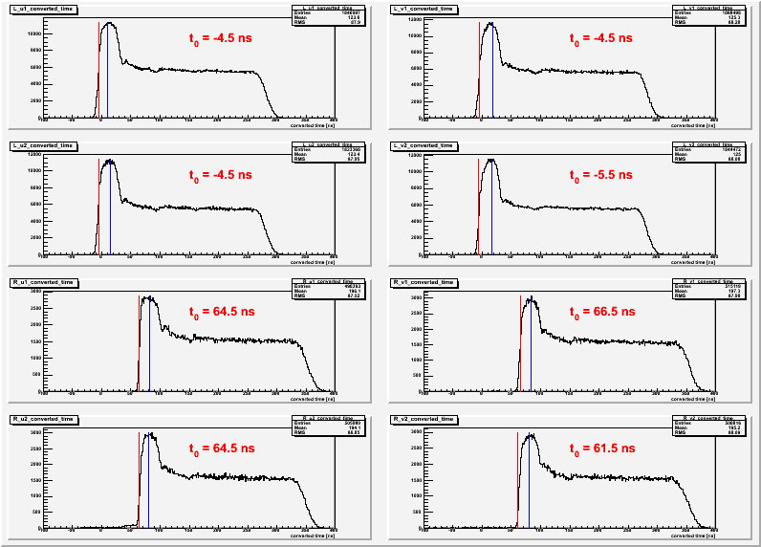

Conventionally, the “zero” is set at the maximum change in the slope of the rising up peak.
[using vdc_check.C] The values that need to be changed are shown per planes from L.u1,v1,u2,v2 the same for R arm.

Make change to the database and rerun the rootfile.
The following is the result:

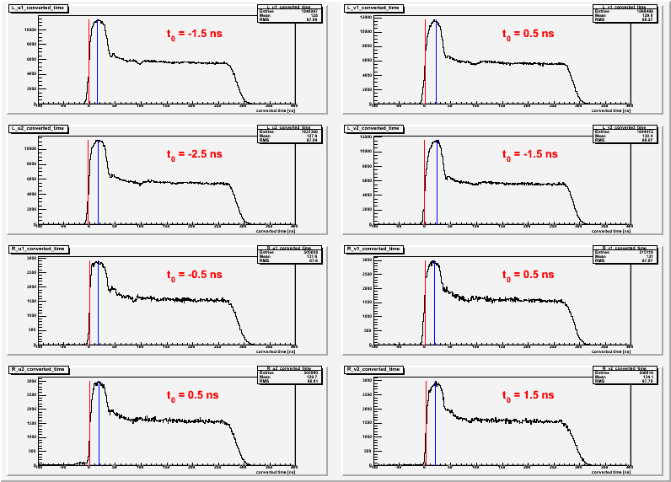
The fluctuation is now in the +/-3 ns.

To get more correct point, I added more rootfile from run 1220-1259 which are in the same setting of the VDC.

The result are given as the follow:

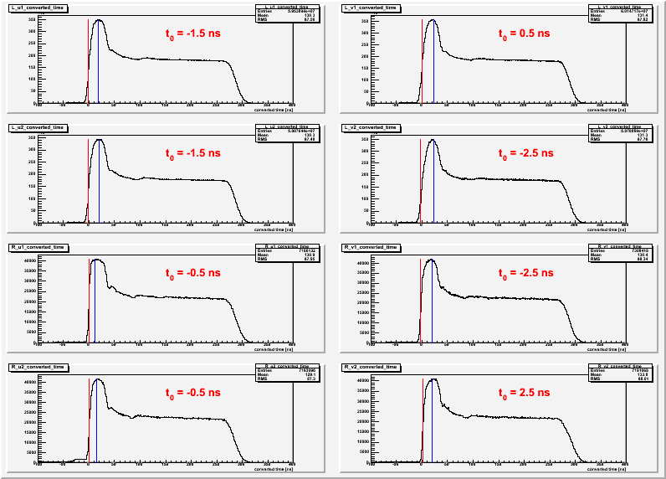

With the same run, I try to get the offset for each wire. Note that as the statistic go, the wires at each ends of the plane has a lot less.

The following is the sample of the t0 setting for L.u1 at the wire 56 to 64.

