::::::::::::::::::::::::::::::::::::::::::::::::::::::::::::::::: List :::::::::::::::::::::::::::::::::::::::::::::::::::::::::::::::::::::::::::::
- VDC: u1,u2,v1,v2
- Gas Cerenkov,
- Scintillator: S1&S2
- Pion Rejector: pr1,pr2

:::::::::::::::::::::::::::::::::::::::::::::::::::::::::::::::::::::::::::::::::::::::::::::::::::::::::::::::::::::::::::::::::::::::::::::::::::::

Gas Cerenkov
:::::::::::::::::::::::::::::::::::::::::::::::::::::::::::::::::::::::::::::::::::::::::::::::::::::::::::::::::::::::::::::::::::::::::::::::::::::

description: The gas Cerenkov detector is used to separate the electron from other particle, i.e. pion-.

Calibration:
- raw ADC -> ADC pedestal correction : Change Offset in db_L.cer.dat
- ADC single PE alignment: ADC_p-> ADC_c: Change Coeff in db_L.cer.dat

The raw ADC offset is calculate using run 3091 (and will later be done for 1run/day)
424 368 374 392 518 458 475 432 411 396

Try to align the single PE at channel = 100. The coefficient is calculated with the following relation.
The SPE ideal channel = Coeff * (mean PE)

....................................................................................................................................................................
[using code:/home/nmuangma/2011SRC/scripts/cerenkov_calibration/GC_adc_adjust.C ]
GC_adc_adjust_firstround(); to get ADC pedestal
corrected for offset then,
GC_adc_adjust_firstround(); to get the Coefficient
corrected in DB then,
GC_adc_adjust(); to see the adc_corrected value draw and asum_c
.....................................................................................................................................................................

The final result is as follow:
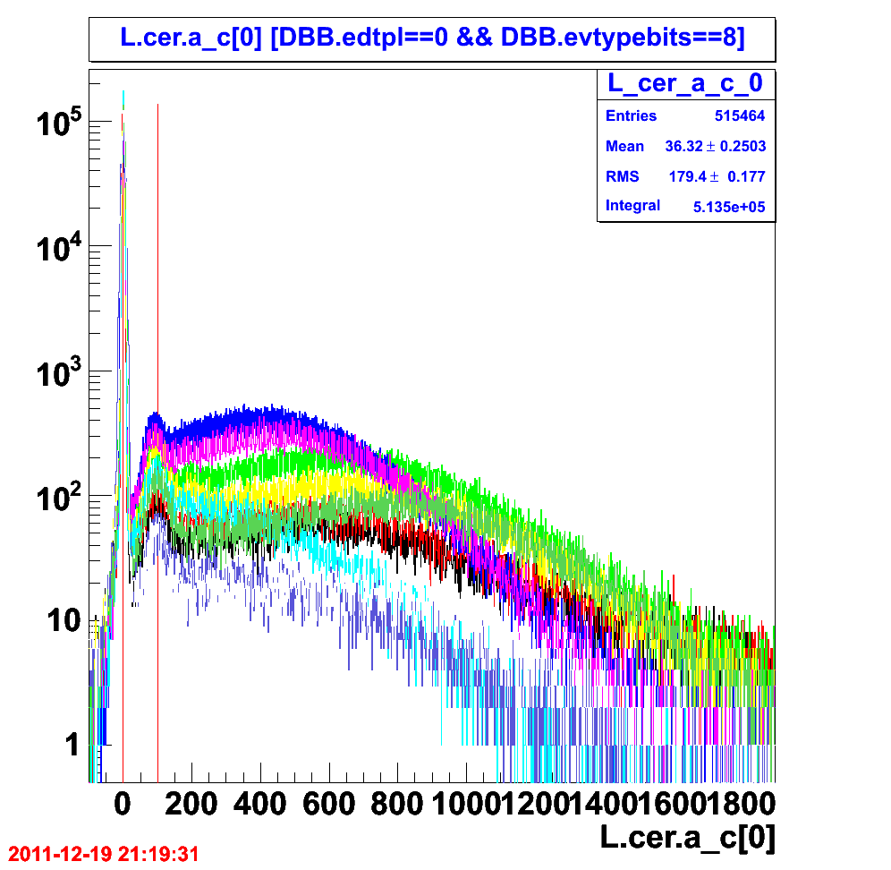
Figure 1.1: The corrected adc after correction for the pedestal then the gain factor. The pedestal alight at channel “zero” identified by the first red line at zero. The gain factor move the single photo electron peak to channel “100” identified by the second red line.

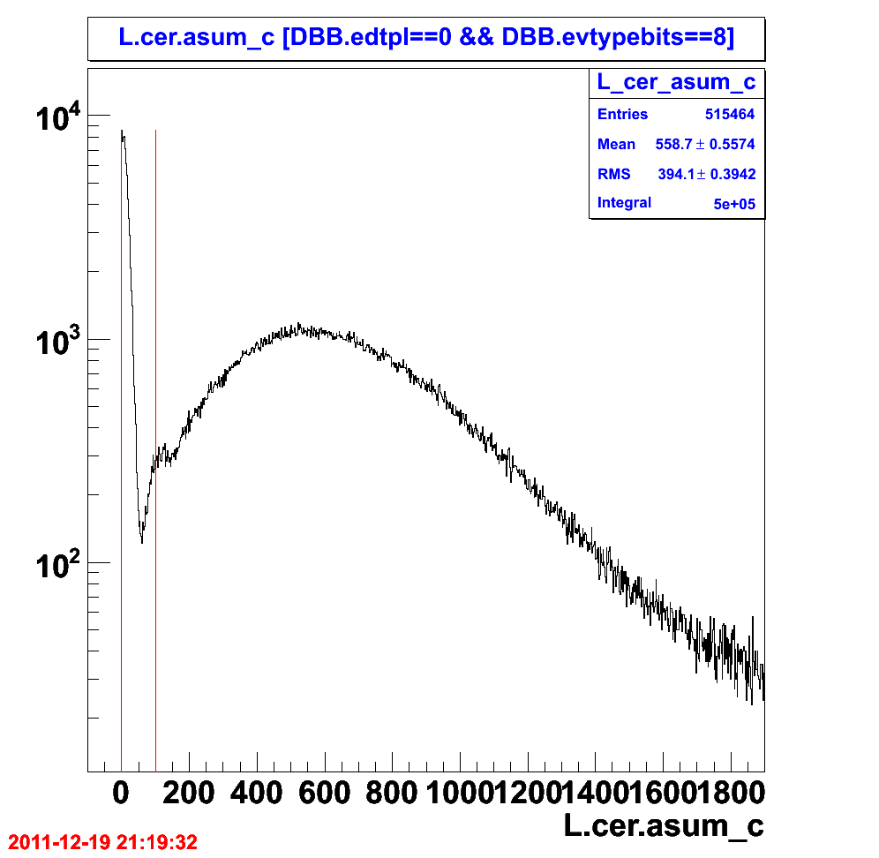
Figure 1.2: The corrected sum of the adc after correction for the pedestal then the gain factor.

