::::::::::::::::::::::::::::::::::::::::::::::::::::::::::::::::: List :::::::::::::::::::::::::::::::::::::::::::::::::::::::::::::::::::::::::::::
- VDC: u1,u2,v1,v2
- Gas Cerenkov,
- Scintillator: S1&S2
- Pion Rejector: pr1,pr2

:::::::::::::::::::::::::::::::::::::::::::::::::::::::::::::::::::::::::::::::::::::::::::::::::::::::::::::::::::::::::::::::::::::::::::::::::::::

Pion Rejector
:::::::::::::::::::::::::::::::::::::::::::::::::::::::::::::::::::::::::::::::::::::::::::::::::::::::::::::::::::::::::::::::::::::::::::::::::::::

description:

Calibration: Same calibration as the Gas Cerenkov calibration. The following are the result.

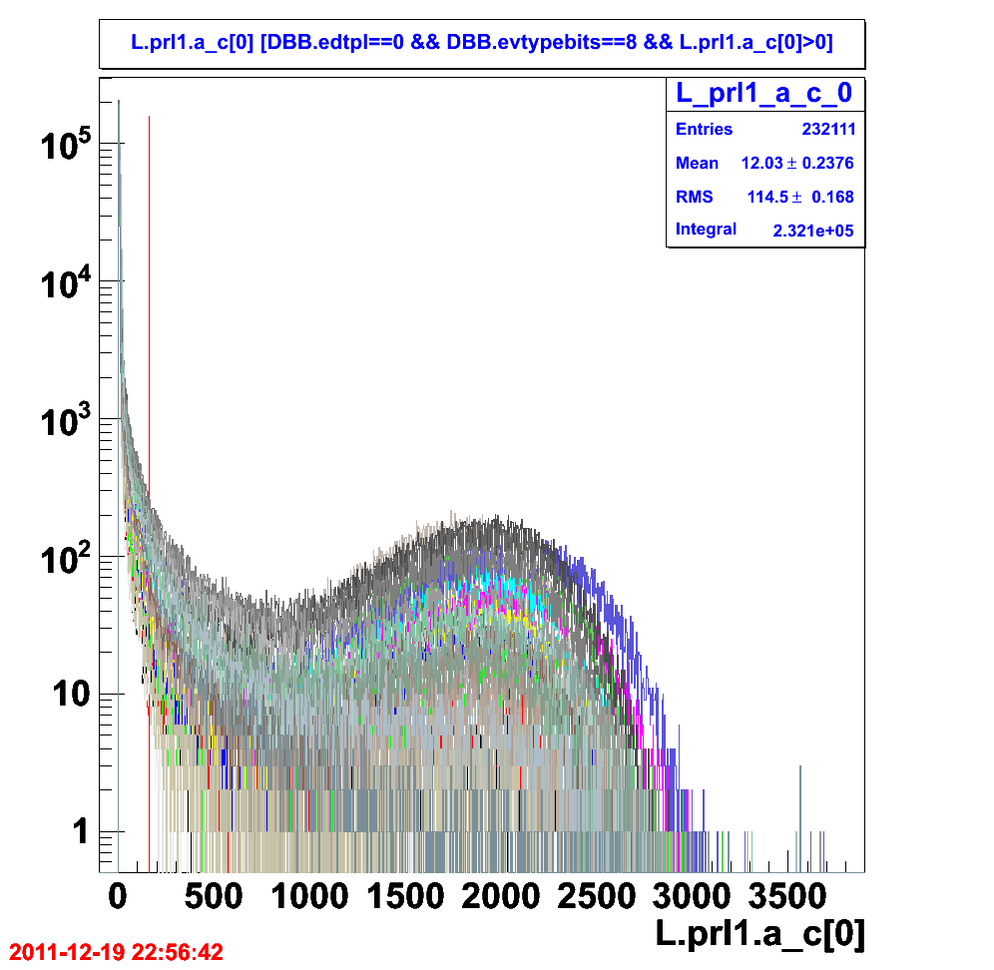
Figure 1.1: The corrected adc for prl1 after correction for the pedestal then the gain factor. The pedestal alight at channel “zero” identified by the first red line at zero (not clearly shown).

The gain factor “should” move the single photo electron peak to channel “160” identified by the second red line. With a single run, this is hard to see.
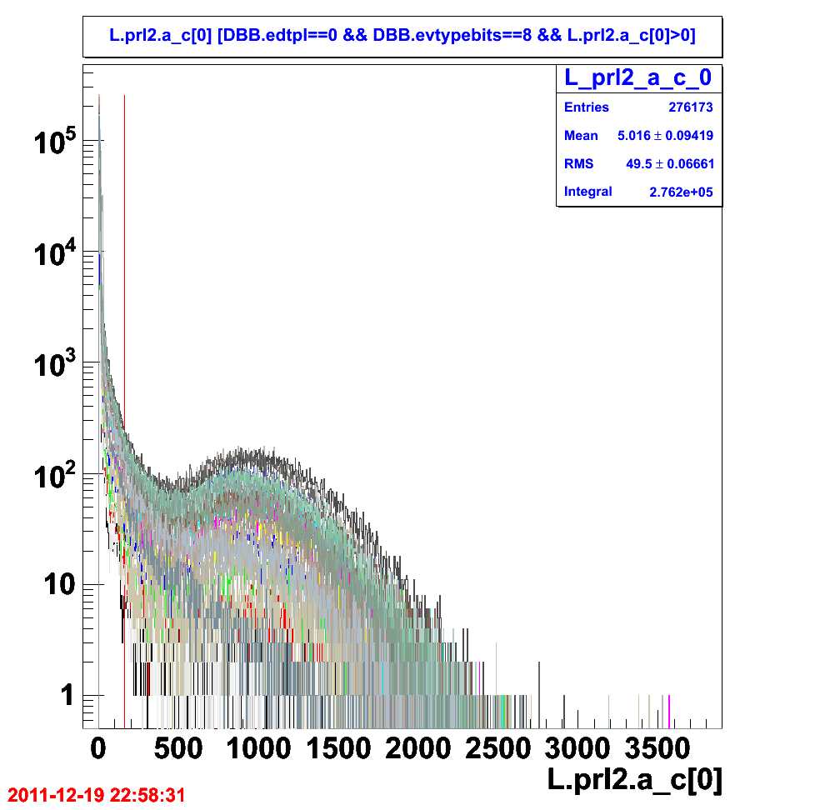
Figure 1.2: The corrected adc for prl2.
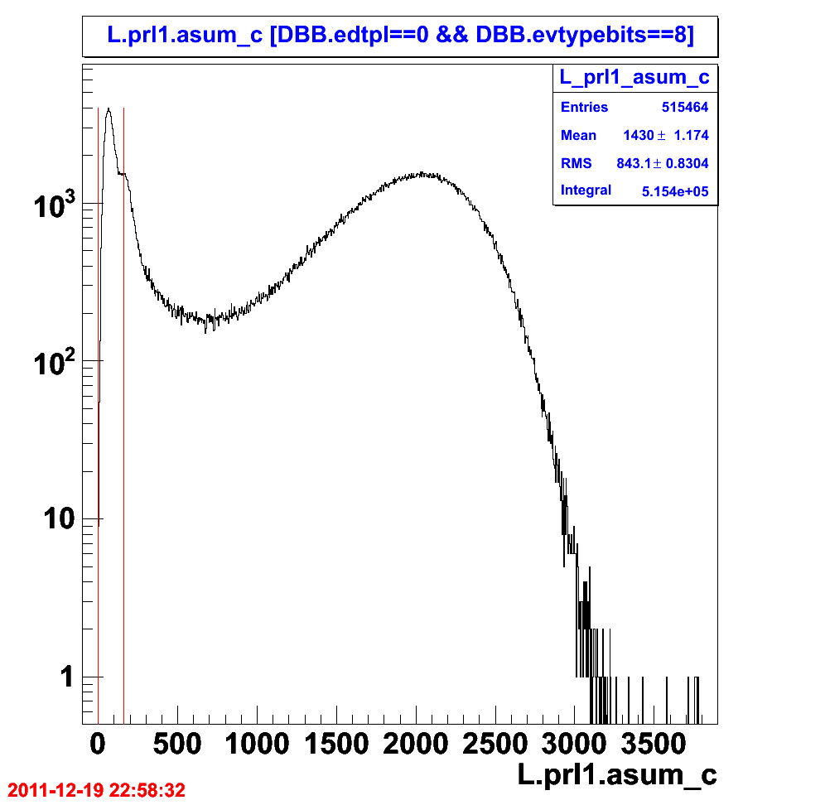
Figure 1.3: The corrected sum of adc for prl.
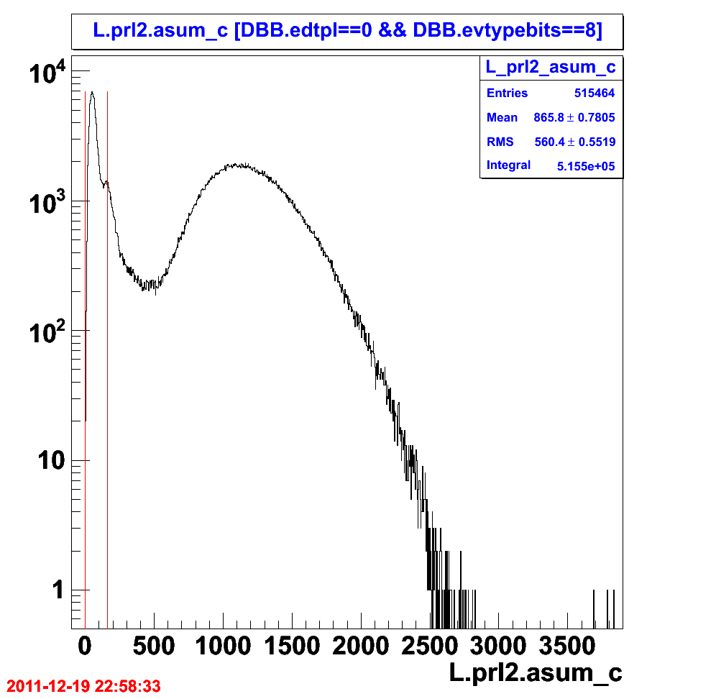
Figure 1.4: The corrected sum of adc for prl.

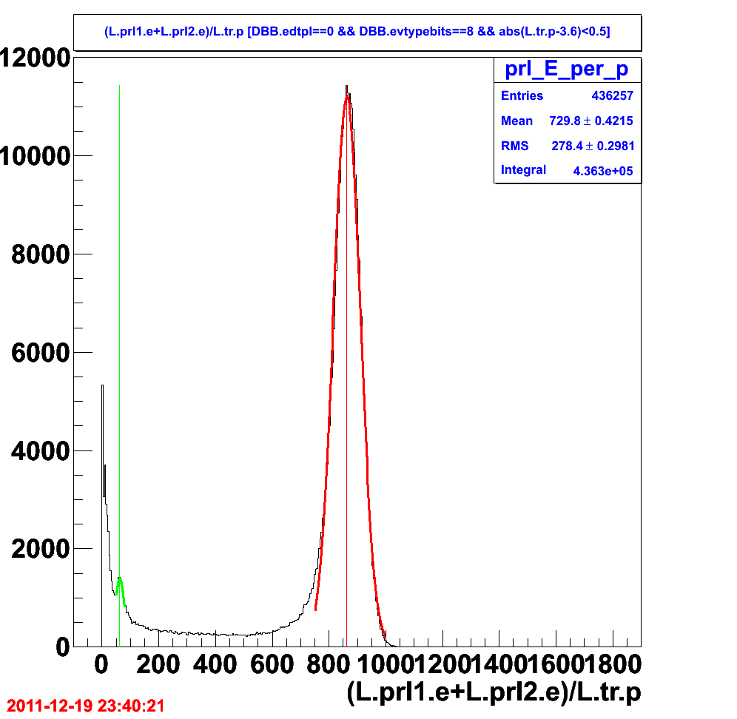
Figure 1.5: The E/p distribution, the ratio of sum of energy deposited in prl1 and prl2 to the track momentum p. The “red” line is at 863 (channel/GeV) where the mean of the “electron” E/p would be. The “green” is the pion E/p peak shown at 62.7 (channel/GeV).

The energy need to go through the conversion factor. With this, the conversion factor should be 863 GeV/channel. (haven't be check)

