Cut
1-9. Electron Cut

- DBB.l1a[0] retiming window
- BB.tr.n>0 (additional)

.................................................................

For data pass cut 1-10. We have 23% of data with NO-Track.

For data with cut 1-11 (including BB.tr.n>0), we have:
    - single track event = 94.46%
    - double track event = 5.27%
    - tripple or more track event = 0.27%

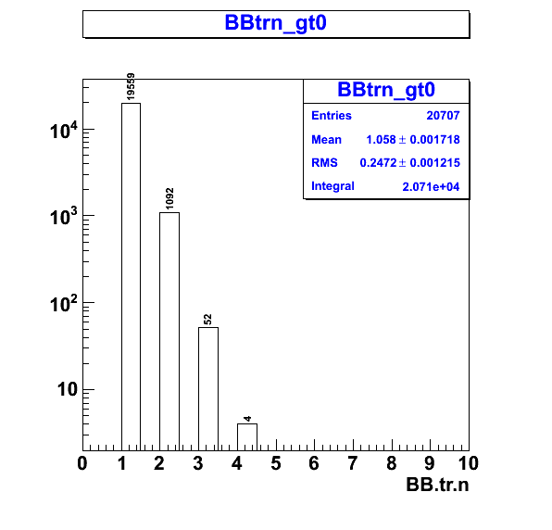
Figure 1. BB number of track per event distribution. Event number is 20707 events with total track 21915 tracks, (single track number *1 + double track number*2 + ...).
When match each track to the data in the trigger plane, we can check whether the match is to four possible categories: to the full hit of the dE & E data, to only dE data, to only E data and to no match at all. The concern variable is “BB.tp.trHitIndex” which give the index of the hit to the track according to the description below.

-1 means the track cannot find any match: 1.36% (297 tracks)
[0,9] means that tracks match to full hit where the value is the associate hit index that correspond to that track: 49.51% (10851 tracks).
110 +[0,9] means that tracks match to only dE hit data (where this data is left over from full hit matching). The actual index is subtracted by 110: 1.21% (265 tracks)
120+[0,9] means that tracks match to only E hit data (where this data is left over from full hit matching). The actual index is subtracted by 120: 47.92% (10502 tracks)

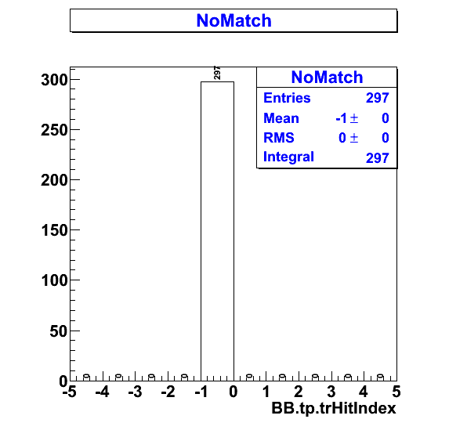
Figure 2.1 Number of tracks that cannot find matching in the trigger plane.
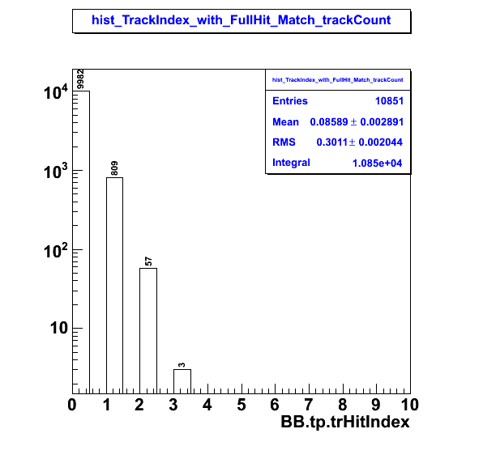
Figure 2.2 : Hit Index associate with the Full track: 49.51% of tracks (10851 tracks) can be match to both dE and E hit data.

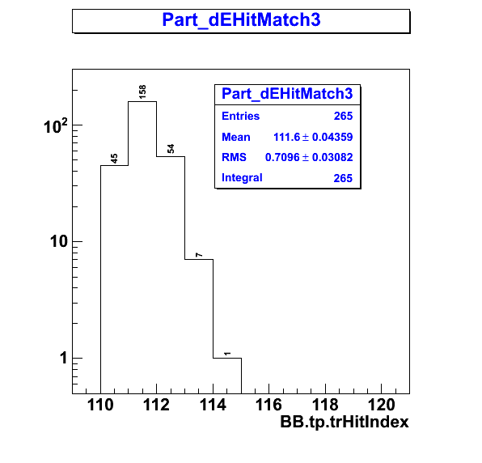
Figure 2.3 Partial Hit index of dE that match to track. 1.2% (265 tracks)

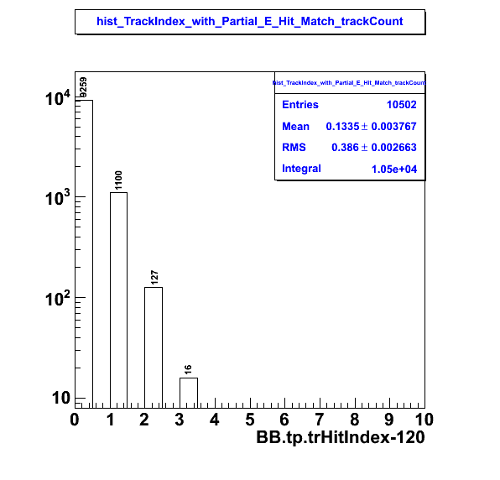
Figure 2.4. Partial Hit index of E that match to track. 47.92% (10502 tracks).

So, we do have 98.64% success to match track with trigger plane hit data.

PID

For the full hit, we can directly draw the Energy deposit in both layers because the data will store in the directly associate hit,

{i.e. for dE : hit_dEdep [trHitIndex] and for E : hit_Edep[trHitIndex]. }

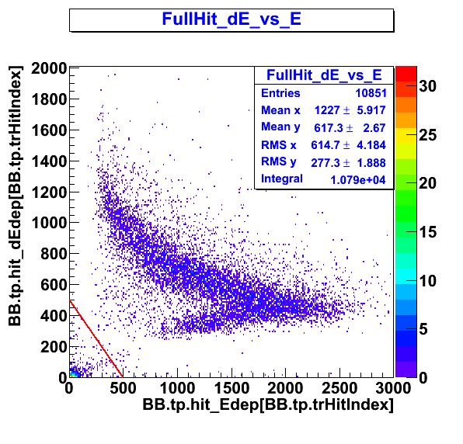
Figure 3.1 dE vs E energy deposited for FULL HIT. I put the cut at dE+E<500 for pion and dE+E>500 for proton/deutron. We have 4.76 % of pion (517 tracks) and 95.24% proton/deutron (10334 tracks) from this full hit.
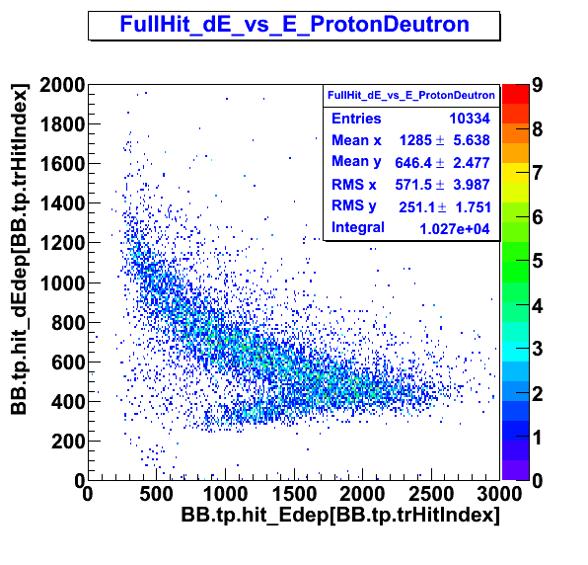
Figure 3.2: Non-minimum ionized particle. This separation of proton/deuteron is not clear.

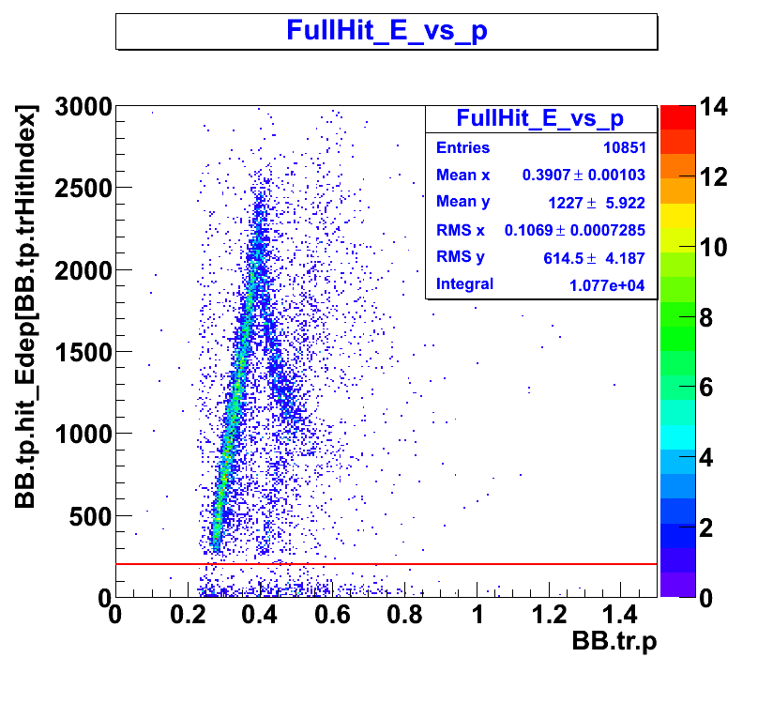
Figure 3.3: the possible separation of MIP, proton and deuteron. MIP cut at E>=200. With this cut we have 95.60% as proton/deutron (10374 tracks). The Clearer separation of proton and (faint) deuteron strip will make an easier PID. I do need more statistic for this.

For partial Hit, the only one that make sense to look at is the partial hit with the E plane (47.92% of track data)

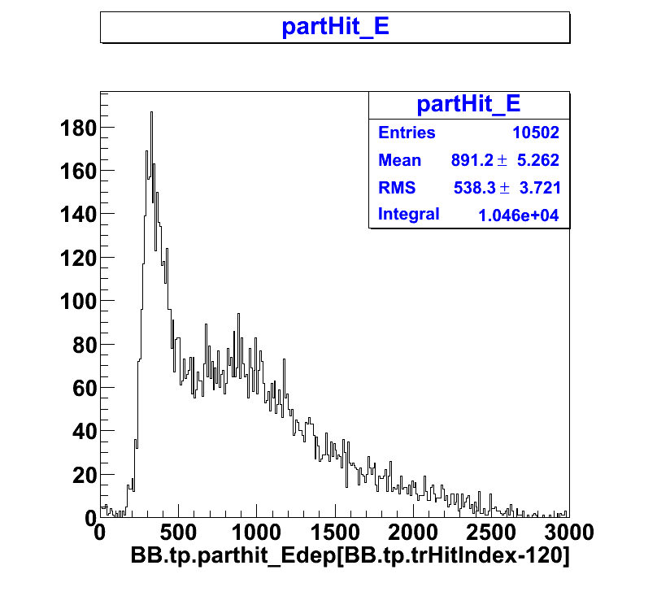
Figure 4.1: The Energy distribution of the E plane for the partial hit of track to the E plane. This clearly do not contain the MIP which would show up around “0” which is true for the case that we have no signal register to the dE plane that can match to this set of data. However, I cannot say much else.
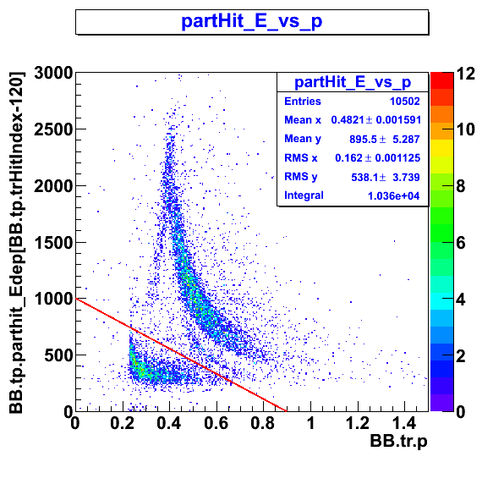

Figure 4.2: The E vs p for all the matching track to only E plane. There are two sets of data. For the data at E ~ 500 and low momentum (0.2-0.4 GeV), this cannot be the proton.
The proton strip is the strip spans from E 2500 channel down to p 0.8 GeV.

With this separation of data we can take out the lower strip section which I do not know exactly what it is but only speculate.

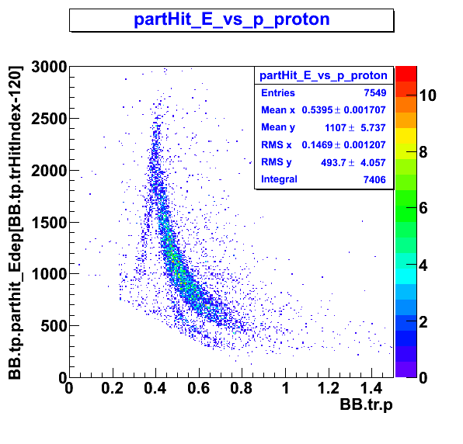
Figure 4.3. With a stright line cut.
Combining Figure 3.3 and 4.3 to get the full strip of the proton.
- For Full Hit, I cut out E_energy_dep>200 (as the pion)
- For Part Hit, I cut out the lower strip where I don't know what it is (E_energy_dep + Momentum(GeV)*1000/0.9) > 1000.

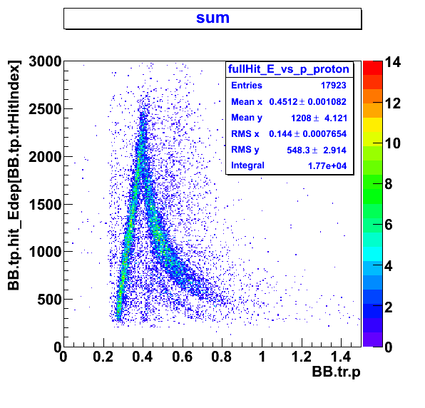

Figure 5.1 The combine of the full hit and parthit data from E_energy deposited and associate track momentum.
I think I understand the two portion of the proton strip. For which lower momentum(< 400 MeV) will have data in both dE and E, and for higher momentum (> 400 MeV) the event only show up in E plane.
TOF (not good resolution)
Now let make a cut of the proton strip and check the timing.

Let First consider the partHit as it contain most of the high momentum which has shown before that that section has high signal to background ratio.

PartHit TOF

Figure 6. CT for PartHit data
(top) for all
(middle) proton cut with the same cut of figure 4.2 ( above line from (0,1000) to (0.9,0) in E vs p)
(bottom) other unidetify section

I do not show you the fit. Don't ask. I am secretly checking it. But from the graphs below, the “other” is clearly random as the background.

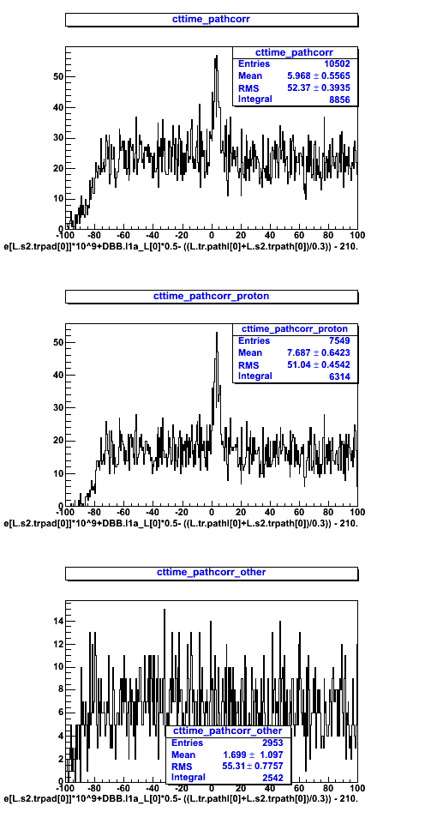
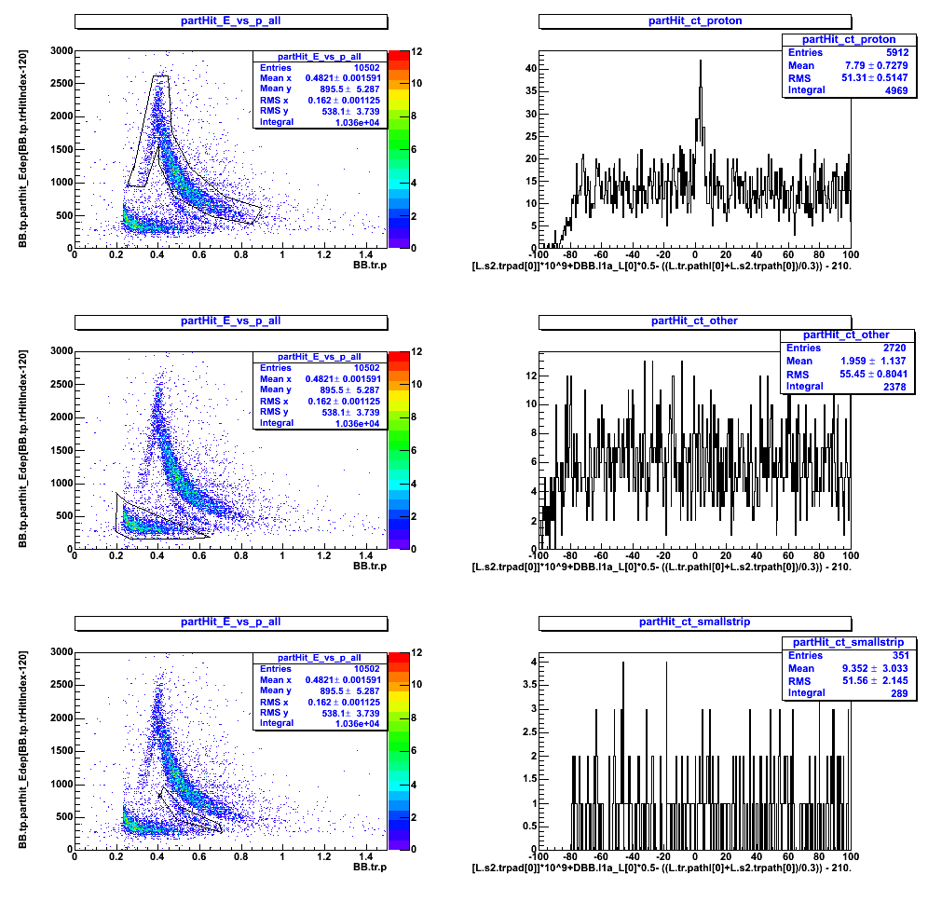
Figure 7. The CT with Graphic cut in E vs p for partHit with E. The pathlengh correction is assume the mass of the proton. See figure 8 for change in mass.
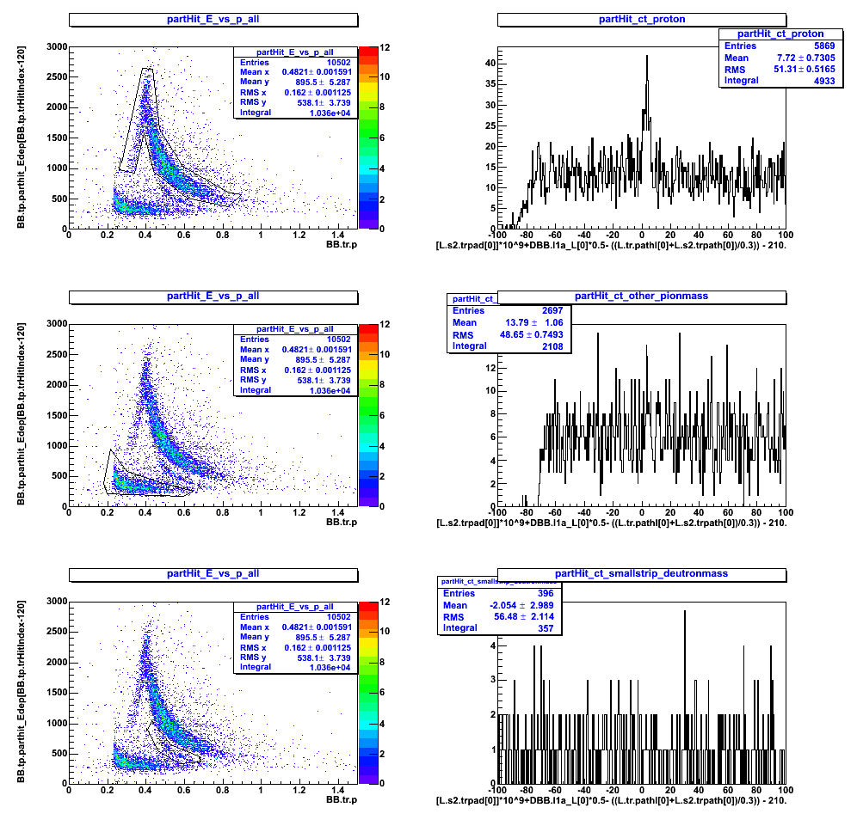
Figure 8. So I try the CT with pathlengh correction now with graphic cut of the E vs p plot.
(top row) with the assume mass of proton.
(middle) with the assume mass of the pion.
(bottom) with the assume mass of the deutron.

I still do not see the peak except for the case of the proton.

Full Hit: I make a graphic cut but I do not see the peak above background.

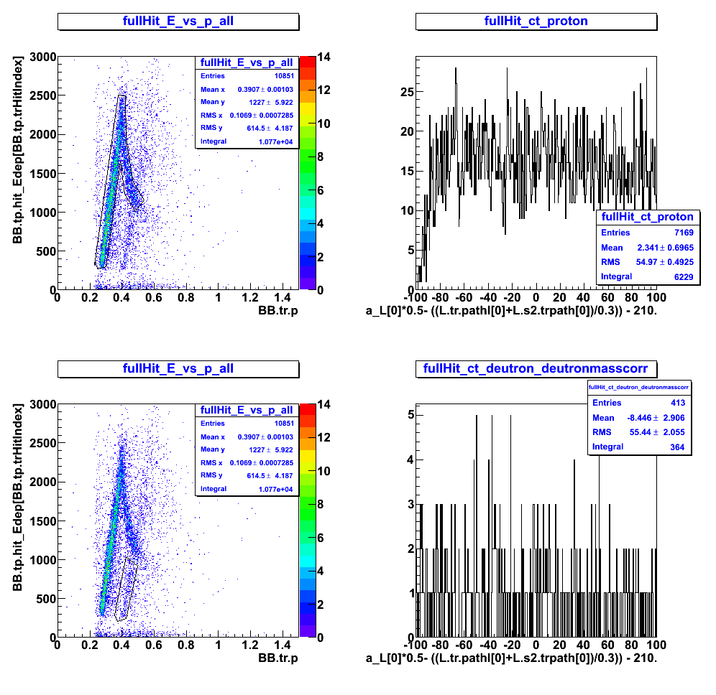

Figure 9. for the Full Hit (low momentum), Using the graphic cut but I do not see any peak for either one of the data.

