TOF Signal background subtracted
scan through vertex difference cut and proton momentum cut

Combine data for the following list1:
{2939 2940 2941 2942 2943 2944 2945 2946 2947 2985
2986 2987 2988 2989 2994 2995 2996 2997 2998 2999
3000 3001 3002 3004 3005 3006 3007 3008 3009 3010
3011 3012 3014 3015 3016 3017 3018 3019 3020 3021 }
and list2:
{3022 3025 3026 3027 3028 3029 3031 3033 3034 3035
3036 3037 3038 3039 3040 3043 3044 3045 3046 3047
3048 3049 3050 3051 3053 3054 3055 3056 3058 3059
3061 3062 3063 3064 3065 3066 3067 3068 3069 3070 }

CUT: [DBB.evtypebits&(1<<3) && DBB.edtpl==0 && exL.ok==1 && abs(exL.dp)<0.045 && abs(exL.th)<0.060 && abs(exL.ph)<0.030 && (L.prl1.e/1100.+L.prl2.e/850.)/(exL.p) >=0.6 && L.tr.n ==1 && abs(rpl.z) <= 0.08 && L.s2.trpad[0]>-1 && abs(L.s2.y_t[L.s2.trpad[0]])<0.5 && abs(DBB.l1a[0]-345)<235 && BB.tr.n==1 && abs(1.10742*BB.tr.vz-0.00540)<= 0.08"
]

with proton selection :E vs p graphic cut (for both parthit and fullhit) and dE vs p graphic cut (for fullhit).

- Vertex difference cut scan

Object: study the number of BB TOF signal above background from the effect of making additional cut on the LHRS-BB vertex difference cut. At +/- 0.8,0.7,0.6,0.5,0.4,0.3,0.2 cm

The End caps for both LHRS and BigBite are already pre-cut at +/- 8 cm.

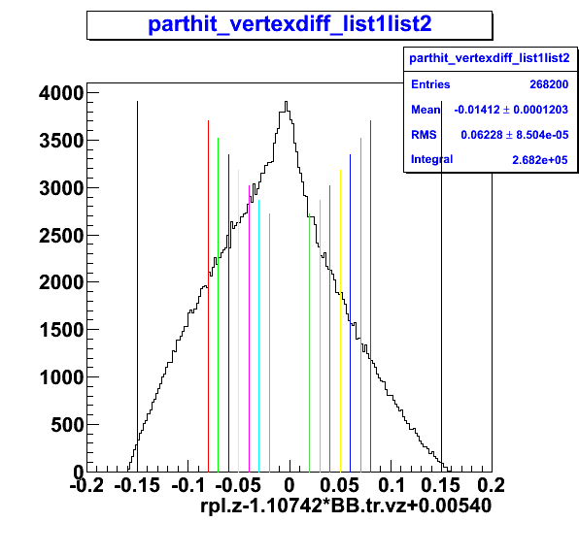 | 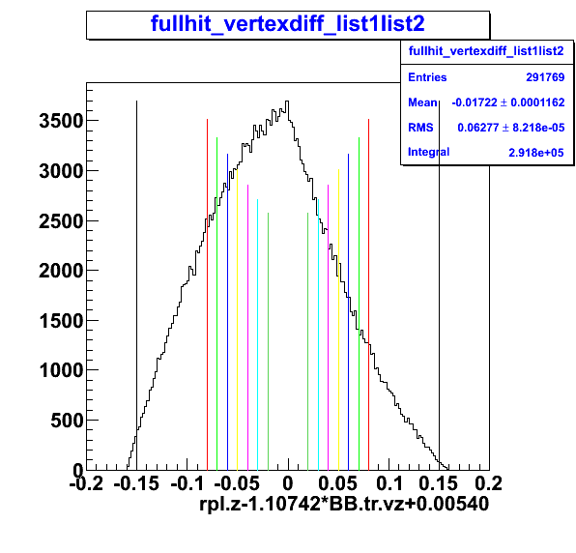
Figure 1.1: parthit: LHRS – BB vertex difference with each cut show in the color line  at  0.8,0.7,0.6,0.5,0.4,0.3,0.2 cm | Figure 1.2: fullhit: LHRS – BB vertex difference with each cut show in the color line  at  0.8,0.7,0.6,0.5,0.4,0.3,0.2 cm
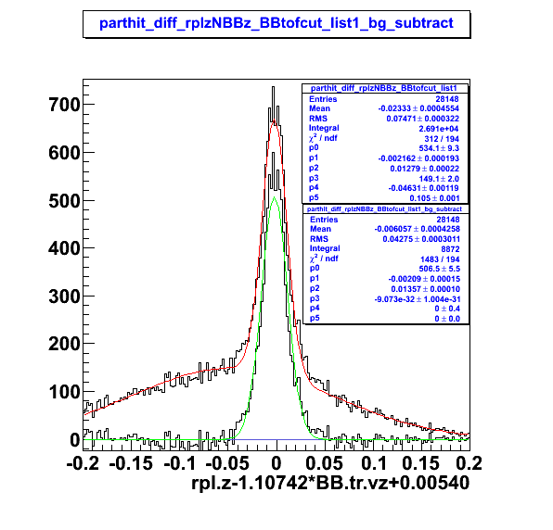
Figure 1.3: parthit vertex difference within the 3*sigma of the BB tof peak
For each vertex cut the BB TOF signal with background subtracted is extracted and the error is estimated and count the event within 3 sigma.

Example:

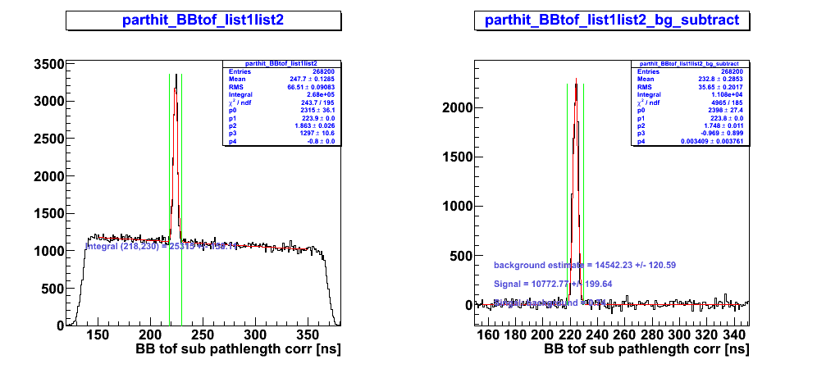
Figure 2.1(Left):BB TOF without vertex difference cut.
Figure 2.2 (Right): BB TOF with background subtracted.

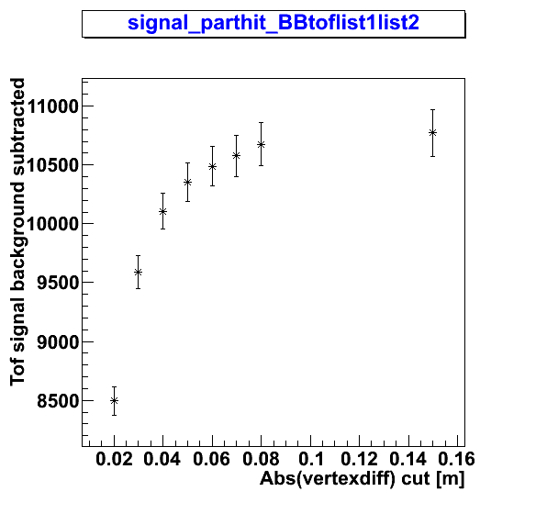 | 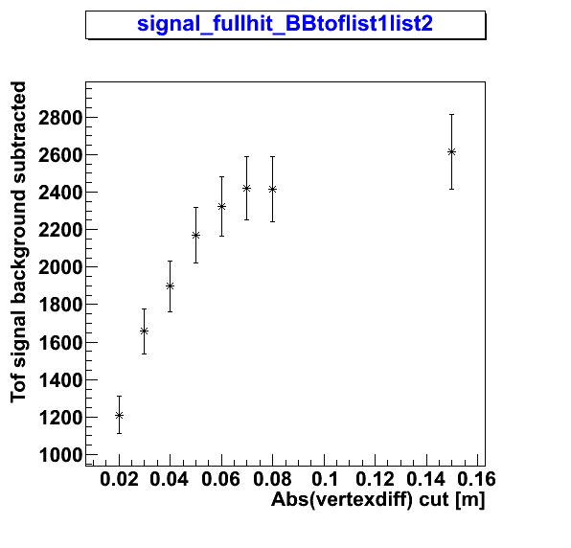
Figure 3.1: Parthit: Number of event TOF Signal background subtracted with error estimate  vs  the absolute vertex difference cut | Figure 3.2: Fullhit: Number of event TOF Signal background subtracted with error estimate  vs  the absolute vertex difference cut
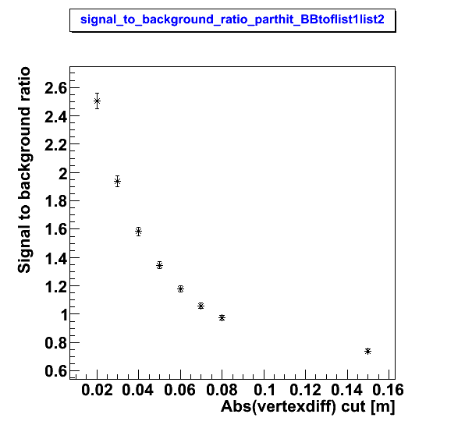 | 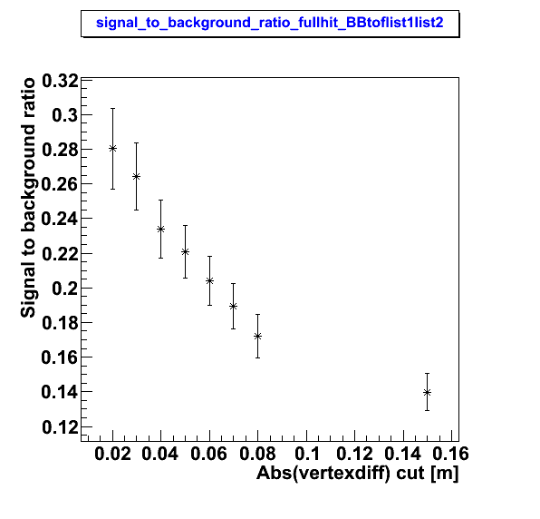
Figure 3.3: Parthit; Signal to background ratio  vs  the absolute vertex difference cut | Figure 3.4: Fullhit; Signal to background ratio  vs  the absolute vertex difference cut

- Momentum cut scan

Pick the vertex difference cut at +/- 5 cm. Then scan the momentum cut at > 250, 300,350,400,450,500,550 MeV/c

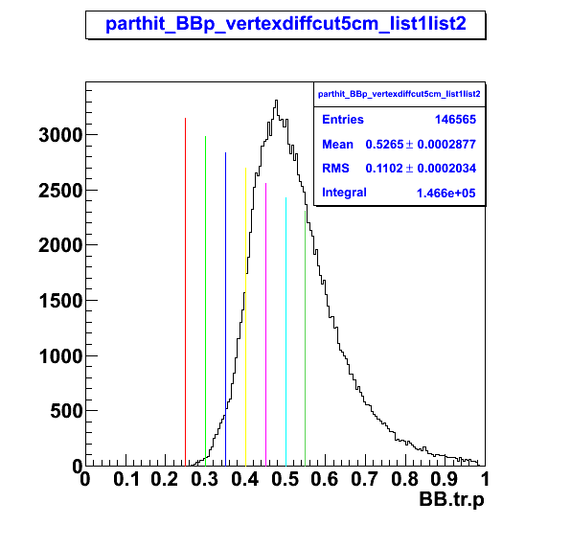 | 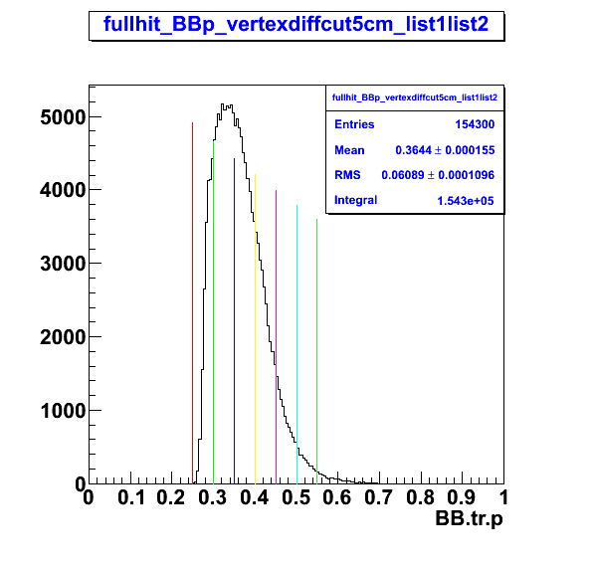
Figure 4.1: Parthit: Momentum distribution with the cut in color line | Figure 4.2: Parthit: Momentum distribution with the cut in color line

For each Momentum cut the BB TOF signal with background subtracted is extracted and the error is estimated.

Example:
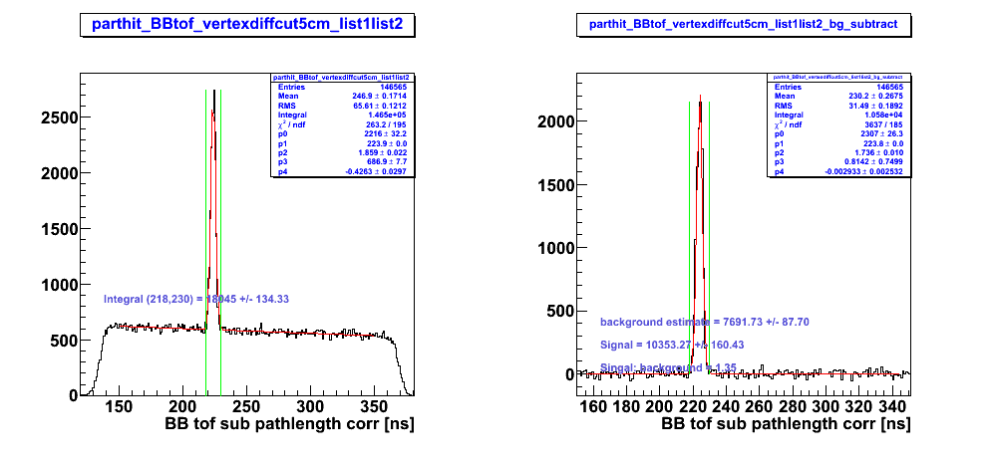
Figure 5.1: (Left) :BB TOF with vertex difference cut at +/- 5 cm.
Figure 5.2: (Right): BB TOF with background subtracted.
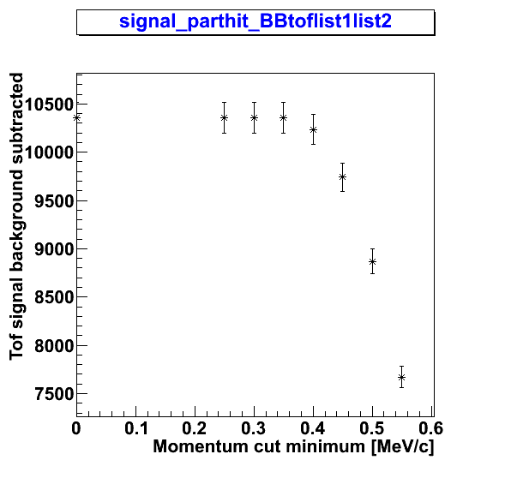 | 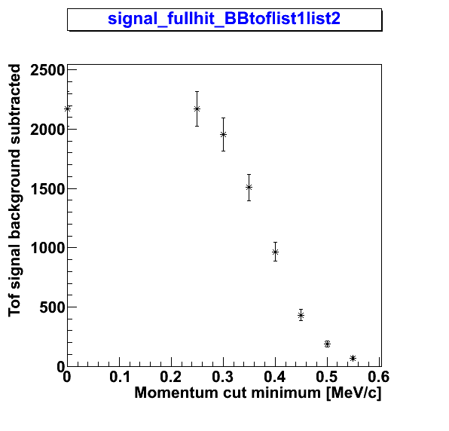
Figure 6.1: Parthit: Number of event TOF Signal background subtracted with error estimate  vs  the Minimum proton momentum cut | Figure 6.2: Fullhit: Number of event TOF Signal background subtracted with error estimate  vs  the Minimum proton momentum cut
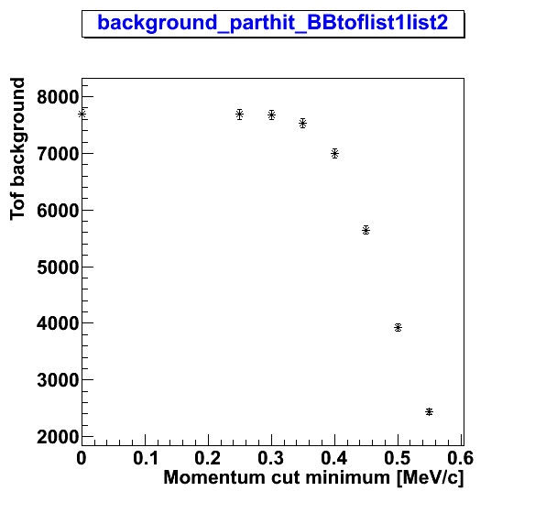 | 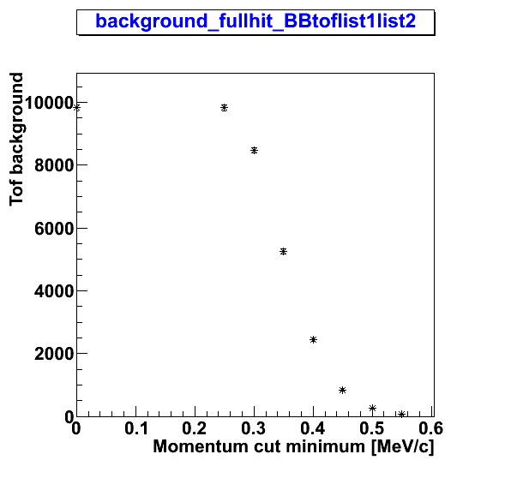
Figure 6.3: Parthit; BB TOF background  vs  the Minimum proton momentum cut | Figure 6.4: Fullhit; BB TOF background  vs  the Minimum proton momentum cut
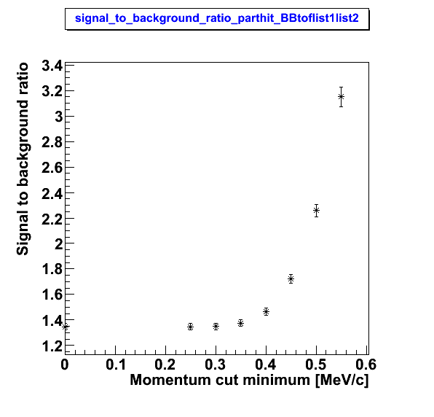 | 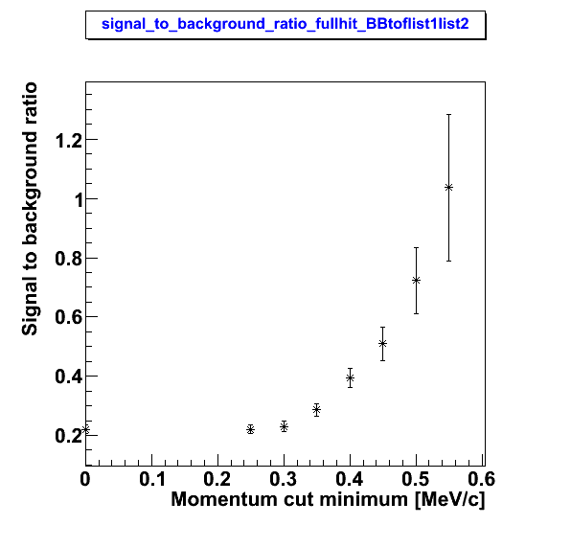
Figure 6.5: Parthit; Signal to background ratio  vs  the Minimum proton momentum cut | Figure 6.6: Fullhit; Signal to background ratio  vs  the Minimum proton momentum cut

Table A.1: parthit BB TOF with the vertex cut scan
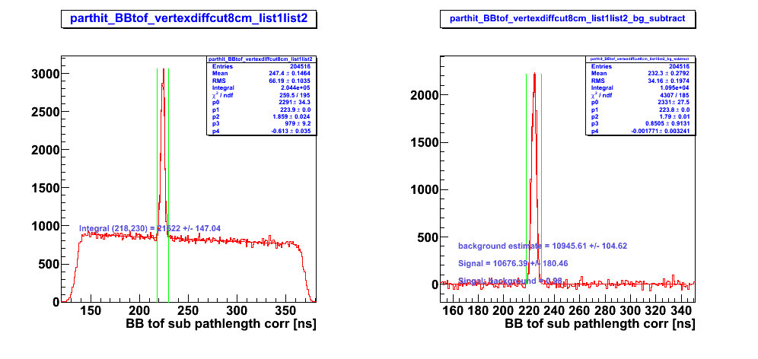
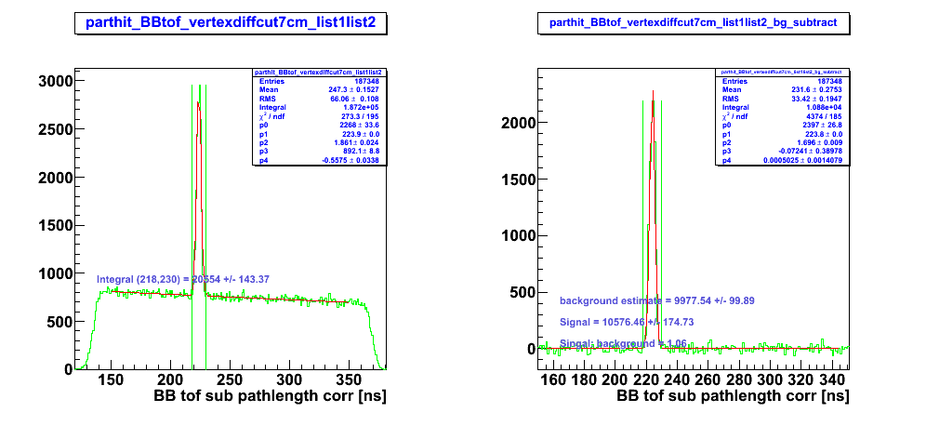
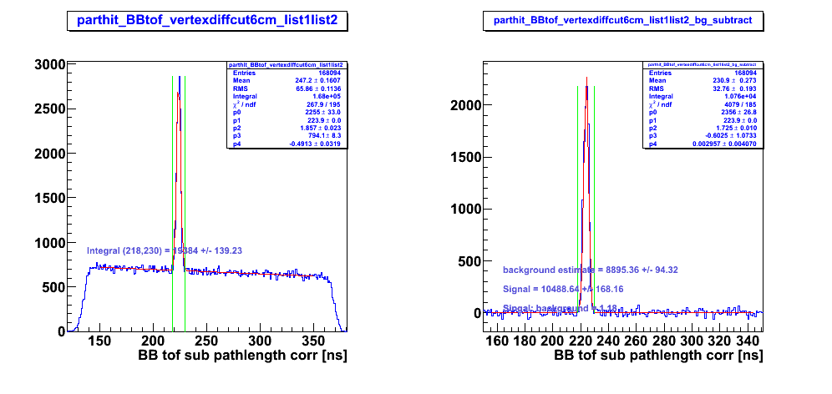
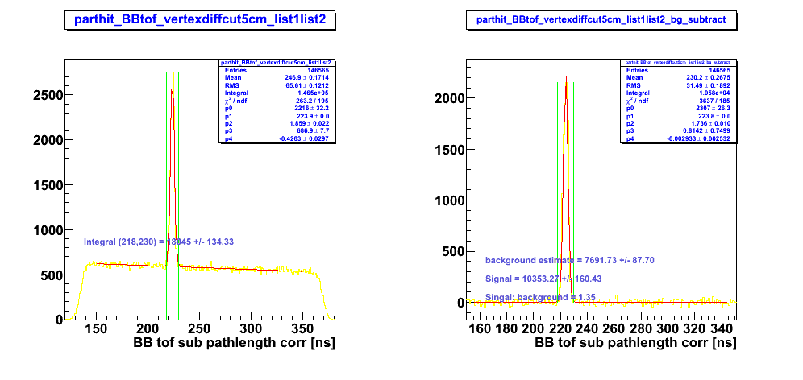
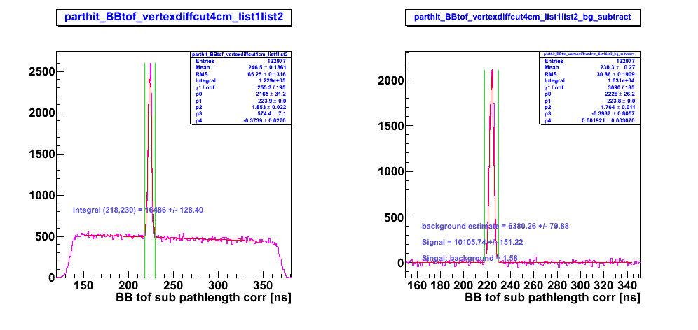
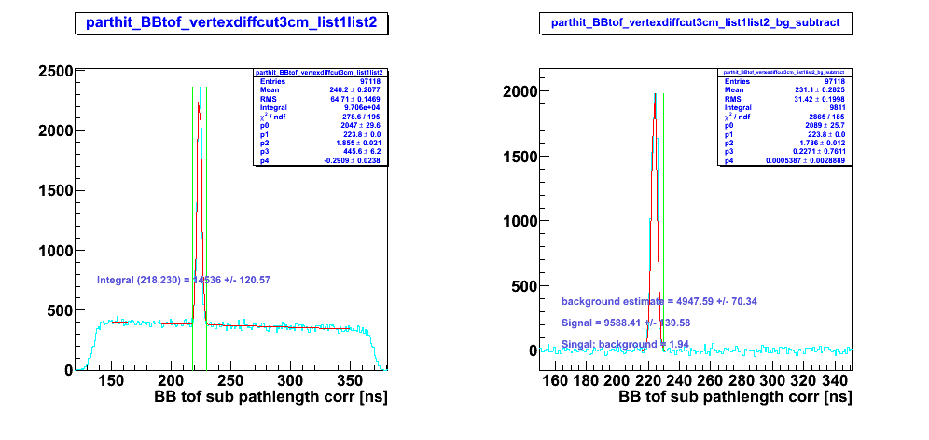
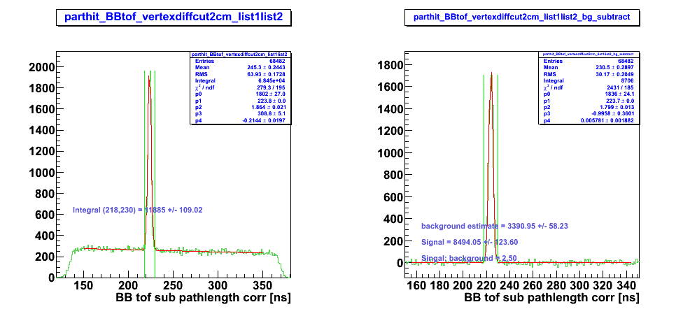

Table A.2 Fullhit vertex difference cut scan
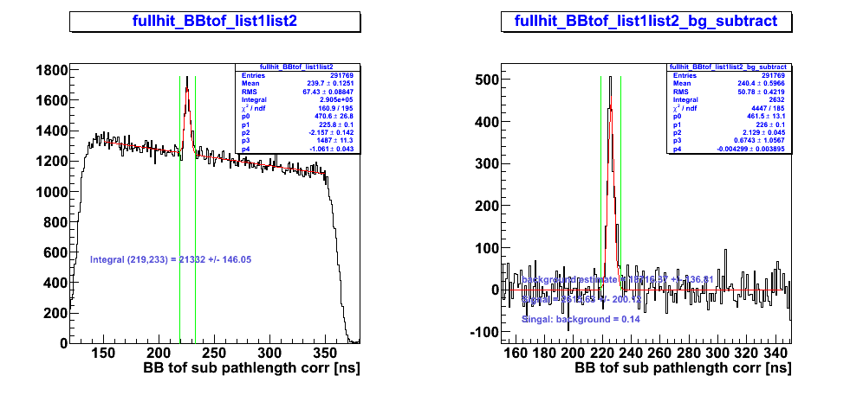
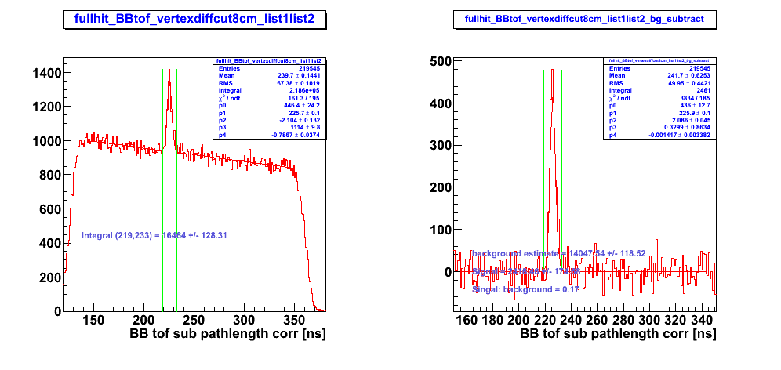
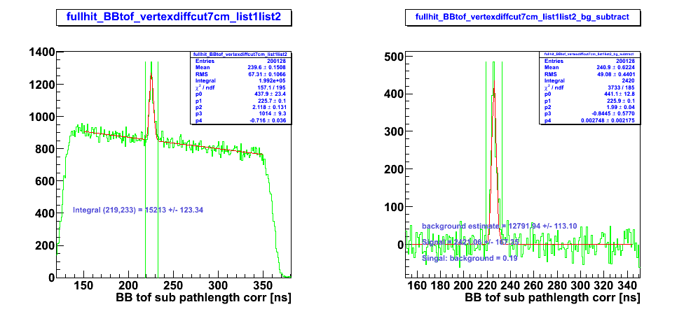
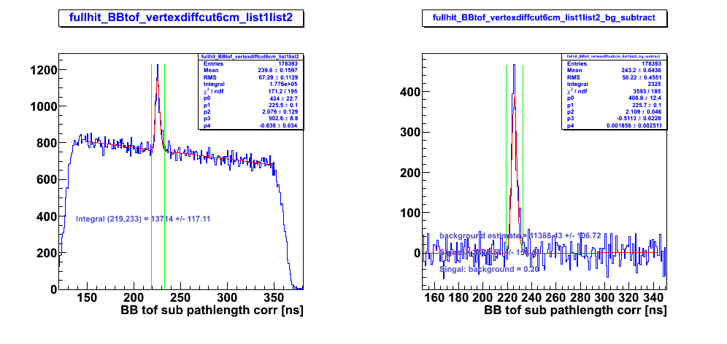
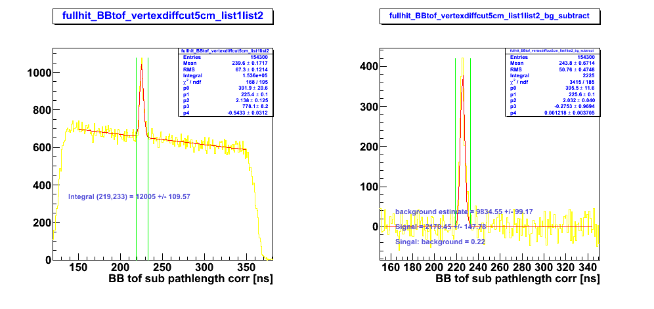
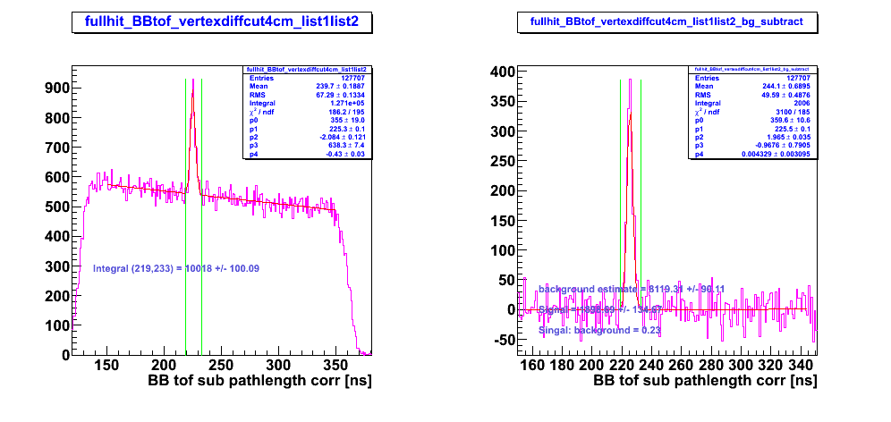
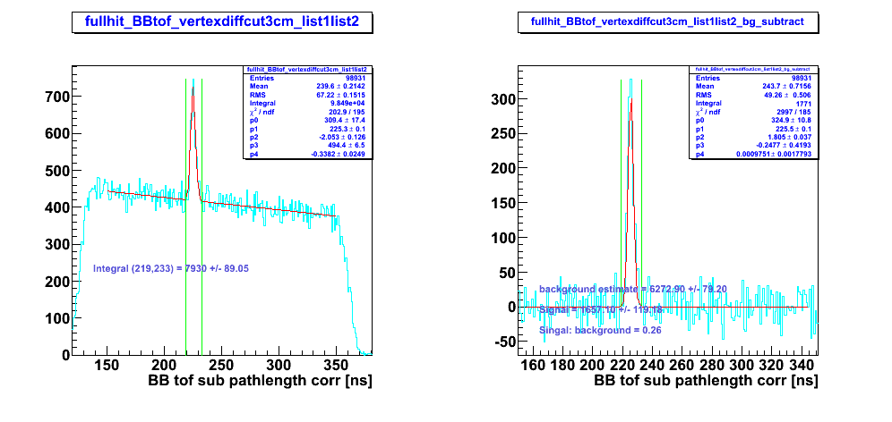
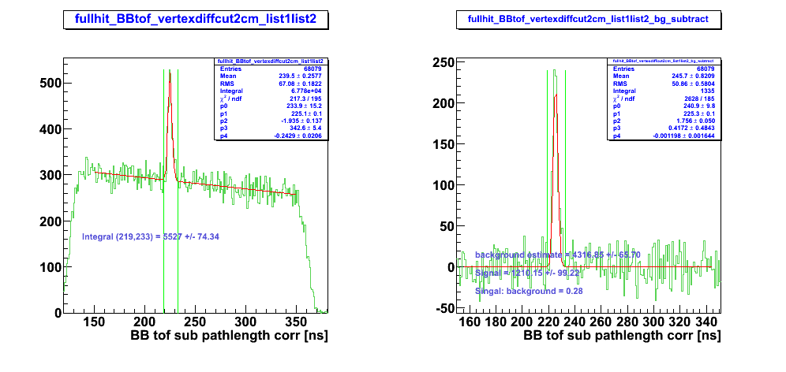

B1
