Channel to MeV for dE & E plane.

Using information from Miha's thesis, two point on the E (dE) vs p can be used to translate channel to energy deposited in E (dE) plane. I can also run a simulation which I don't have yet.

Punch through point in E is at proton's momentum (340 MeV/c) with Energy deposit in E-plane at 60 MeV/c (see figure 4.12 page 114 of Miha's thesis :ref)

If assumed directed Energy deposit = “const” *channel

I have, ~ channel 2000 at the punch through point (ave) to equivalent to 60 MeV/c
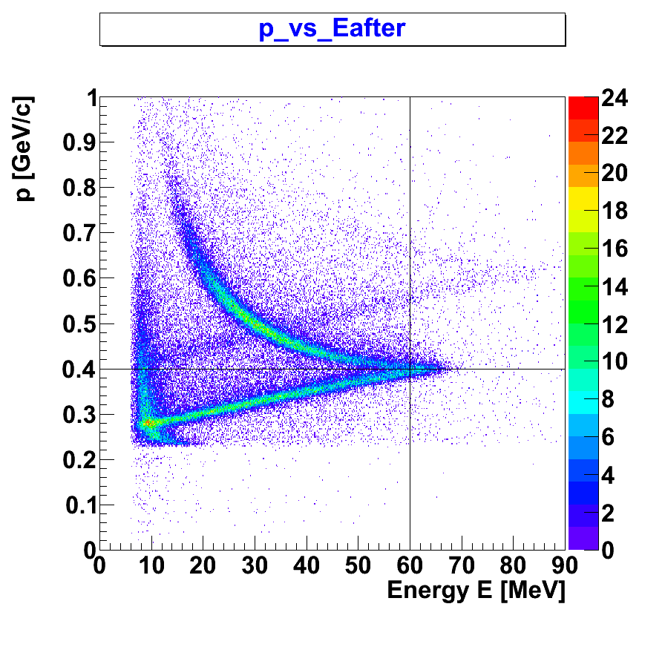
Figure 1. p vs Energy in E

