|  |  |  |  |
| --- | --- | --- | --- |
|  | | **TITLE:** | [**ES&H Manual**](mailto:mbailey@jlab.org?subject=ESH%20Manual) |
|  | | | |
| **DOCUMENT ID:** | **(draft) PREX-II/CREX Detector**  **Operational Safety Procedure Form** | | |
|  | | | |

|  | |  | | | | | | | | | | | | | | |  | | | | | | | | | | | | | | | | | |  |
| --- | --- | --- | --- | --- | --- | --- | --- | --- | --- | --- | --- | --- | --- | --- | --- | --- | --- | --- | --- | --- | --- | --- | --- | --- | --- | --- | --- | --- | --- | --- | --- | --- | --- | --- | --- |
|  | | Serial Number: | | | | | | | | | | |  | | | | | | | | | | | | | | | | | | | | |  | |
|  | |  | | | | | | | | | | | (Assigned by [ESH&Q Document Control](mailto:mbailey@jlab.org?subject=Operational%20Safety%20Procedure%20Number%20Needed) x7277) | | | | | | | | | | | | | | | | | | | | |  | |
|  | |  | | | | | | | | | | | | | | |  | | | | | | | | | | | | | | | | | |  |
|  | |  | | | | | | | | | | | | | | | | | | | | | | | | | | | | | | | | |  |
|  | | X | **OSP** | | | | |  | | **TOSP** | | | | | | | | | | |  | | | | | |  | | | | | | | |  |
|  | | **\*Attach the Task Hazard Analysis (THA) related to this procedure** | | | | | | | | | | | | | | | | | | | | | | | | |
|  | |  | | | | |  | | | | | | | | | |  | | | | | |  | | | | | | | | | | | |  |
|  | | Issue Date: | | | | |  | | | | | | | | | | Expiration Date: | | | | | |  | | | | | | | | | | | |  |
|  | | (No more than three years from Issue Date except TOSP which is three months from issue date) | | | | | | | | | | | | | | | | | | | | |  |
|  | | Title: | | **Integrating Detector in HRS Focal Plane for PREX-II and CREX** | | | | | | | | | | | | | | | | | | | | | | | | | | | | | | |  |
|  | | Location: | | | | Hall A | | | | | | | | | | | | | | | | | | | | | | | | | | | | |  |
|  | | Risk classification  (See [*ESH&Q Manual Chapter 3210 Appendix T3 Risk Code Assignment*](http://www.jlab.org/ehs/ehsmanual/3210T3.htm).) | | | | | | | | | | | | | | | | | | | | Without mitigation measures (3 or 4): | | | | | | | | | | 3 (M+M) | | |  |
|  | | With mitigation measures in place (0, 1, or 2): | | | | | | | | | | 1 (M+EL) | | |  |
|  | | Document Owner(s): | | | | | | | | Robert Michaels | | | | | | | | | | | | | | Date: | |  | | | | | | | | |  |
|  | |  | | | | | | | |  | | | | | | | | | | | | | |  | |  | | | | | | | | |  |
| Supplemental Technical Validations: | | | | | | | | | | | | | | | | | | | | | | | | | | | | | | | | | | | |
|  | | Hazard Reviewed (per [ES&H Manual 2410-T1](https://www.jlab.org/ehs/ehsmanual/2410T1.htm)): | | | | | | | | | | | | | | | | | Subject Matter Experts Signature: | | | | | | | | | | | Date: | | | | |  |
|  | |  | | | | | | | | | | | | | | | |  | |  | | | | | | | |  | | |  | | | |  |
|  | |  | | | | | | | | | | | | | | | |  | |  | | | | | | | |  | | |  | | | |  |
|  | |  | | | | | | | | | | | | | | | |  | |  | | | | | | | |  | | |  | | | |  |
|  | |  | | | | | | | | | | | | | | | | | | | | | | | | | |  | | |  | | | |  |
| Approval Signatures: | | | | | | | | | | | | | | | | Print Signature | | | | | | | | | | | | | | | Date: | | | | |
|  | | Division Safety Officer: | | | | | | | | | Ed Folts | | | | | | | | | | | | | | | | | |  | | | |  | |  |
|  | | Department or Group Head: | | | | | | | | | | | | | Cynthia Keppel | | | | | | | | | | | | | |  | | | |  | |  |
|  | | **Safety Warden of Area:** | | | | | | | | | | Javier Gomez | | | | | | | | | | | | | | | | |  | | | |  | |  |
|  | | Other Approval(s): | | | | | | |  | | | | | | | | | | | | | | | | | | | |  | | | |  | |  |
|  | |  | | | | | | | | | | | |  | | | | | | | | | | | | | | | | |  | | | |  |
| Document History: | | | | | | | | | | | | | | | | | | | | | | | | | | | | | | | | | | | |
|  | Revision: | | | | Reason for revision or update: | | | | | | | | | | | | | | | | | | | | Serial number of superseded document | | | | | | | | | |  |
|  |  | | | |  | | | | | | | | | | | | | | | | | | | |  | | | | | | | | | |  |
|  |  | | | |  | | | | | | | | | | | | | | | | | | | |  | | | | | | | | | |  |

**Distribution:** Copies to: affected area, authors, Division Safety Officer, ESH&Q Document Control

**After expiration:** Forward original and log sheet of trained personnel to ESH&Q Document Control.

|  |  |  |  |
| --- | --- | --- | --- |
|  | | | |
|  | 1. **Purpose of the Procedure** | |  |
| A detector system will be deployed in the HRS focal plane on both Left and Right spectrometers. The detectors consists of a set of 4 GEM chambers and a pair of quartz detectors. | |
| 1. **Scope –** include operations, people, and/or areas where procedure applies | |
| These procedures include how to install and operate the detectors | |
| 1. **Description of the Facility: (**include floor plans and layout of a typical experiment or operation) | |
| **Figure 1** shows the overall assembly in each spectrometer. It consists of four GEM chamber assemblies and two Quartz detectors. **Figure 2** shows the quartz detector mounts. The quartz detectors are connected to a PMT. The quartz detectors are used for our main production data taking in integration mode. The purpose of the GEM detectors is to supplement the HRS tracking for measuring Q2 primarily. Tracking is also used for backgrounds studies and optics calibrations. | |
| 1. **Authority and Responsibility:** | |  |
|  | **4.1 Who has authority to implement/terminate** |
| System Owner | |
|  | **4.2 Who is responsible for key tasks** |
| Only authorized personnel may enable to set up and set up the water flow to the collimator. | |
| 1. **Who analyzes the special or unusual hazards (See** [**ES&H Manual Chapter 3210 Appendix T1 Work Planning, Control, and Authorization Procedure**](http://www.jlab.org/ehs/ehsmanual/3210T1.htm)**)** | |
| N/A | |
| 1. **Personal and environmental hazard controls including:** | |
|  | **6.1 Shielding** |
| * None, the detectors are deployed in the HRS shield hut. No residual significant residual radiation is anticipated. . | |
|  | **6.2 Interlocks** |
| * None | |
|  | * 1. **Other** |
|  | |
| 1. **Monitoring systems** | |
| Shift workers will only be allowed to take shifts after they have read and signed the COO of the experiment. | |
| 1. **Ventilation** | |
| N/A | |
| 1. **List of safety equipment (i.e: personal protective equipment or special tools)** | |
| N/A | |
| 1. **Associated administrative procedures** | |
| **De- Installation:** Once the PREX-II and CREX experiments are finished, the detectors will need to be taken out with the supervision of Jack Segal. | |
| 1. **Operating guidelines** | |
| **This is the same as 10. Associated Administrative Procedures.** | |
| 1. **Notification of Affected Personnel (How and Who)** | |
| N/A | |
| 1. **List of steps required to execute the procedure from start to finish.** | |
| **.** | |
| 1. **Back out procedures, i.e., steps necessary to restore the equipment/area to a safe level.** | |
|  | |
| 1. **Special environmental control requirements:** | |
| N/A | |
| 1. **Environmental Impacts (See** [**EMP-04 Project/Activity/Experiment Environmental Review**](https://jlabdoc.jlab.org/docushare/dsweb/View/Collection-1349) | |
| N/A | |
| 1. **Abatement Steps – Secondary Containment, or Special Packaging requirements** | |
| N/A | |
| 1. **Training requirements** | |
| Shift workers must have standard Hall A/ JLab user required safety training and have read and signed the COO for the experiment for which they are taking shifts. | |
| 1. **Unusual/Emergency procedures e.g., Injury, Fire, Loss of power** | |
| N/A | |
| 1. **Instrument calibration requirements, e.g., safety system/device recertification, RF probe calibration** | |
| N/A | |
| 1. **Inspection schedules** | |
| N/A | |
| 1. **References/Associated Documentation** | |
| JLab  ES&H manual   * I’m not yet sure what chapters apply. | |
| 1. **List of Records Generated (Include Location / Review and Approved procedure)** | |
|  | |
|  |  | |  |

**Authorized/Trained Individuals**

| **Print Name/Signature** | **Date** |
| --- | --- |
|  |  |
|  |  |
|  |  |
|  |  |
|  |  |
|  |  |
|  |  |
|  |  |
|  |  |
|  |  |
|  |  |
|  |  |

|  |  |  |  |  |  |  |  |  |
| --- | --- | --- | --- | --- | --- | --- | --- | --- |
|  | **ISSUING AUTHORITY** | **APPENDIX AUTHOR** | **APPROVAL DATE** | **EFFECTIVE DATE** | **EXPIRATION DATE** | **REV.** |  |  |
|  | ESH&Q Division | [Harry Fanning](mailto:fanning@jlab.org?subject=ESH%20Manual%203310%20Appendix%20T2%20Operational%20Safety%20Procedure%20Form) | 10/05/09 | 01/01/10 | 10/05012 | 0 |  |

***This document is controlled as an on line file. It may be printed but the print copy is not a controlled document. It is the user’s responsibility to ensure that the document is the same revision as the current on line file. This copy was printed on 5/22/2017.***

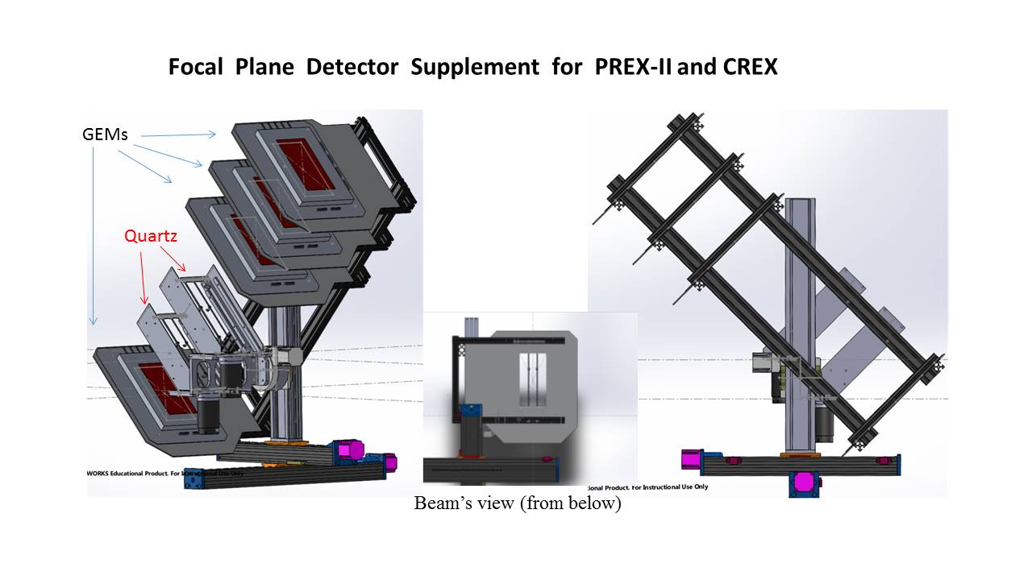

Fig 1.

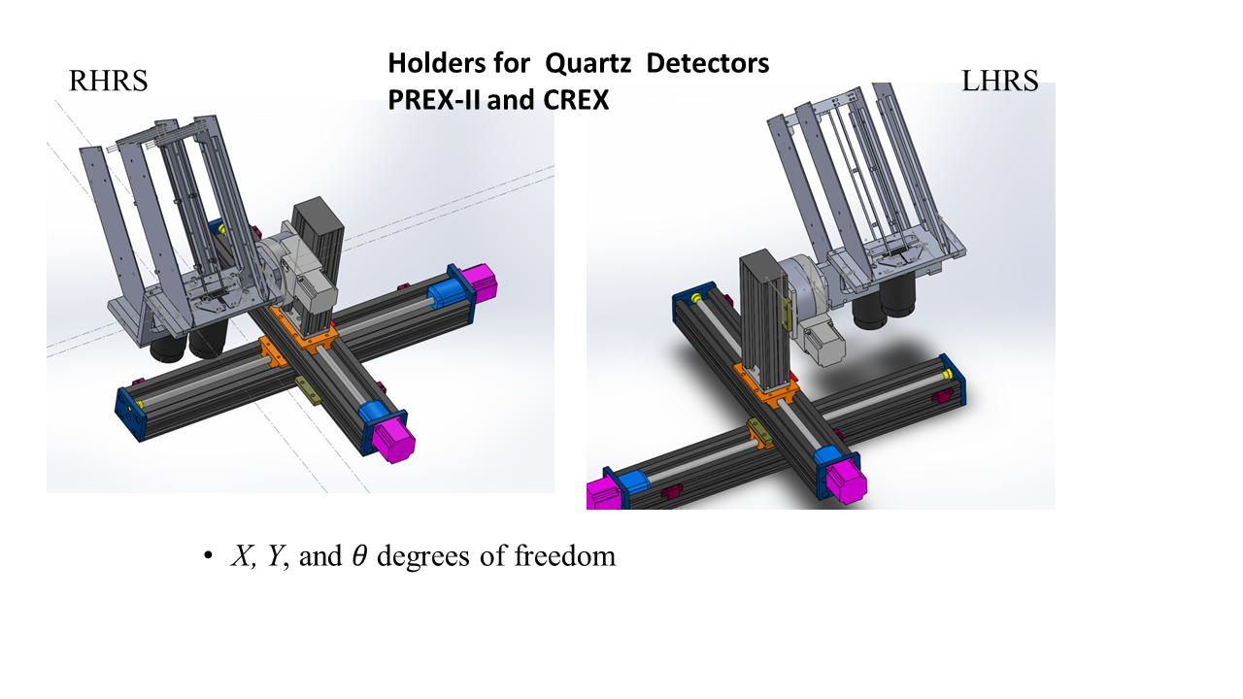

Fig 2