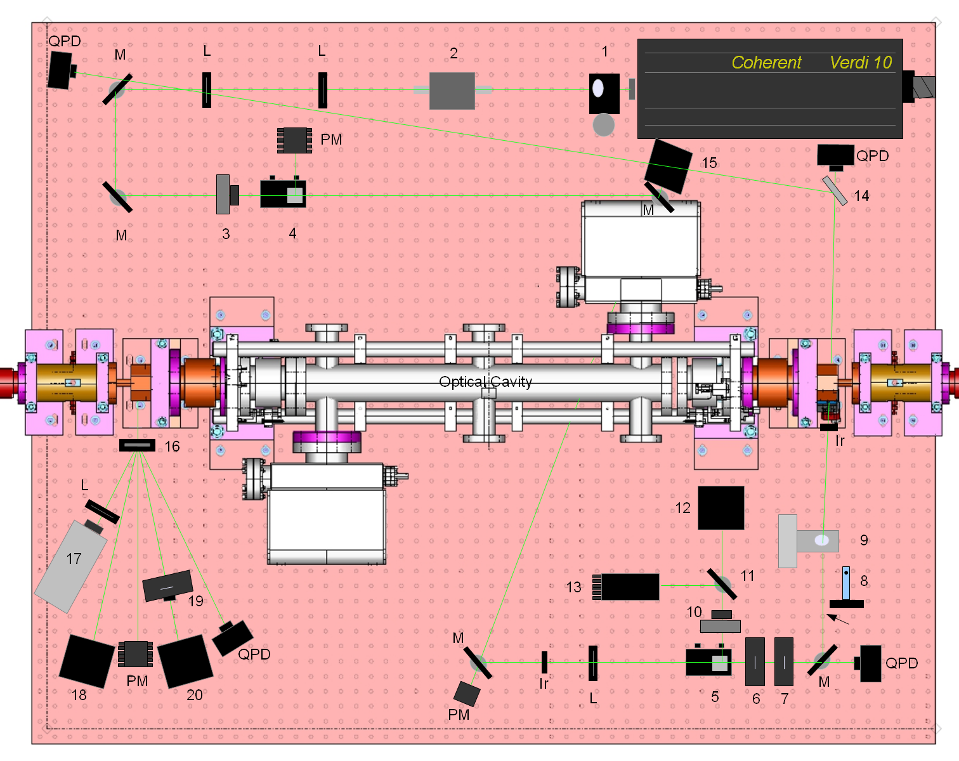

QPD: quadrant photodiode to track laser position

L: lens for shaping beam

M: turning mirror

PM: power meter for monitor beam power

Ir: iris collimator (used only for setup and alignment of laser)

1. Manual periscope for dropping laser from 5 inch height at laser opening to 3 inches above table
2. EOM (electro-optical modulator) modulates frequency of laser at 6MHz for Pound-Drever-Hall (PDH) cavity locking technique
3. Remote controlled (RC) rotatable half wave plate. In conjuction with the polarizing cube at 4 we could control the fraction of laser power that was dumped into the power meter and the fraction that continued to the cavity.
4. Polarizing beam splitter. Here the vertically polarized light from the laser was changed to horizontally polarized.
5. Polarizing beam splitter. Creates horizontal linear polarization.
6. RC rotatable half wave plate.
7. RC rotatable quarter wave plate. Combination of quarter and half wave plates allows one to tune the polarization to create perfect circular polarization at the cavity.
8. Flipper mirror inserted to block the beam during laser off times.
9. RC periscope raises laser from 3inches above the table to 9.5 inches above to the electron beam height.
10. Half wave plate used to adjust the fraction of light that goes through the partially reflecting mirror (11) into the Reflection Photodiode (12) and the fraction that is reflected into the beam dump (13).
11. Partially reflecting mirror (reflection coefficient sensitive to polarization state).
12. Photodiode attached to integrating sphere used to maintain cavity lock using PDH method.
13. High power beam dump.
14. 50% beam splitter
15. Residual reflection photodiode. Monitors component of light that is reflected off the cavity mirror and back through the linear polarizer (5). Adjusting the HWP(6) and QWP(7) to minimize the light in the photodiode (15) maximizes the degree of circular polarization at the optical cavity.
16. Holographic beam splitter (HBS) splits the beam into several beam approximately 17 degrees apart. The main beam carries about 98% of the power with the first order beams on either side having 1% each and the second order beams a very small fraction.
17. LCD camera for viewing transmitted beam. Used for imaging transmitted beam on screen in counting house.
18. Transmitted photodiode monitors relative power of transmitted beam and thus the power stored in the cavity.
19. RC rotatable Glan Laser linear polarizer.
20. Transmitted photodiode. The degree of linear polarization (DOLP)of the transmitted beam was measured by rotating the linear polarizer and measuring the photodiode signal as a function of rotation angle. This signal was normalized to the power in (18) to remove laser and cavity power fluctuations. DOLP=amplitude/offset of sine fit to signal vs angle.