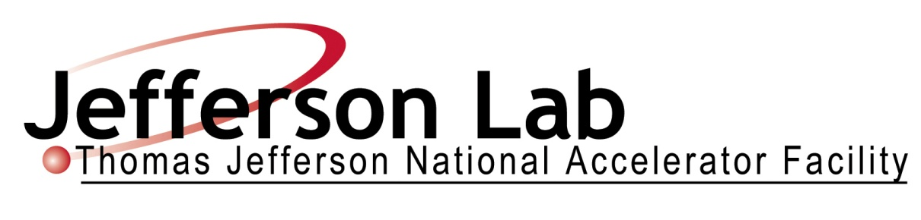

**SHMS TRANSFER LINE**

**TECHNICAL SPECIFICATION**

**THOMAS JEFFERSON**

**NATIONAL ACCELERATOR FACILITY**

Nov 8, 2010

Technical Specification

Specification 67145-SPEC-00700

Approved ________________________________________ Date_______________

Paul Brindza – JLab Technical Representative

Approved ________________________________________ Date_______________

Howard Fenker – CAM for Physics Hall C

Approved ________________________________________ Date_______________

Robert May – Acting 12 GeV Safety Manager

Approved ________________________________________ Date_______________

Bruce Lenzer – JLab QA/CI Manager

Approved ________________________________________ Date_______________

Claus Rode – Acting APM for Physics

Summary of Revisions

Initial issue Date

**Table of Contents**

**1.0** **STATEMENT OF WORK** 5

1.1 General Overview 5

1.2 Scope of Work 5

1.3 Information Furnished by Jefferson Lab Prior to Award 6

1.4 Responsibility 7

1.5 SHMS XTR Line Requirements Summary 7

1.6 SHMS XTR Line Design Documentation 8

1.7 Acceptance Testing 9

1.8 Shipping and Delivery 9

1.9 Warranty and Spare Parts 9

1.10 Applicable Documents 10

1.10.1 ASME Code for Pressure Piping 10

1.10.2 ASME Boiler and Pressure Vessel Code (see Paragraph 6.4.2) 10

1.11.3 Miscellaneous ASME Codes 10

1.11.4 NEMA and NEC 10

1.11.5 Institute of Electrical and Electronics Engineers (IEEE) 11

1.11.6 American Welding Society 11

1.11.7 American Society for Testing and Materials 11

1.11.8 Compressed Gas Association 11

1.11.9 American Conference of Governmental Industrial Hygienists 11

1.11.10 Physical Properties 11

**2.0** **LIST OF CXFER LINE REFERENCE DESIGN DRAWINGS** 12

**3.0** **CXFER LINE CRYOSTAT Requirements** 17

3.1 Introduction 17

3.2 Structural Requirements 17

3.2.1 ASME Requirements 17

3.2.2 Shipping and Handling Loads 18

3.3 Vacuum Vessel Leak Test Requirement 18

3.4 Helium Vessel Leak Test Requirement 18

3.5 Liquid Nitrogen Leak Test Requirement 19

**4.0** **REQUIRED INSTRUMENTATION** 20

4.1 Temperature Sensors 20

**5.0** **CXFER LINE ASSEMBLY ACCEPTANCE TESTING** 20

5.1 Location 20

5.2 Requirements for Acceptance Testing 21

5.3 Exceptions to Standard Conditions 21

5.4 Scope of CXFER LINE Acceptance Test 21

5.4.1 Acceptance Test Scope 21

5.4.2 Instrumentation Acceptance Tests 21

**6.0** **QUALITY ASSURANCE PROGRAM REQUIREMENTS** 21

**7.0** **SCHEDULE and Milestones** 22

7.1 ASME Milestones 22

7.2 Fabrication, Test and Delivery Milestones 23

7.3 Required Documentation 25

7.4 Approval of Documentation and Milestones 25

7.5 Monthly Progress Reports 25

7.6 Schedule Modification and Changes 25

**Figure 1. SHMS Plan View** 26

**Figure 2. CXFER LINE (#2, 3, 4, 5 &6) 3D CAD Exterior View** 27

**Figure 4. Typical SHMS Magnet Installation of CXFER LINE** 29

**Figure 5. CXFER LINE #1 Assembly as used on Hall D Solenoid** 30

**Single coil test configuration shown** 30

**Figure 6. Bottom View of CXFER LINE #1 Assembly for Hall D Solenoid** 31

**Figure 7. Cut away view CXFER LINE #1 Assembly for Hall D Solenoid.** 32

**Supporting Documents** 33

1. **STATEMENT OF WORK**
   1. **General Overview**

The Thomas Jefferson National Accelerator Facility (Jefferson Lab) 12 GEV Upgrade requires a superconducting Horizontal Bend Dipole magnet (HB), three superconducting Quadrupole magnets (Q1, Q2, and Q3) and a superconducting Dipole magnet (Dipole) for the Super High Momentum Spectrometer (SHMS) to be installed within Experimental Hall C at the Continuous Electron Beam Accelerator Facility (CEBAF). **This Statement of Work covers the requirements for the Cryogenic Transfer line (CXfer), a common element used on by five superconducting magnets for the SHMS (drawings Table 2.1).**  The HB, Q1, Q2, Q3 and Dipole magnets will be procured under separate Requests for Proposals already issued in July 2008, January 2009 and May 2009. A plan view drawing of the SHMS showing the Horizontal Bend Dipole, all three Quadrupoles and the Dipole installed on the support structure is shown in Figure 1 SHMS Plan View. Figure 2 shows the CXfer line as used on the five SHMS magnets and Figure 3 shows the layout of the CCfer line.

* 1. **Scope of Work**

This specification covers the ASME Pressure piping documentation, shop drawings, weld process specifications, manufacturing, assembly, testing and delivery of the cryogenic transfer line (CXfer). The CXfer line will be installed on the SHMS utility platform and will be connected to five superconducting magnets that will not have to be code stamped but will otherwise meet all ASME code requirements. The Offeror shall submit an offer for the CXfer line assembly as per this specification and the Jefferson Lab supplied design. The Jefferson Lab design CXfer line is based upon the ASME B31.3-2006 Process Piping Code. The Offeror may propose alternate methods of construction that otherwise meet Jefferson Lab requirements and are consistent with ASME required fabrication. The Offeror shall clearly describe any alternate constructions as part of the Offeror’s proposal for the CXfer line assembly.

* + 1. The subcontractor shall, unless otherwise noted, furnish all labor, materials, equipment and facilities to manufacture, fabricate, document, deliver and test the CXfer line assembly in accordance with this specification. The CXfer line assembly shall be fabricated according to the drawings listed in Table 2.1.
    2. The CXfer line assembly shall include the following: Helium piping, Nitrogen piping, Heat Exchanger, Jefferson Lab standard control valves, valve actuators, and bayonet style u-tube sockets, vacuum vessel cryostat, insulation, warm-to-cold support system, liquid nitrogen cooled heat intercept shields, internal instrumentation (Helium temperature thermometers, LN2 temperature thermometers) and any other items required for a complete operating CXfer line not covered by this specification.
    3. The subcontractor shall perform the CXfer Acceptance Tests at the site of manufacture.
    4. The subcontractor shall supply all documentation required in this specification to include all required ASME Pressure Piping fabrication documentation such as but not limited to material certification and traceability, weld process specifications, welder certifications, weld examination records, weld inspection reports, any required materials testing reports, leak testing documentation and pressure testing documentation.
  1. **Information Furnished by Jefferson Lab Prior to Award**

The drawings for the CXfer line are provided. The Jefferson Lab CXFER LINE design represents an approach which Jefferson Lab considers adequate for meeting the requirements of this specification when fabricated by the subcontractor. The Jefferson Lab design consist of 3D CAD models, drawings, Jefferson Lab pressure analysis, FEA analysis, engineering reports. Jefferson Lab will furnish 3D CAD models either in IDEAS format or as step translation files and 2D drawings in either Ideas format, IGES or DXF. Offerors should inquire as to availability and feasibility of Jefferson Lab providing 3D and 2D CAD files in other formats than the above.

* 1. **Responsibility**

1.4.1 In accordance with subcontract Terms and Conditions (TC-2 Non-Commercial Supply Rev 5/2009) containing JSA Clause 106, Jefferson Lab will designate a lead Subcontracting Officer's Technical Representative (SOTR) and an assistant SOTR. The Jefferson Lab SOTR for the Cryogenic Transfer Line will be a Jefferson Lab staff engineer with extensive expertise and experience in all aspects of cryogenic design and technology. Jefferson Lab reserves the right to change the individual designated as Technical Representative. Jefferson Lab reserves the right to send additional support personnel along with the (SOTR) to witness or participate in any contract event or function. The Jefferson Lab Technical Representative will review and approve all required documentation, make all Jefferson Lab required witness inspections, approve all milestones and other submittals (see section 7.0) and deliverables required by the CXFER LINE subcontract.

1.4.2 Any aspects of the CXFER LINE which are not covered explicitly by this specification, but which are obviously necessary to meet the requirements shall be furnished by the subcontractor. In the event of an oversight and/or apparent error in this specification, the subcontractor shall notify Jefferson Lab for clarification/correction before proceeding with the aspect in question.

* 1. **SHMS XTR Line Requirements Summary**

Table 1-1 below provides a summary of the CXFER LINE requirements as defined in this specification.

Table 1-1. CXFER LINE Requirements Summary

|  |  |  |
| --- | --- | --- |
| **Physical Requirement** | **Units** | **Value** |
| **Pressures and Temperatures** |  |  |
| **Helium operating Temperature** | **Kelvin** | **4.4** |
| **Helium Operating Pressure** | **psig** | **4** |
| Maximum Allowable Working Pressure of Helium piping | psig | 95 |
| Test Pressure of Helium circuit | psig | 323 |
| **Nitrogen operating Temperature** | **Kelvin** | **80** |
| **Nitrogen operating pressure** | **Psig** | **1.5** |
| Maximum Allowable Working Pressure of Nitrogen piping | psig | 95 |
| Test Pressure of Nitrogen circuit | psig | 49 |
| **Heat Exchanger operating Temperature** | **Kelvin** | **80** |
| **Heat Exchanger operating pressure** | **Psig** | **1.5** |
| Maximum Allowable Working Pressure of Heat Exchanger | psig | 95 |
| Test Pressure of Heat exchanger | psig | 49 |
| **Leak Checking** | There shall be no leaks detectable at this sensitivity | sensitivity |
| Helium circuit including heat exchanger | atm-cc/sec | 1x10-9 |
| Nitrogen circuit including heat exchanger | atm-cc/sec | 1x10-9 |
| Insulating vacuum space | atm-cc/sec | 1x10-9 |

* 1. **SHMS XTR Line Design Documentation**

The subcontractor shall provide Jefferson Lab with an electronic copy in MS Word and one signed original hard copy of all documents according to the Milestone Schedule. Jefferson Lab requires that CXFER LINE fabrication shop drawings if any be performed on a CAD system. The CAD files of all subcontractor produced drawings related to the CXFER LINE fabrication shall be furnished to Jefferson Lab in IDEAS, 3D Step translations, IGES or DXF format. The subcontractor shall be responsible for providing 2D CAD drawing files that are compatible with or can easily be converted to Jefferson Lab’s IDEAS 3D and 2D CAD without significant error, distortion or loss of information. Offerors should inquire about other drawings formats that may be compatible or convertible to Jefferson Lab’s IDEAS drawing format.

* 1. **Acceptance Testing**

Final acceptance of the Cryogenic Transfer Line shall be at the subcontractor’s facility where the CXFER LINE assembly must meet all the performance requirements in this document.

In the event that any of the CXFER LINE components cannot successfully meet the requirements of this specification, the subcontractor shall be responsible for all costs associated with modification or repair or rework of the CXFER LINE’s including shipping costs necessary to permit the CXFER LINE to meet the final acceptance tests.

* 1. **Shipping and Delivery**

Delivery of the completed CXFER LINE assembly shall be made to Thomas Jefferson National Accelerator Facility 12000 Jefferson Avenue, Newport News, Virginia 23606. The subcontractor shall be responsible for all delivery arrangements from the CXFER LINE fabrication facility to Jefferson Lab including shipping fixtures, special custom fabricated lifting devices if any for the CXFER LINE, lifting points on the CXFER LINE Assembly, crating, packing, weather proofing, and transportation costs to Jefferson Lab. All CXFER LINE flanged openings shall be covered with sealed blank off covers and all other openings shall be sealed appropriately.

The subcontractor shall provide a durable metal plate on the side of the CXFER LINE assembly in a visible location with the CXFER LINE total weight in pounds and kilograms and the pressure rating information from the requirements table. This information can be inscribed on the metal plate required by Section 3.2.1.

* 1. **Warranty and Spare Parts**

1.9.1 The CXFER LINE Assembly shall be warranted by the subcontractor for one year from the date of the final acceptance (Milestone F5, F10 & F15). Items supplied by JLAB are excluded from this requirement.

1.9.2 Minor spare parts and warranty spares – The subcontractor shall provide an ample quantity of minor spare parts, if any, required to ensure smooth operation of the CXFER LINE Assembly through the full one year warranty period. These spares shall include but are not limited to spare o-rings, vacuum seals, connectors and miscellaneous hardware. The subcontractor shall provide this spare hardware, a complete list and sources for these spares. The subcontractor shall add to this inventory of spares all items requiring replacement or repair during commissioning and acceptance.

* 1. **Applicable Documents**

The following documents by reference herein are part of this specification. If any apparent conflict between the requirements of the reference documents and the specification is found, it shall be brought to the attention of the Jefferson Lab for resolution.

* + 1. ASME Code for Pressure Piping
* B31.3 Process Piping
* B31.5 Refrigeration Piping
* B31.9 Building Services Piping
  + 1. ASME Boiler and Pressure Vessel Code (see Paragraph 6.4.2)
* Section II: Materials, Parts A, B, C, and D
* Section V: Nondestructive Examination
* Section VIII: Rules for Construction of Pressure Vessels (Divs. I and II)
* Section IX: Welding and Brazing Qualifications

1.11.3 Miscellaneous ASME Codes

* B16.9 Factory Made Wrought Steel Butt Welding Fittings
* B36.19 Stainless Steel Pipe
* B46.1 Surface Texture

Note: All fittings incorporated in this delivery shall be marked “WP”. “CR” fittings (SP-43) and “TR” fittings **shall not** be incorporated in this delivery.

1.11.4 NEMA and NEC

* NEMA Standards for Electrical Control 1C1-1954, latest revision, 155 East 44th St., N.Y., N.Y., which shall constitute the minimum acceptable standards.
* National Electric Code, NFPA-70-2008

1.11.5 Institute of Electrical and Electronics Engineers (IEEE)

* All electrical equipment shall conform to the latest standards of the Institute of Electrical and Electronics Engineers (IEEE).

1.11.6 American Welding Society

* AWS A 2.4 Standard Symbols for Welding, Brazing and Nondestructive Testing
* AWS A5.9 Corrosion-Resisting Chromium and Chromium-Nickel Steel Bare and Composite Metal Cored and Standard Welding Electrode and Welding Rods
* AWS A5-10 Specification for Aluminum and Aluminum Alloy Bare Welding rods and Electrodes
* AWS C5.2 Recommended Practices for Plasma Arc Cutting
* AWS D10.4 Recommended Practice for Welding Chromium Nickel Stainless Steel Piping and Tubing
* AWS D10.7 Recommended Practices for Gas Shielded Arc Welding Aluminum and Aluminum Alloy Pipe

1.11.7 American Society for Testing and Materials

* E493 Standard Test Method for Leaks using Mass Spectrometer Leak Detector in the Inside-out Testing Mode
* E498 Testing for Leaks Using the Mass Spectrometer Leak Detector in the Tracer Probe Mode
* E499 Testing for Leaks Using the Mass Spectrometer Leak Detector in the Detector Probe Mode
* A380 Standard Practices for Cleaning and De-scaling Stainless Steel Parts

1.11.8 Compressed Gas Association

* Insulated Tank Truck Specification CGA (for cold liquefied gases)

1.11.9 American Conference of Governmental Industrial Hygienists

* Pamphlet ISBN: 1882417585 “Threshold Limit Values for Chemical Substances and Physical Agents and Biological Exposures Indices (2005)

1.11.10 Physical Properties

* Thermophysical Properties of Helium-4 from 2 to 1500°K with Pressures to 1000 Atmospheres, NBS TN 631
* Thermodynamic Properties of Nitrogen from 64 to 300°K between 0.1 and 200 Atmospheres, NBS N 129
* Handbook on Materials for Superconducting Machinery, MCIC-HB-04, Battelle Columbus Laboratories
* Material Properties Database Software from JAHM Software Inc. http://www.jahm.com, e-mail:[info@jahm.com](mailto:info@jahm.com)
* Bubble Chamber Group, Selected Cryogenic Data Notebook, Brookhaven National Laboratory, November 11, 1966

1.11.11 ANSI codes

* Y14.5 Dimensioning and Tolerancing

1. **LIST OF CXFER LINE DESIGN DRAWINGS**

The CXFER LINE Assembly consists of the following items as shown in the drawings. The drawings supplied with this specification are in English Units. All CAD drawing files can be supplied upon request from the subcontractor in one of the following formats, DXF or IGES. 3D CAD files can be supplied in IDEAS STEP format. Jefferson Lab cannot supply copies of proprietary software.

Table 2-1. SHMS Cryogenic Transfer Line Design Drawing List

|  |  |  |  |  |  |
| --- | --- | --- | --- | --- | --- |
|  |  |  |  |  |  |
| Project | Size | Dwg # | Description |  | Total Shts |

|  |  |  |  |  |  |  |
| --- | --- | --- | --- | --- | --- | --- |
| 67145 | E | 00700 |  | SHMS TRANSFER LINE ASSY | Dwg | 6 |
| 67145 | E | 00630 |  | BAYONET 1-1/2 IN FEMALE | Dwg | 1 |
| 67140 | C | 56493 |  | HMS CRYOGENICS DIST SPACER 4 X SPEC | Dwg | 1 |
| 67140 | C | 56492 |  | HMS CRYOGENICS DIST SPACER 6 X4 | Dwg | 1 |
| 67140 | C | 56487 | C | HEAT EXCHANGER | Dwg | 4 |
| 67140 | C | 56502 |  | HMS CRYOGENICS DIST SHIELD BOTTOM CLOSURE | Dwg | 1 |
| 67140 | E | 56495 |  | HMS CRYOGENICS DIST SHIELD CLOSURE Q1/SUPPLY | Dwg | 1 |
| 67140 | E | 56494 |  | HMS CRYOGENICS DIST SHIELD CLOSURE Q2/Q3 CAN | Dwg | 1 |
| 67140 | C | 56484 |  | HMS CRYOGENICS DIST SHIELD TOP PLATE Q2/Q3 CAN | Dwg | 1 |
| 67140 | D | 56503 |  | HMS CRYOGENICS DIST BOTTOM PLATE | Dwg | 1 |
| 67140 | E | 56499 |  | OUTER SHELL Q2/Q3 CAN | Dwg | 1 |
| 67140 | E | 56500 |  | OUTER SHELL Q1/SUPPLY CAN | Dwg | 1 |
| 67140 | E | 56501 |  | OUTER SHELL DIPOLE CAN | Dwg | 1 |
| 67140 | C | 56490 |  | ADAPTER RING 8(10) X 6(10) | Dwg | 1 |
| 75400 | B | 0004 |  | RELIEF FLANGE 3 IN DIA | Dwg | 1 |
| 75400 | B | 0005 |  | SPRING | Dwg | 1 |
| 75400 | B | 0006 |  | UPPER PLATE | Dwg | 1 |
| 67140 | B | 56504 |  | HMS CRYOGENICS DIST BRACKET HEAT EXCHANGER | DIST | 1 |
| 67140 |  |  |  |  | Dwg | 1 |
| 67145 |  |  |  |  | Dwg | 1 |
| 67145 |  |  |  |  | Dwg | 1 |
| 67145 |  |  |  |  | Dwg | 1 |
| 67145 |  |  |  |  | Dwg | 1 |
| 67145 |  |  |  |  | Dwg | 1 |
| 67145 |  |  |  |  | Dwg | 1 |
| 67145 |  |  |  |  | Dwg | 1 |
| 67145 |  |  |  |  | Dwg | 1 |
| 67145 |  |  |  |  | Dwg | 1 |
| 67145 |  |  |  |  | Dwg | 1 |
| 67145 |  |  |  |  | Dwg | 1 |
| 67145 |  |  |  |  | Dwg | 1 |
| 67145 |  |  |  |  | Dwg | 1 |
| 67145 |  |  |  |  | Dwg | 1 |
| 67145 |  |  |  |  | Dwg | 1 |
| 67145 |  |  |  |  | Dwg | 1 |
| 67145 |  |  |  |  | Dwg | 1 |
| 67145 |  |  |  |  | Dwg | 1 |
| 67145 |  |  |  |  | Dwg | 1 |
| 67145 |  |  |  |  | Dwg | 1 |
| 67145 |  |  |  |  | Dwg | 1 |
| 67145 |  |  |  |  | Dwg | 1 |
| 67145 |  |  |  |  | Dwg | 1 |
| 67145 |  |  |  |  | Dwg | 1 |
| 67145 |  |  |  |  | Dwg | 1 |
| 67145 |  |  |  |  | Dwg | 1 |
| 67145 |  |  |  |  | Dwg | 1 |
| 67145 |  |  |  |  | Dwg | 1 |
| 67145 |  |  |  |  | Dwg | 1 |
| 67145 |  |  |  |  | Dwg | 1 |
| 67145 |  |  |  |  | Dwg | 1 |
| 67145 |  |  |  |  | Dwg | 1 |
| 67145 |  |  |  |  | Dwg | 1 |
| 67145 |  |  |  |  | Dwg | 1 |
| 67145 |  |  |  |  | Dwg | 1 |
| 67145 |  |  |  |  | Dwg | 1 |
| 67145 |  |  |  |  | Dwg | 1 |
| 67145 |  |  |  |  | Dwg | 1 |
| 67145 |  |  |  |  | Dwg | 1 |
| 67145 |  |  |  |  | Dwg | 1 |
| 67145 |  |  |  |  | Dwg | 1 |
| 67145 |  |  |  |  | Dwg | 1 |
| 67145 |  |  |  |  | Dwg | 1 |
| 67145 |  |  |  |  | Dwg | 1 |
| 67145 |  |  |  |  | Dwg | 1 |
| 67145 |  |  |  |  | Dwg | 1 |
| 67145 |  |  |  |  | Dwg | 1 |
| 67145 |  |  |  |  | Dwg | 1 |
| 67145 |  |  |  |  | Dwg | 1 |
| 67145 |  |  |  |  | Dwg | 1 |
| 67145 |  |  |  |  | Dwg | 1 |
| 67145 |  |  |  |  | Dwg | 1 |
| 67145 |  |  |  |  | Dwg | 1 |
| 67145 |  |  |  |  | Dwg | 1 |
| 67145 |  |  |  |  | Dwg | 1 |
| 67145 |  |  |  |  | Dwg | 1 |
| 67145 |  |  |  |  | Dwg | 1 |
| 67145 |  |  |  |  | Dwg | 1 |
| 67145 |  |  |  |  | Dwg | 1 |
| 67145 |  |  |  |  | Dwg | 1 |
| 67145 |  |  |  |  | Dwg | 1 |
| 67145 |  |  |  |  | Dwg | 1 |
| 67145 |  |  |  |  | Dwg | 1 |
|  |  |  |  |  |  |  |
| 67145 |  |  |  |  | Dwg | 1 |
| 67145 |  |  |  |  | Dwg | 1 |
| 67145 |  |  |  |  | Dwg | 1 |
| 67145 |  |  |  |  | Dwg | 1 |
| 67145 |  |  |  |  | Dwg | 1 |
| 67145 |  |  |  |  | Dwg | 1 |
| 67145 |  |  |  |  | Dwg | 1 |
| 67145 |  |  |  |  | Dwg | 1 |
| 67145 |  |  |  |  | Dwg | 1 |
| 67145 |  |  |  |  | Dwg | 1 |
|  |  |  |  |  |  |  |
| 67145 |  |  |  |  | Dwg | 1 |
| 67145 |  |  |  |  | Dwg | 1 |
| 67145 |  |  |  |  | Dwg | 1 |
| 67145 |  |  |  |  | Dwg | 1 |
| 67145 |  |  |  |  | Dwg | 1 |
| 67145 |  |  |  |  | Dwg | 1 |
| 67145 |  |  |  |  | Dwg | 1 |
| 67145 |  |  |  |  | Dwg | 1 |
| 67145 | B | 0609 |  | SEAL RING | Dwg | 1 |
| 67145 | B | 0610 |  | VALVE PLUG ADAPTER | Dwg | 1 |
| 67145 | B | 0611 |  | INNER TUBE ADAPTER | Dwg | 1 |
| 67145 | B | 0612 |  | ROD GUIDE / TOP FLANGE WELDMENT | Dwg | 1 |
| 67145 | B | 0613 |  | TOP FLANGE | Dwg | 1 |
| 67145 | B | 0614 |  | ROD GUIDE | Dwg | 1 |
| 67145 | B | 0615 |  | BULLET CV = .32 | Dwg | 1 |
| 67145 | B | 0616 |  | BULLET CV = 3.0 | Dwg | 1 |
| 67145 | C | 0617 |  | BELLOWS ASSEMBLY | Dwg | 1 |
| 67145 | B | 0618 |  | HEAT INTERCEPT TAB | Dwg | 1 |
| 67145 | B | 0619 |  | VALVE BELLOWS PROTECTION RING | Dwg | 1 |
| 67145 | B | 0620 |  | ADAPTER RING | Dwg | 1 |
| 67145 | B | 0621 |  | BELLOWS GUIDE PIPE | Dwg | 1 |
| 67145 | B | 0622 |  | BOTTOM ADAPTER | Dwg | 1 |
| 67145 | B | 0623 |  | CV 0.32 CONTROL VALVE SEAT | Dwg | 1 |
|  |  |  |  |  |  |  |
| 67145 | E | 0630 |  | 1 1/2" FEMALE BAYONET ASSEMBLY | Dwg | 1 |
| 67145 | C | 0631 |  | SEAL ASSEMBLY | Dwg | 1 |
| 67145 | C | 0632 |  | CHEVRON HOUSING | Dwg | 1 |
| 67145 | C | 0633 |  | BASE PLATE | Dwg | 1 |
| 67145 | B | 0634 |  | VACUUM COUPLING CAP | Dwg | 1 |
| 67145 | C | 0635 |  | VALVE ASSEMBLY | Dwg | 1 |
| 67145 | B | 0636 |  | HEAT INTERCEPT TAB | Dwg | 1 |
| 67145 | B | 0637 |  | VALVE FLANGE | Dwg | 1 |
| 67145 | C | 0638 |  | FEMALE BAYONET SEAL | Dwg | 1 |
|  |  |  |  |  |  |  |
| 67145 | D | 0650 |  | ELECTRIC VALVE ACTUATOR | Dwg | 1 |
| 67145 | C | 0651 |  | ACTUATOR SUPPORT SUB-ASSEMBLY | Dwg | 1 |
| 67145 | B | 0652 |  | BASE PLATE | Dwg | 1 |
| 67145 | C | 0653 |  | MOVEABLE PLATE | Dwg | 1 |
| 67145 | B | 0654 |  | STOP - 1/2 | Dwg | 1 |
| 67145 | B | 0655 |  | GUIDE ROD | Dwg | 1 |
| 67145 | C | 0656 |  | TOP PLATE SUB-ASSEMBLY | Dwg | 1 |
| 67145 | C | 0657 |  | CONNECTOR SUPPORT | Dwg | 1 |
| 67145 | B | 0658 |  | MICROSWITCH MOUNTING PLATE | Dwg | 1 |
| 67145 | B | 0659 |  | LOCK NUT | Dwg | 1 |
| 67145 | B | 0660 |  | THREADED EXTENSION | Dwg | 1 |
| 67145 | B | 0661 |  | STOP SCREW MOUNTING PLATE | Dwg | 1 |
| 67145 | B | 0662 |  | LVDT PLUNGER ROD | Dwg | 1 |
| 67145 | B | 0663 |  | WIRING SCHEMATIC | Dwg | 1 |
|  |  |  |  |  |  |  |
| 67145 | C | 0670 |  | 1" CRYOGENIC CHECK VALVE ASSEMBLY | Dwg | 1 |
| 67145 | B | 0671 |  | PLUNGER | Dwg | 1 |
| 67145 | B | 0672 |  | HOUSING | Dwg | 1 |
| 67145 | B | 0673 |  | SEAT | Dwg | 1 |
| 67145 | B | 0674 |  | ADAPTER | Dwg | 1 |
|  |  |  |  |  |  |  |
| 67125 | E | 00110 |  | TEMPERATURE ELECTICAL CONNECTIONS | Dwg | 1 |
| 67125 | E | 00114 |  | CRYO FLOW DIAGRAM | Dwg | 1 |

**3.0 CXFER LINE Requirements**

**3.1 Introduction**

The Jefferson Lab-provided CXFER LINE Design represent an approach which Jefferson Lab considers adequate for meeting the requirements of this specification including Jefferson Lab Pressure System requirements which require fabrication and documentation according to the ASME pressure system code for piping and vessels, when fabricated, documented and tested by the subcontractor.

Table 2-1 summarizes the basic cryostat requirements for the CXFER LINE Assembly. The subcontractor shall have full responsibility for meeting the requirements of this specification. The CXFER LINE Assembly shall meet the dimensional requirements of this specification and drawing 67145-E-01000. CXFER LINE Design Drawings are listed in Section 2.0 Tables 2-1.

**3.2 Structural Requirements**

3.2.1 ASME Requirements

The following considerations shall govern the manufacture, fabrication, documentation and testing of the CXFER LINE Assembly. The helium reservoir and the nitrogen reservoir shall conform to the requirements stated within the ASME 2007 Boiler and Pressure Vessel Code (BPVC) - Section II, Section V, Section VIII (Division 2), Section IX – including but not limited to, material requirements, material certifications and traceability, impact testing, welding procedure specifications, welder qualifications, fabrication, examination, inspection, pressure testing, and documentation. The piping shall conform to the requirements stated within the ASME Process Piping Code B31.3-2006 including, but not limited to, material requirements, material certifications and traceability, welding procedure specifications, welder qualifications, fabrication, examination, inspection, pressure testing, UA-1 U stamp certificate and documentation.

The subcontractor shall provide all documents required by this section and those listed in the Milestone Table for ASME Requirements (Section). These documents shall be marked with a Jefferson Lab Pressure System Identification Number (to be supplied by Jefferson Lab).

The subcontractor shall furnish and attach a durable metal vessel information plate (to the side of each CXFER LINE Assembly in a visible location. The plates shall be permanently inscribed with the following information for the insulating vacuum vessel, nitrogen reservoir and helium reservoir:

* Maximum allowable working pressure (MAWP) in pounds per square inch at specified temperature
* Minimum design metal temperature at specified MAWP
* Type of construction
* Year built
* Jefferson Lab Pressure System Identification Number (to be supplied by Jefferson Lab)

3.2.2 Shipping and Handling Loads

The CXFER LINE Assembly contractor shall ensure a suitable shipping fixture or internal restraint to withstand shipping and handling loads equal to the CXFER LINE dead weight plus an acceleration of 3 *g* in any direction. The subcontractor has complete responsibility for any damage resulting from shipping from contractors CXFER LINE Assembly manufacturing facility to Jefferson Lab.

3.3 Vacuum Vessel Leak Test Requirement

The CXFER LINE Assembly vacuum vessel shall be free of leaks as demonstrated by a helium mass spectrometer with a minimum sensitivity of 1x10-9 atm-cc/sec as demonstrated by a Helium Mass Spectrometer leak test as described in Section 3.4 below.

3.4 Helium Vessel Leak Test Requirement

The complete CXFER LINE Assembly helium reservoir and related piping shall be helium mass spectrometer leak tested with a minimum sensitivity of 1x10-9 atm.-cc/sec. There shall be no leaks detectable at a minimum sensitivity of 1x10-9 atm.-cc/sec. Leak tightness shall be demonstrated by recording the helium mass spectrometer leak detector output on a chart recorder for a minimum of one hour. Suitable techniques such as “bagging” may be used as interim tests. The final leak check shall be performed in the CXFER LINE insulating vacuum cryostat. The final leak check shall include a calibration of the CXFER LINE leak detector system sensitivity by attaching a standard leak at a suitable port on the CXFER LINE under test at a distant location from the port where the leak detector is connected and measuring directly the leak rate due to the standard leak with all auxiliary pumps attached and open in an identical configuration as that used during leak testing. The Jefferson Lab Technical Representative shall witness these tests and the subcontractor shall give Jefferson Lab a minimum of fourteen calendar days’ notice of the time and place of the tests. Written acceptance of successful test results are required from Jefferson Lab. Jefferson Lab will respond within ten calendar days after receipt of the test result documents. The subcontractor shall be prepared to demonstrate to the Jefferson Lab Technical Representative at the time of testing the ability of their equipment to detect deviations from the specifications of Section 3.4.

3.5 Liquid Nitrogen Leak Test Requirement

The complete CXFER LINE Assembly liquid nitrogen reservoir and related piping shall be mass spectrometer leak tight to a minimum sensitivity of 1x10-9 ATM.-cc/sec in a similar manner to the helium system leak rate test described in Section 3.4. There shall be no leaks in the magnet nitrogen reservoir and related piping detectable at a minimum sensitivity of 1x10-9 ATM.-cc/sec.

3.6 Pneumatics pressure test requirements

The Helium system and Nitrogen system shall be pressure tested pneumatically to 110 % of the maximum Working Pressure as listed in Table 1-1. The subcontractor shall perform the pneumatic pressure tests of the Helium, Nitrogen, Warm Helium and Heat exchanger piping systems while the insulating vacuum space is under vacuum with a Helium mass Spectrometer Leak Detector present. No leaks shall be detectable at a sensitivity of 1 x 10^-9 atm-cc/sec.

**4.0 REQUIRED INSTRUMENTATION**

The subcontractor shall supply all internal instrumentation within the CXFER LINE Assembly as described below. The internal instrumentation shall be wired according to the requirements shown on the instrumentation drawings # 67125-E-00110.

* 1. **Temperature Sensors**

4.1.1 PT 102 Temperature sensors shall be used at the two (2) locations shown on drawing 67145-E - 00200. Lakeshore Cryotronics part number PT102-AL-SMOD-3-TL32-15 shall be used. Dual sensors are required for each sensing location. Four PT100 type sensors in all are required.

1. **CXFER LINE ASSEMBLY ACCEPTANCE TESTING**
   1. **Location**

CXFER LINE Acceptance Testing is required at the subcontractor’s facility. Each CXFER LINE Assembly shall be tested in accordance with the requirements of the Specification to include leak testing, pressure testing, dimensional inspection and electrical testing.

* 1. **Requirements for Acceptance Testing**

The CXFER LINE insulating vacuum shall be evacuated to a minimum of 1 x10^(-5) torr as measured on a vacuum gauge mounted on the CXFER LINE assembly and far from the vacuum pump or preferably with the vacuum pumps valved off.

LHE and LN2 internal pressure tests shall be conducted with the CXFER LINE under vacuum and a Helium mass Spec. Leak Detector. The Helium Mass. Spec. leak detector shall show no indication of a leak from either the Helium space or Nitrogen space during the pressure testing.

* 1. **Exceptions to Standard Conditions**

It is the subcontractor’s sole responsibility to perform each acceptance test and this responsibility shall not be altered or lessened by any exception granted under this section.

* 1. **Scope of CXFER LINE Acceptance Test**
     1. Acceptance Test Scope

The acceptance test shall demonstrate compliance with all of the requirements of this specification. The acceptance tests shall include but are not limited to final leak testing, test of thermometer instrumentation, pressure testing and dimensional inspection.

* + 1. Instrumentation Acceptance Tests

The acceptance tests shall confirm that all required internal and external magnet instrumentation functions as specified.

1. **QUALITY ASSURANCE PROGRAM REQUIREMENTS**

The subcontractor shall be certified under an internationally recognized quality assurance program (for example ISO9001) or be an ASME certified fabricator. The offer shall provide a copy of their QA certification or ASME QSC certification with their offer. This certification shall have an effective date prior to the date of this specification. The Offeror shall present a list of similar scope cryogenic projects with their offer that were completed while the Offeror was certified under the internationally recognized QA program (ISO9001or other as above). This list of completed cryogenic projects shall include the contract name and a brief description, the customer and a customer technical contact, the contract value and the dates of start and completion. The dates of reference contract start shall be after the date of QA Certification and reference contract completion dates shall be prior to the date of this Technical Specification. Jefferson Lab reserves the right to audit the Offerors performance under their QA certification and reject offers that do not comply with this requirement.

1. **SCHEDULE and Milestones**
   1. **ASME Milestones**

The following table lists the proposed milestones and deliverables relating to the ASME Code requirements as defined in Section 3.4.2. Payments or a payment schedule related to milestone events and in accordance with JSA Clause 120 Milestone Payments and JSA 203(g) First Article Testing stated in TC-2 may be proposed.

Table 7.1 ASME BPV Code Milestones and Deliverables

|  |  |  |  |
| --- | --- | --- | --- |
| Mile-stone Number | Milestone | Months ARO  CXFER LINE | Deliverables |
| C-1 | CXFER LINE Materials Certifications | 5 | Documents |
| C-2 | CXFER LINE Components Materials Traceability | 5 | Documents and drawings |
| C-3 | Weld Process Specification | 5 | Report, documents |
| C-4 | Welder qualifications | 5 | Documents |
| C-5 | Weld inspection reports | 5 | Documents |
| C-6 | CXFER LINE pressure test report | 5 | Document,  Witness Inspection |
| C-7 | CXFER LINE leak test report | 5 | Document,  Witness Inspection |

* 1. **Fabrication, Test and Delivery Milestones**

The following table lists the proposed milestones and deliverables relating to the fabrication of the SHMS Superconducting CXFER LINE Assembly. Payments or a payment schedule related to milestone events and in accordance with JSA Clause 120 Milestone Payments and JSA 203(g) First Article Testing stated in TC-2 may be proposed.

Table 7-2 Fabrication Milestones and Deliverables CXFER LINE Assembly

|  |  |  |  |
| --- | --- | --- | --- |
| Mile-stone Number | Milestone | Months ARO | Deliverables |
| F-1 | Receipt of Materials for CXFER LINE #1 | 0.25 mo | Materials documentation in accordance with Table 7.1 |
| F-2 | CXFER LINE # 2&3 Valves and Bayonets complete | 2 mo | Inspection Report |
| F-3 | CXFER LINE #1 Complete | 4 mo | Inspection Report |
| F-4 | CXFER LINE #1 Acceptance Test Complete | 5 mo | Report-Witness Inspection |
| F-5 | CXFER LINE #1 Test and Fabrication Documentation Complete | 5 mo | Documents for JLAB approval |
| F-6 | Materials CXFER LINE’s #2, #3, #4, #5, and #6 | 5 mo | Materials documentation in accordance with Table 7.1 |
| F-7 | CXFER LINE # 2&3 Valves and Bayonets complete | 8 mo | Inspection Report |
| F-8 | CXFER LINE #2 & 3 Complete | 12 mo | Inspection Report |
| F-9 | CXFER LINE #2 & 3 Acceptance Test Complete | 13 mo | Report-Witness Inspection |
| F-10 | CXFER LINE #2 & 3 Test and Fabrication Documentation Complete | 14 mo | Documents for JLAB approval |
|  |  |  |  |
| F-12 | CXFER LINE # 4,5&6 Valves and Bayonets complete | 19 mo | Inspection Report |
| F-13 | CXFER LINE # 4,5 &6 Complete | 24 | Inspection Report |
| F-14 | CXFER LINE #4,5 &6 Acceptance Tests Complete | 25 | Report-Witness Inspection |
| F-15 | CXFER LINE #4,5 & 6 Test and Fabrication Documentation Complete | 26 | Documents for JLAB approval |

7.3 Required Documentation

The subcontractor shall submit to the Jefferson Lab Technical Representative for approval all documentation or evidence of milestone completion listed in Section 7.0 Schedule. All milestone reports or documents shall be in electronic form MS Word with one signed original hard copy to follow.

7.4 Approval of Documentation and Milestones

The Jefferson Lab Technical Representative shall respond within 10 days either approval, conditional approval with changes, or disapproval.

7.5 Monthly Progress Reports

On a monthly basis, the subcontractor shall provide by email to the Jefferson Lab Technical Representative a brief narrative progress report that indicates activities started and progress, activities complete, activities late and corrective action required and any schedule changes.

* 1. Schedule Modification and Changes

Offerors shall include a milestone schedule with their proposal. The Offeror’s overall schedule must meet the delivery and acceptance test milestones presented in Table 7-1 and 7-2 but may differ from the Jefferson Lab proposed schedule for other milestones.

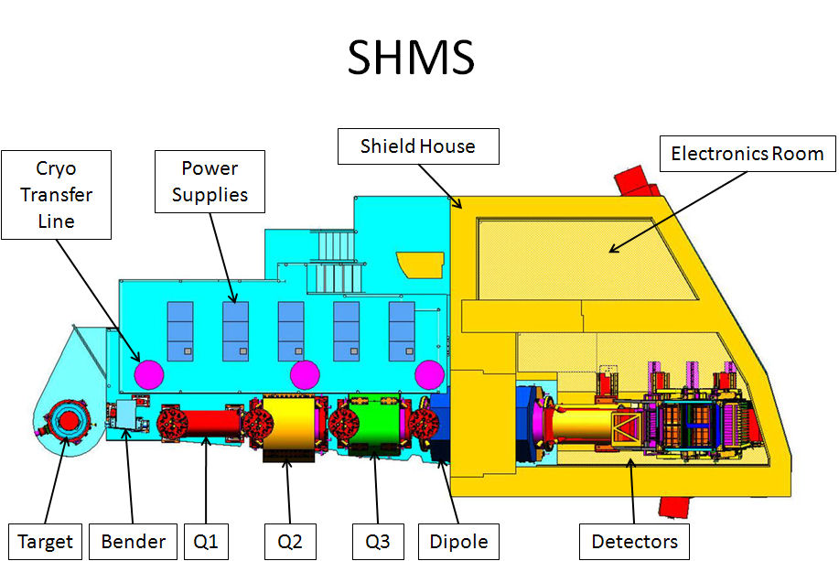

**Figure 1. SHMS Plan View**

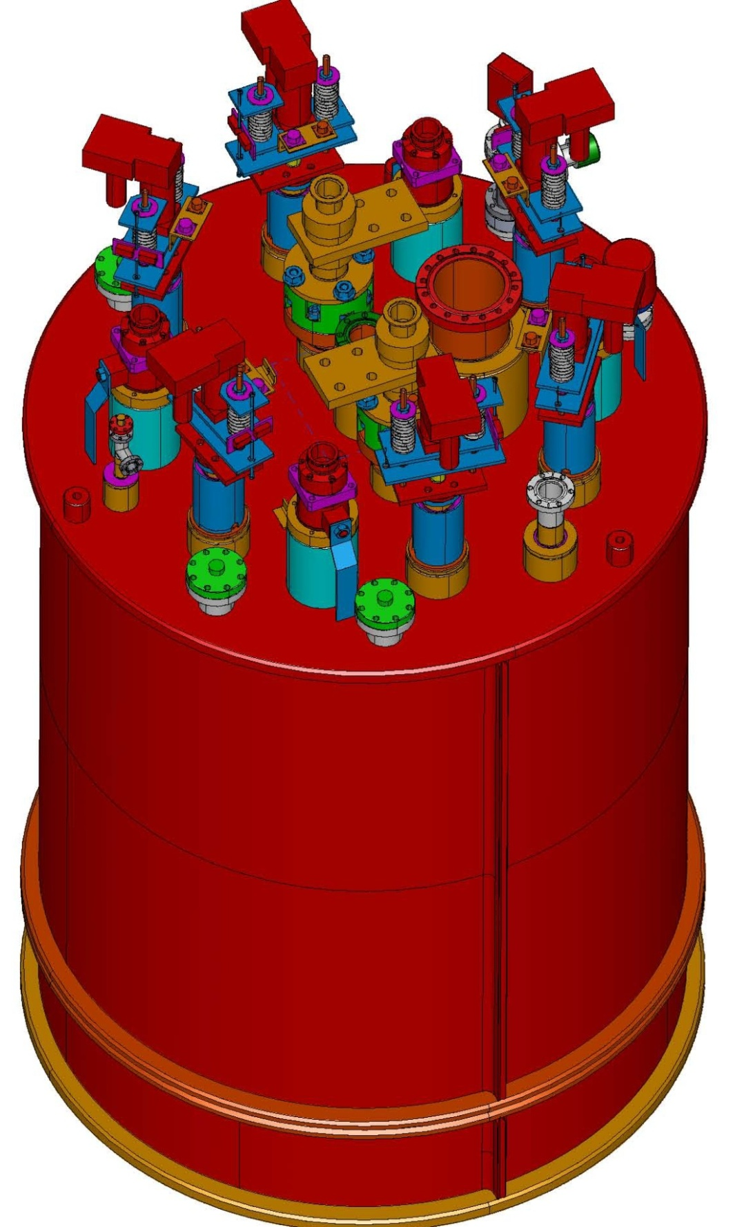

**Figure 2. CXFER LINE (#2, 3, 4, 5 &6) 3D CAD Exterior View**

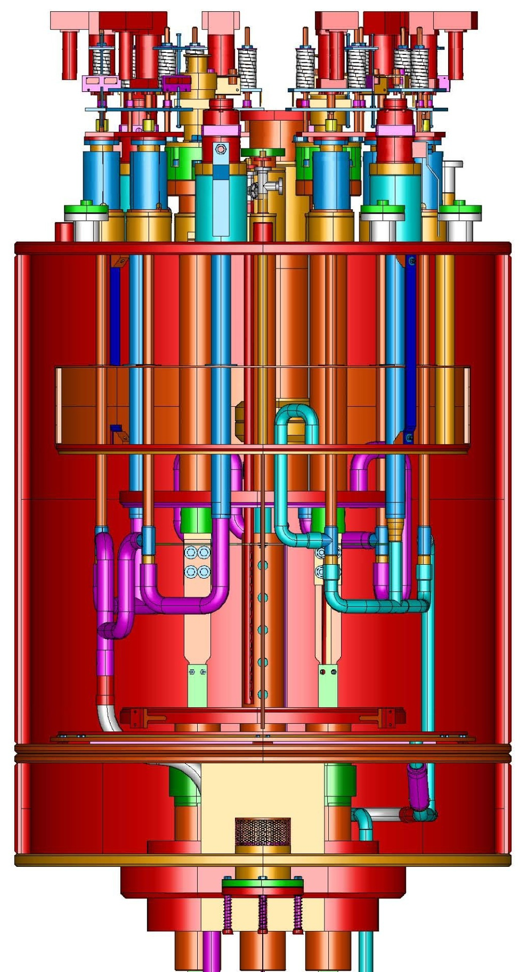

**Figure 3 Cutaway CXFER LINE #2, 3, 4, 5 & 6 for SHMS Magnets**

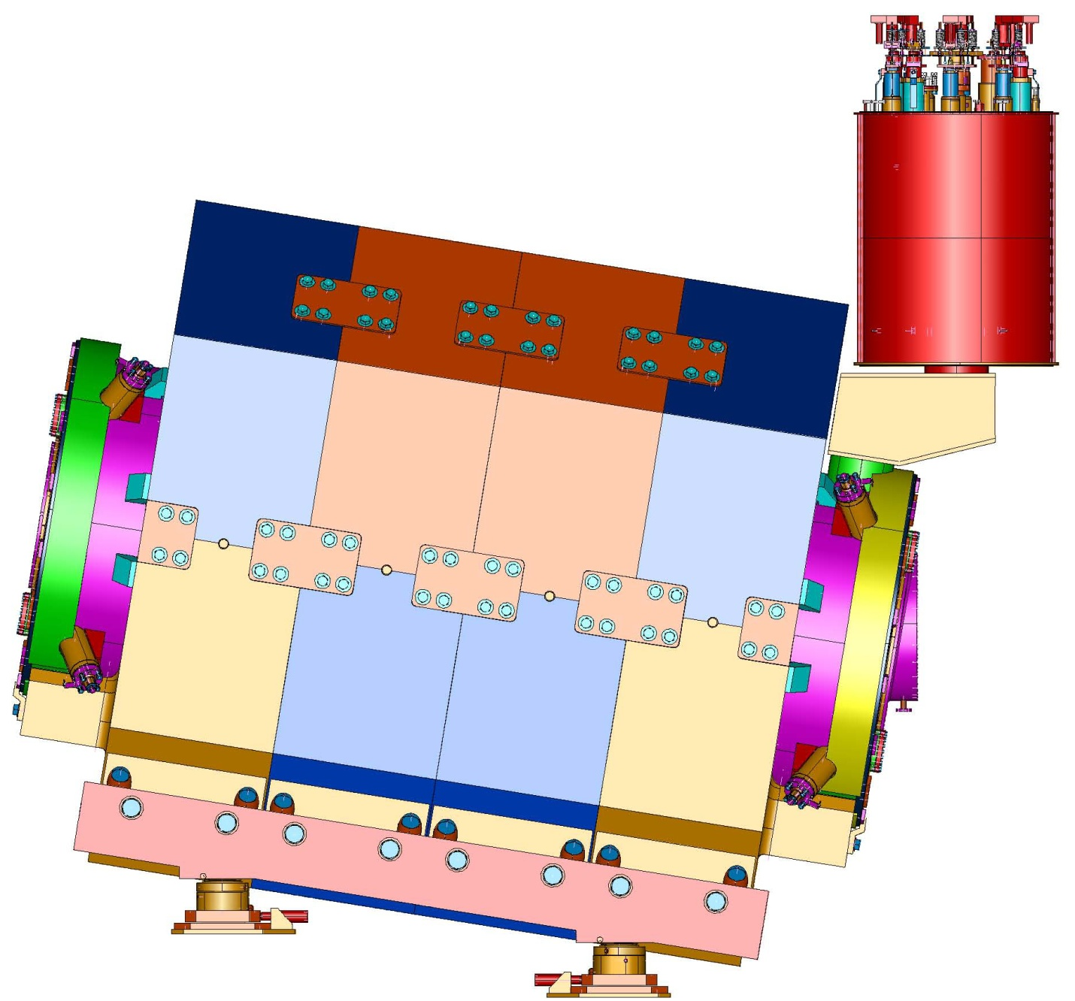

**Figure 4. Typical SHMS Magnet Installation of CXFER LINE**

**Assembly # 2, 3, 4, 5 &6**

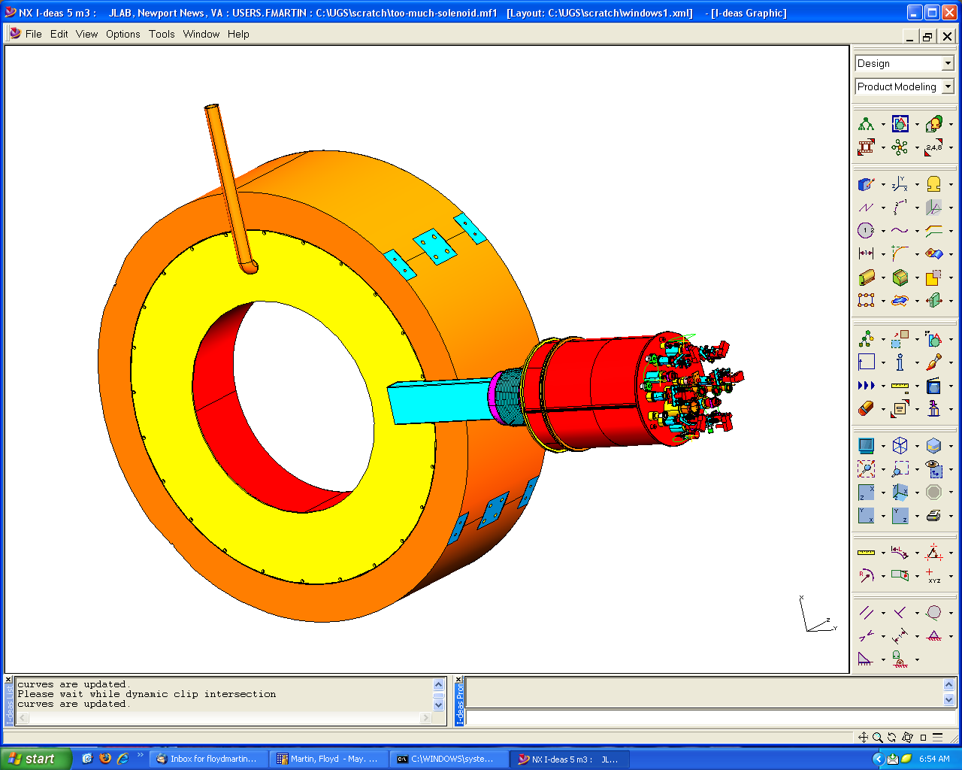

**Figure 5. CXFER LINE #1 Assembly as used on Hall D Solenoid**

**Single coil test configuration shown**

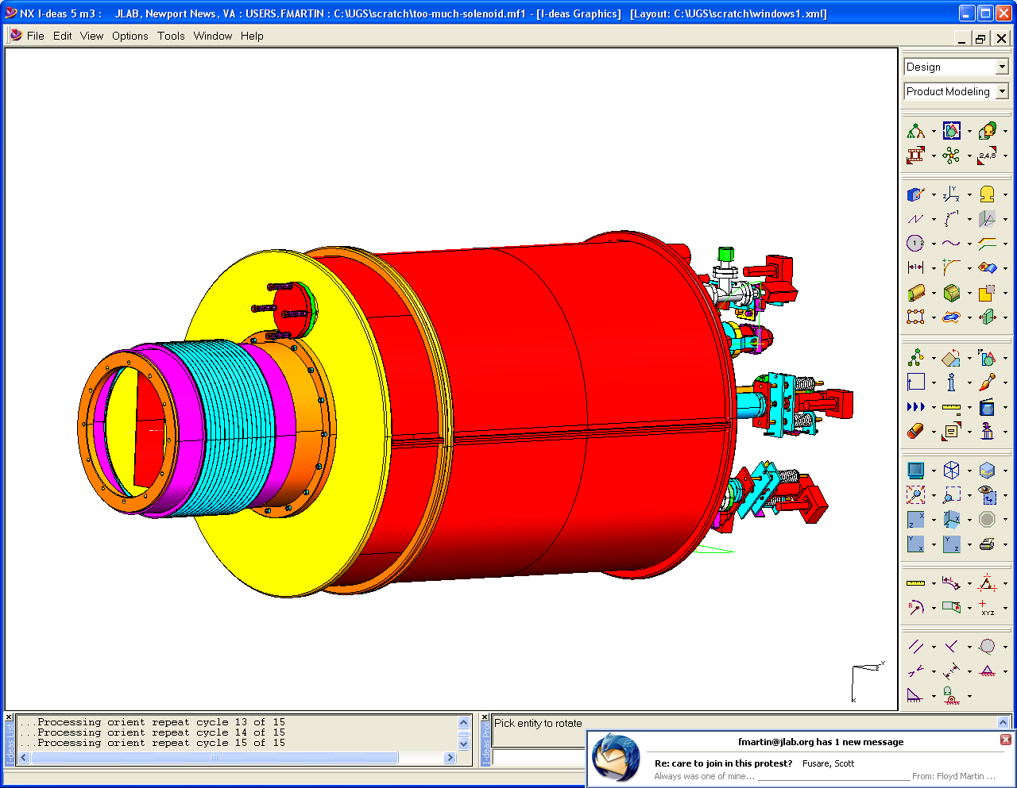

**Figure 6. Bottom View of CXFER LINE #1 Assembly for Hall D Solenoid**

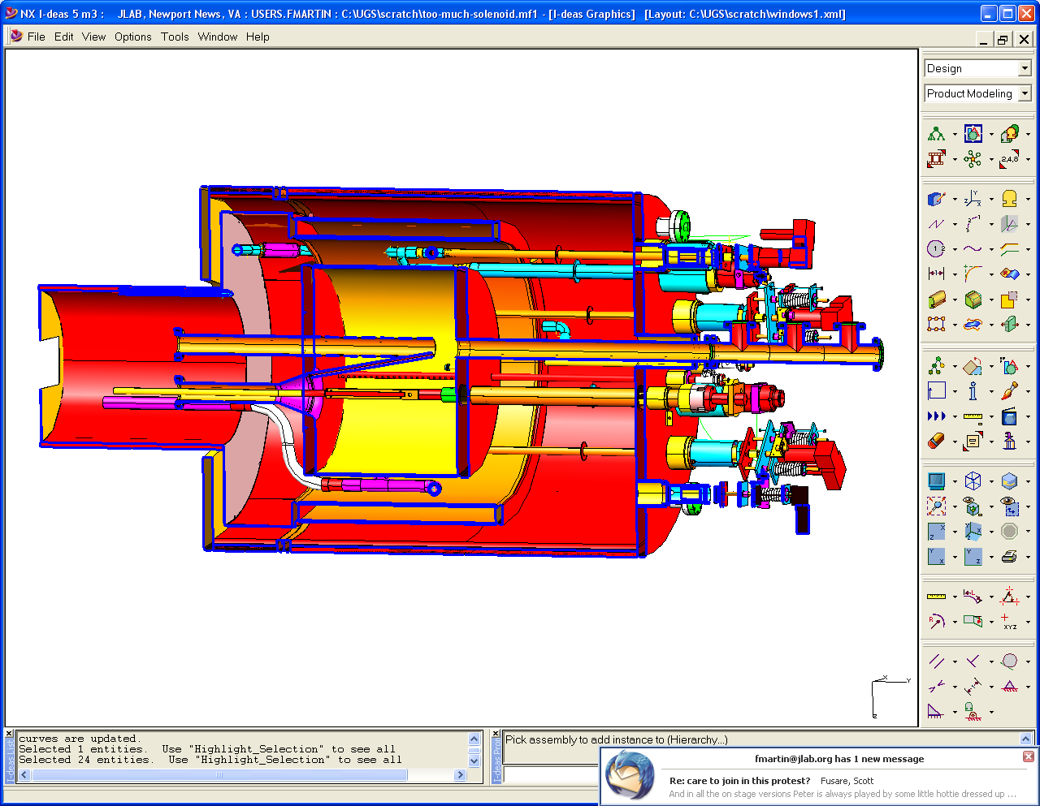

**Figure 7. Cut away view CXFER LINE #1 Assembly for Hall D Solenoid.**

**Supporting Documents**

1. SHMS CXFER LINE Assembly Pressure safety analysis
2. SHMS Magnet Pressure safety Analysis and Relief valve sizing
3. ES&H Manual Chapter 3410 *ESH&Q Aspects of Material Acquisitions*
4. ES&H Manual Chapter 3420 *ESH&Q Aspects of Procured Services & Construction*
5. Jefferson Lab Safety and Heath Requirements
6. Jefferson Lab 3520 Facilities Guide Specifications
7. CXFER LINE Assembly CXFER LINE Assembly 3D CAD Model File (Step file and Ideas Archive file
8. Jefferson Lab Quality Assurance Plan JLAB-QAP-01
9. Jefferson Lab Graded Approach Procedure
10. Jefferson Lab Pressure Systems Requirements