**Notes on data taken** when testing the HB quench detector circuit 8-Jan-2016, and comments on the meaning of that data.

H. Fenker

J. Segal

S. Lassiter

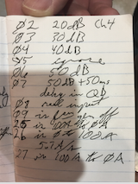

Above: photo of Jack’s notes about conditions during each photo below. “02” means the corresponding image file for “20dB Ch4” is “TEK0002.BMP”.

For all images “02” through “07”…

* Ch. 4 (green) is the raw signal from Howard’s old function generator. This signal gets attenuated by the values shown in Jack’s notes and the attenuated signal is applied to the input of the spare Quench-Detector channel of the HB magnet system (QD channel 3).
* Scope channel 1 (yellow) is the voltage at the output of the instrumentation amplifier chip on the QD board. Such a signal is available on a TP of each QD channel. This point in the circuit is also the input to the pair of comparators used to discriminate the analog signal on each channel (one for positive-going signals and one for negative-going signals). The amplifier chip is configured with a fixed gain of 1300. The comparators are configured with a fixed threshold of ±1.28 V. There are filters, an offset adjust, and a sensitivity adjust (called “GAIN” by Danfysik) that modify the analog signal prior to the amplifier.
* Scope channel 2 (blue [aka cyan]): output of one of the comparators. This is a logic signal which is quiescently at +15v, being pulled down by the comparator to -15v.
* Scope channel 3 (magenta) is the “SUM” of QD outputs that gets sent back to the DCPS chassis to indicate that a quench was sensed. 0v means “quench detected.”
* The scope is triggered on the negative edge of the “SUM” signal.

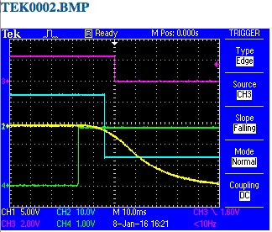

TEK0002: attenuation= 20dB (x10): 3 V input signal is attenuated to 300 mV.

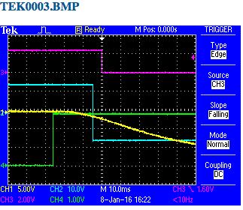

TEK0003: attenuation= 30dB (x32): 3 V input signal is attenuated to 94 mV.

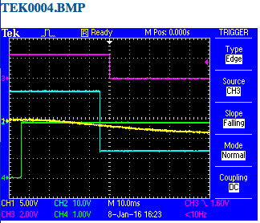

TEK0004: attenuation= 40dB (x100): 3 V input signal is attenuated to 30 mV.

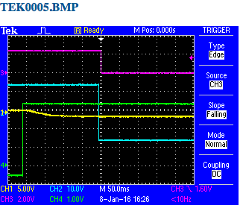

“IGNORE THIS IMAGE”

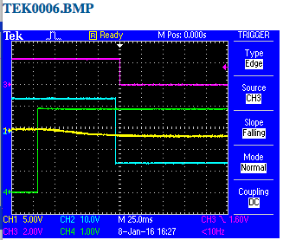

TEK0006: attenuation= 50dB (x320): 3.8 V input signal is attenuated to 12 mV.

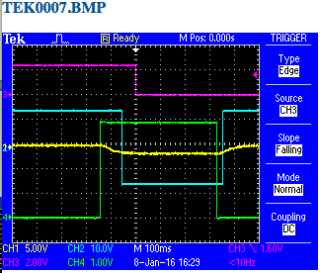

TEK0007: as in TEK00006 but QD Ch. 3 “Delay” setting was changed from zero to 50 ms. The added 50ms delay is apparent between the cyan (comparator output) and magenta (SUM) traces.

Observations:

1. Delay from comparator output to SUM output is (about 5ms) PLUS (whatever is set in the “DELAY” control of the quench detector).
2. The analog input stage of the quench detector converts a step-function input to a pulse having a risetime of about 60ms.
3. The time elapsed between (appearance of a sharply-rising analog pulse at the input of the quench detector) and (the firing of the comparator) is a function of the input pulse amplitude.

|  |  |
| --- | --- |
| **QD Input Pulse Amplitude (millivolts)** | **Delay from Input pulse to SUM output (milliseconds)** |
| 300 | 18 |
| 94 | 26 |
| 30 | 45 |
| 12 | 95 |

Images 08, 09, 25, 26, 27 are all measurements of the waveforms at the output of the instrumentation amplifier on HB QD Channel #2. The purpose was to learn what the noise level and charging voltage is like at this point in the circuit for a channel whose analog input is connected to the magnet.

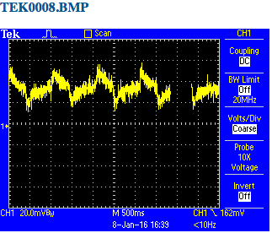

Trace 08 was taken with the pulse generator still running and injecting signals into a neighboring QD channel. The sawtooth pattern at about 1 Hz is caused by crosstalk from this nearby circuit.

When the pulse generator was turned off and the scope display was set to “min-max” display mode, we obtained trace 09.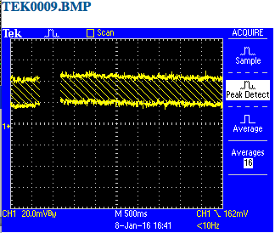

Traces 25, 26, and 27 were taken during ramps up to 100 Amps or back down to zero. The charging-current offset is seen to be about 100 mV on this channel at the nominal ramp rate (5.7 A/s I believe), while the min-to-max noise band is about 50 mV. Note that this point in the QD circuit is AFTER the x1300, amplifier, so these voltages are to be compared with the comparator threshold of 1,280 mV.

