Hall A Lift plan
Lift Description: Lift Big Bite Magnet onto Big Bite stand in Hall A
Lift Supervisor: Folts
Lift Date: 3/10/08
Lift Criteria | Notes/Comments
- What item(s) will be lifted?
Big Bite magnet
- Are there any special precautions (such as mats for mobile cranes)?
Standard warning cones and traffic control
- What is the weight of each item and total weight of the load? (For mobile cranes, see the manufacturer's instructions about components and attachments that must be considered as part of the load.) above 36000lb is a critical lift requiring an OSP
FOR NO REASON EXCEED 40000 LBS!
Magnet, coils, cooling manifold 38900 lbs

- Where is the center of gravity located?
In the upright orientation, with the right foot mounted the CG is 3 inches off the centerline of the magnet and 5 feet below the lifting points. The magnet is kept level with this offset CG by a 3 ton chainfall from the hook to a swivel lifting eye on the side of the right foot
- List each piece of equipment, accessory, and rigging component, by type and rated capacity, that will be used during the lift.

a. Crane 20 Ton polar in Hall A
b. Hoist no
c. Fork Truck no
d. Slings (identify the configuration used: choker, basket, or vertical, and angle (see Figure 1 below)) 1 20 ft 64000 lb capacity liftall sling in basket configuration.
e. Shackles none
f. Eye Bolts/Swivel Eyes 7000 lb or greater capacity swivel liftin eye bolted to the side of the right foot
g. Turnbuckles none
h. Spreader Bars none
i. Hook (Type and WLL) _______
j. Other (Special Lifting Fixture, Below the Hook Lifting Devices, Multi Leg Bridle, etc) no
6. Are there designated checkpoints or hold points? Hold just prior to setting the load on the pink stand.
Instructions are found in the Move Big Bite to stand procedure.
7. If yes, list them and their estimated instrument readings, as relevant, so that job progress can be checked against the plan. N/A
8. How will you rig the load? 4 point basket to built in lift points mounted in the magnet steel.
9. Will tag lines be needed to control the load? Yes
10. What personnel will you need to assist with the lift?
a. Crane operator 1
b. Riggers 1
c. Spotters at least 1
d. Tag Line Handlers 1 when needed
e. Fork truck driver no
f. Other no
11. Safety equipment (hard hats, safety shoes, gloves) all of these
12. Mobile Crane location N/A
a. Will crane be set up on concrete? If yes, can concrete support the weight of the crane and the load? N/a
b. Will crane be set up on asphalt? If yes, will cribbing be needed (for asphalt temp > 90° F)? N/A
c. Will crane be set up on gravel or rough ground? If yes, cribbing will be required. N/A
13. Are any of the structures listed below located in the area of the crane set up? If yes, indicate their location on the Load Path Sketch.
a. Manholes N/A
b. Underground voids N/A
c. Pipe chases N/A
d. Overhead obstructions or power lines Cryo lines and utilities
14. Additional information N/A
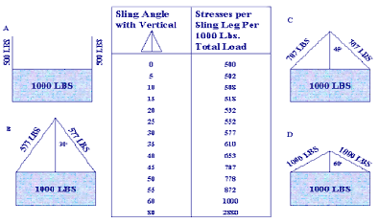
The chart in the middle offers a handy guide for assessing the effective angle of the sling to the relative weight. It is always better to limit the angle of the sling. Further, such changes in sling angle must be accounted for in lifts that are close to the sling weight limit and/or for critical lifts (greater than 90% of the crane limit).
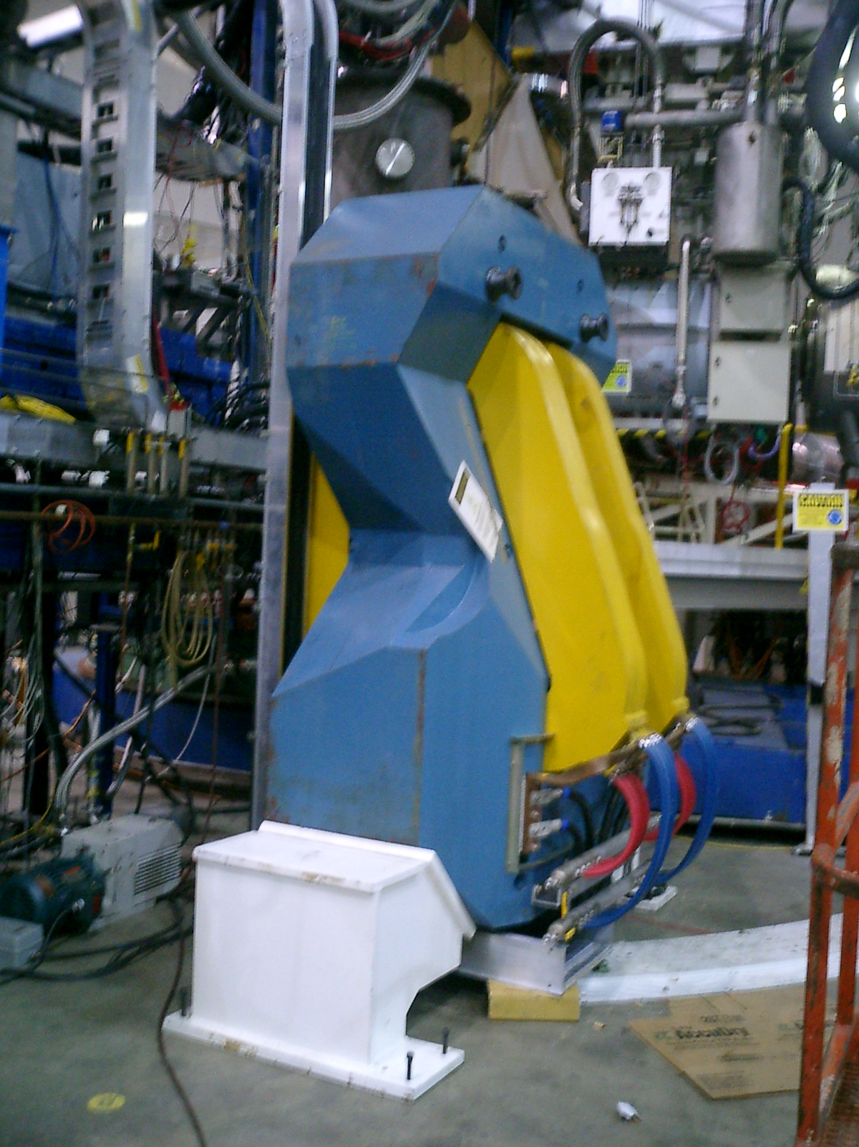

Identify the following on your sketch:
a. Lift point identification 4 round spool shaped lift points above and outboard of the yellow coils
b. Method(s) of attachment basket
c. Load angle factors (e.g., vertical and horizontal vectors of sling loads)
d. Sling angles > 60 degrees
e. Accessories used none
f. Other factors affecting the equipment capacity close to load limit of the crane
g. Rated capacity of equipment in the configuration(s) in which it will be used. (For mobile cranes, many factors affect rated capacity, including boom length, boom angle, and work area.)←← 40000lb polar crane
Load Path Sketch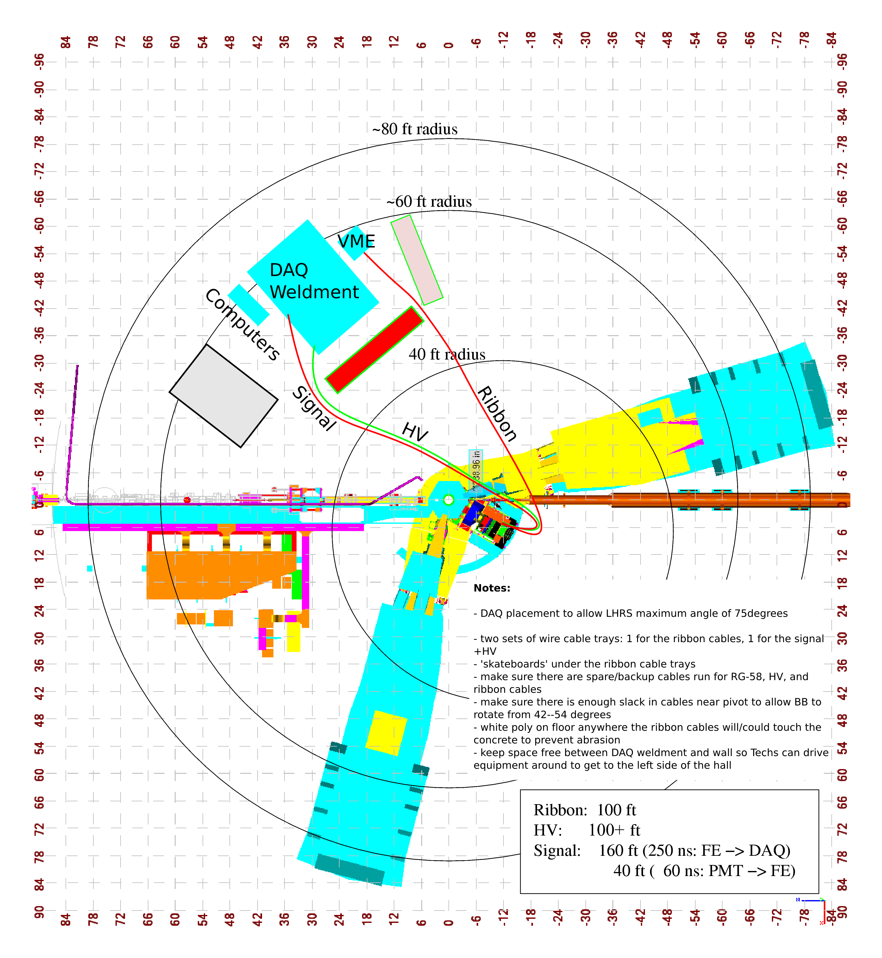

A load-path sketch shows the load path and height at key points in the job. For lifts with mobile cranes, include the crane position(s) relative to the load and relative to surrounding obstructions. Where appropriate, include floor or soil-loading diagrams. Indicate lifting and travel speed limitations if applicable.

