Directions: Save this template as a new file name that contains the title. Double click on the header and update the title, author and date, the pages are automatic. Double click outside the header and answer the lift criteria questions. Put your answers in the notes/comments box. Send the completed document to the Hall coordinator for review and approval.

Define the scope of work

Lift Supervisor

Lift Criteria | Notes/Comments
- What item(s) will be lifted?

- Are there any special precautions (such as mats for mobile cranes)?
no
- What is the weight of each item and total weight of the load? (For mobile cranes, see the manufacturer's instructions about components and attachments that must be considered as part of the load.) above 36000lb is a critical lift requiring an OSP
FOR NO REASON EXCEED 40000 LBS!

- Where is the center of gravity located? Note: The center of gravity of an object is that point at which the object will balance. A stable load is one in which the center of gravity of the load is directly below the main hook and below the lowest point of attachment of the slings.

- List each piece of equipment, accessory, and rigging component, by type and rated capacity, that will be used during the lift.

a. Crane
b. Hoist
c. Fork Truck
d. Slings (identify the configuration used:
e. Shackles
f. Eye Bolts/Swivel Eyes
g. Turnbuckles
h. Spreader Bars
i. Hook (Type and WLL)
j. Other (Special Lifting Fixture, Below the Hook Lifting Devices, Multi Leg Bridle, etc)
6. Are there designated checkpoints or hold points?
7. If yes, list them and their estimated instrument readings, as relevant, so that job progress can be checked against the plan.
8. How will you rig the load?
9. Will tag lines be needed to control the load?
10. What personnel will you need to assist with the lift?
a. Crane operator
b. Riggers
c. Spotters
d. Tag Line Handlers
e. Fork truck driver
f. Other
11. Safety equipment (hard hats, safety shoes, gloves) all of these
12. Mobile Crane location
a. Will crane be set up on concrete? If yes, can concrete support the weight of the crane and the load?
b. Will crane be set up on asphalt? If yes, will cribbing be needed (for asphalt temp > 90° F)? N/A
c. Will crane be set up on gravel or rough ground? If yes, cribbing will be required. N/A
13. Are any of the structures listed below located in the area of the crane set up? If yes, indicate their location on the Load Path Sketch.
a. Manholes N/A
b. Underground voids N/A
c. Pipe chases
d. Overhead obstructions or power lines
14. Additional information
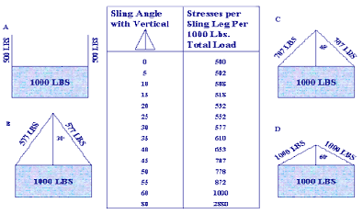
The chart in the middle offers a handy guide for assessing the effective angle of the sling to the relative weight. It is always better to limit the angle of the sling. Further, such changes in sling angle must be accounted for in lifts that are close to the sling weight limit and/or for critical lifts (greater than 90% of the crane limit).



Identify the following on your sketch:
a. Lift point identification
b. Method(s) of attachment
c. Load angle factors (e.g., vertical and horizontal vectors of sling loads)
d. Sling angles
e. Accessories used
f. Other factors affecting the equipment capacity
g. Rated capacity of equipment in the configuration(s) in which it will be used. (For mobile cranes, many factors affect rated capacity, including boom length, boom angle, and work area.)
Load Path Sketch
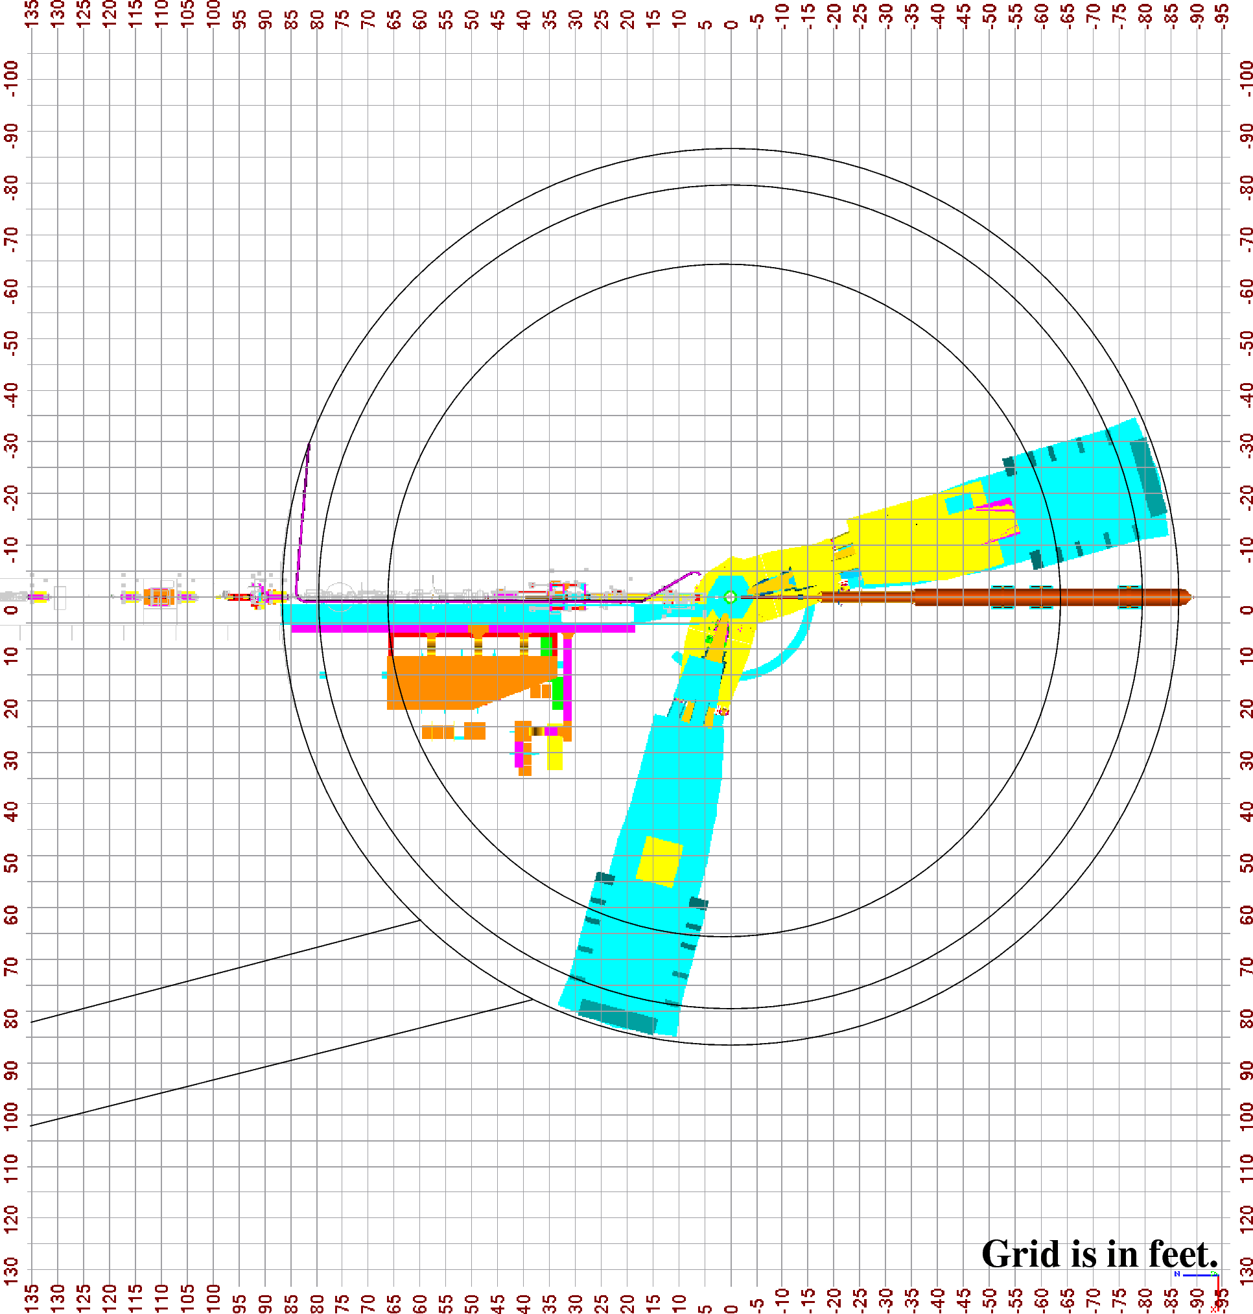

A load-path sketch shows the load path and height at key points in the job. For lifts with mobile cranes, include the crane position(s) relative to the load and relative to surrounding obstructions. Where appropriate, include floor or soil-loading diagrams. Indicate lifting and travel speed limitations if applicable.

