The Huntron Tracker is an electronic test device. It displays the positive/negative junction of a solid state component. The Huntron is used to check de-energized components only.

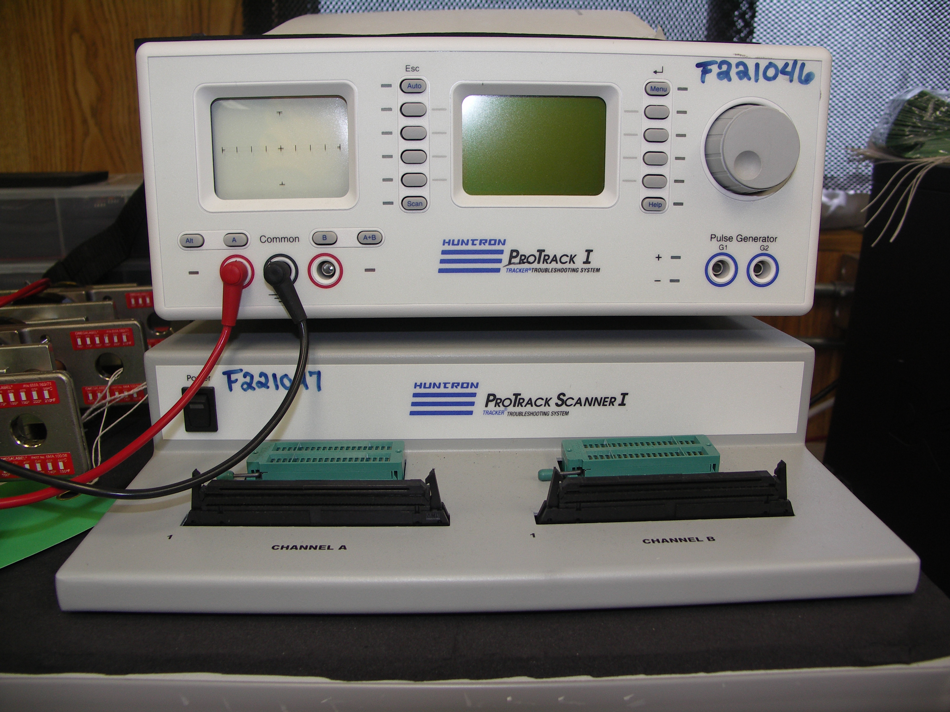

To use the Huntron, turn the test set on at the rear of the device. Plug the negative test lead into the position labeled common. Plug the positive test lead into either position A or B. If your positive lead is plugged into the position labeled “a”, you must depress the button labeled “a”. You will see an LED illuminate to the left of the test lead. This LED indicates that measurements received via test leads “a” and common will be displayed on the screen. If you wish to use channel “b” you must depress the button labeled “b”. You will see an LED illuminate to the right of the test lead. This LED indicates that measurements received via test leads “b” and common will be displayed on the screen.

