**User name Jack (Techs)**

**User name Jack (Techs)**

**Log entry time 19:21:33 on May 16, 2009**

**Entry number 273949**

keyword=Right Q1  
  
It would appear we have lost communication with the Right Q1 power supply. What I would like to do is get a chance to go into the hall and look at the supply directly with a laptop, to see if the supply is hung or the EPICS serial interface is hung. Whichever, it would be a serious setback if someone just went into the hall and reset the power supply without checking this out. I have attached a jpg of the RQ1 GUI taken at 19:11 today. Since the field seems to be stable I would say we could do an access when convenient, but I would give it some priority.

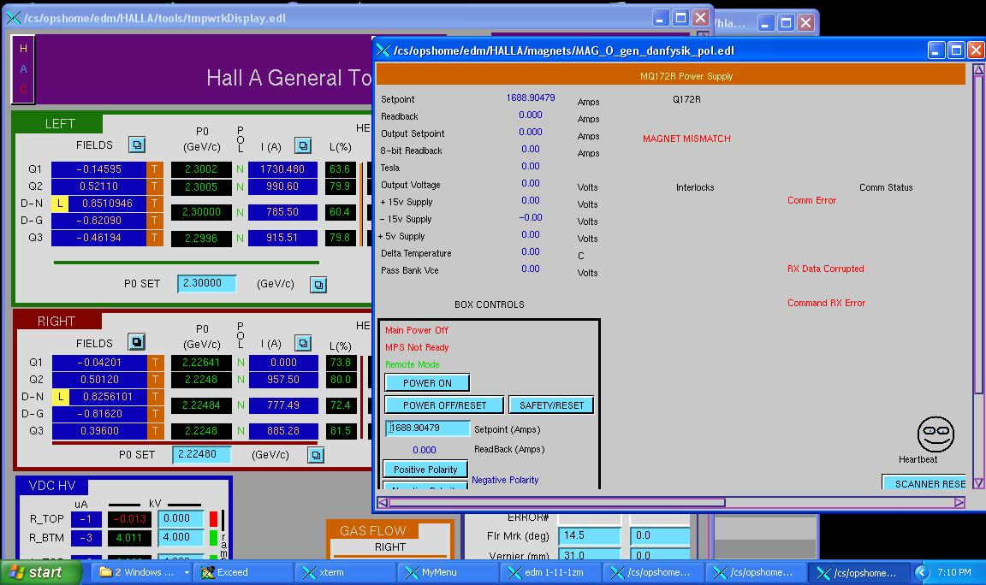

**Log entry time 08:25:30 on May 20, 2009**

**Entry number 275025**

keyword=Right Arm Q1 power supply  
  
This entry is for the work done yesterday on the Right Q1 power supply. I connected the laptop to the supply using the usb to RS-422 adapter and the serial cable from the Q1 spares drawers. It was clear the control board itself was having a problem, not the EPICS interface. When given a 'return' key with nothing on the line it should respond with a '?' to tell you it did not understand the command. It was responding with random snipets of responses. Clearly some register had been corrupted. I set the current to 0, the supply responded by ramping down. At 0A I pushed the 'Reset' button on the Control Board. This reloads the FPGA configuration. The supply behaved correctly after that.